**Unit 2 – soils and natural formations**

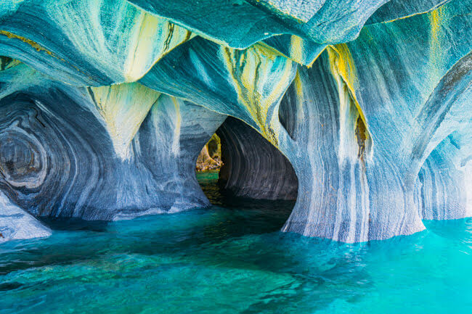

Part 1

Task A

* Open your digital book on pages [29 - 30](https://eclass02.sch.gr/modules/document/?course=T356185) and go through the text on soils and natural formations.
* Then, using your personal ΠΣΔ data, click on the following link, do the exercise and revise relevant vocabulary

<https://e-me.edu.gr/groups/melissoulageo/wall> [revising vocabulary exercise from unit 2]

⮱ How did you do? Your score?

Task B

* Have a look at this short but interesting video: [Cano Cristales](https://www.youtube.com/watch?v=wKp5q6OWTBY)
* Now answer the following comprehension questions:

The video was about a …

a) river b) cave

The red colour is because of a plant.

a)True b) False

People can see this place only from afar.

a)True b) False

____ ____ ____

It is red all year round.

a)True b) False

There are also caves to explore.

a)True b) False

_____ _____

**Unit 2 – soils and natural formations**

Part 2

Task A

Watch a video about ‘**The 10 most wonderful places on Planet Earth’**.

<https://www.youtube.com/watch?v=XH6ER3cNrCY>

You can also check out some ‘**Wild Nature**’ photos on this [blog](https://melissoublog.blogspot.com/).

⮱ Which one did you find the most impressive?

*Maybe, we have something as interesting in Greece…*

Task B

🟋 First, think of an interesting nature formation in Greece or somewhere else…

🟋 Then, go to the shared presentation…

<https://docs.google.com/presentation/d/1s0g3pIqtdOLmAuujbHwtHjBNEOyV5zQoPv_moTs3Sz4/edit?usp=sharing>

🟋 Add your own **2** slides [ 1 photo + 1 slide with info]…

🟋 Sign your part with just your first name.

***Helpful links:*** *For information* 🡢 <https://www.wikipedia.org/>

*Dictionary* 🡢 <https://www.wordreference.com/gren/%CE%91>