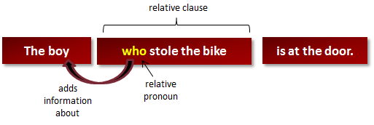

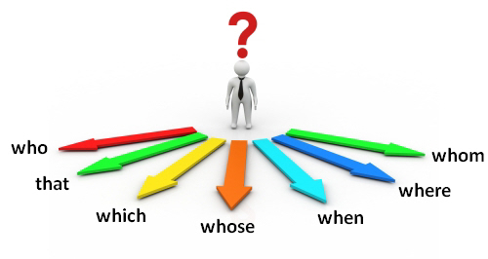
1.- Complete the sentences with relative pronouns.
1. The cook ____________ made the pasta was Italian.
2. I read a book ______________ explained how to make films.
3. This is the hospital _______________ I was born.
4. Summer is the season _______________ I go on holiday.
5. He is the boy _______________ I told you about!

2.- Join each sentence to the correct ending, using who, which, where and whose.

- He’s the player ____________ | - ____ I saw the dress.
- Apollo was the spaceship _____________ | - ____ took man to the moon.
- We went to the shop _____________ | c) ____ was Number One, was a really slow song.
4) The girl ______________ | d) ____ scored the goal.
5) Her last single, ______________ | e) ____ arm was broken is a friend of mine.

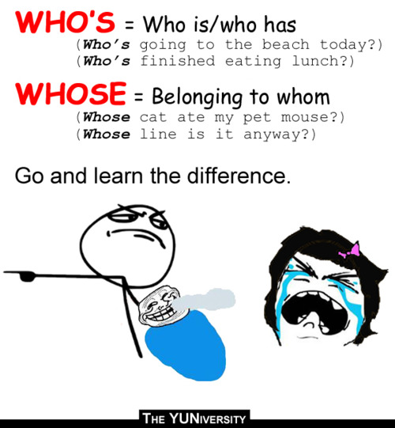
3.- Fill in: who’s or whose.
- Sarah is the woman _______________ moved next door.
- Rita is the girl _______________ father won the lottery.
- Helen is the person _______________ car was stolen.
- Ann’s the one _______________ lost a lot of weight.
- Massimo is the man ______________ going to help me.
- That’s the man _____________ son was killed in an accident.

4.- Join the sentences. use relative pronouns.
1. I know a chef. He makes 100 types of pasta.

2. I read a book. It explained how to make films.

3. This is the garden. He usually walks his dog here.

4. Here is the boy. The teacher was looking for him.

5. I remember the day. You had a surprise party then.

5.- Delete the relative pronoun where possible.
- People who like playing tennis often like playing badminton too.
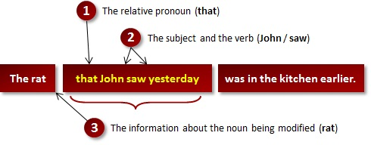
- The children that you saw outside came yesterday too.
- The thing which really annoys me about him is his attitude.
- That room where I slept last night was really warm.
- The film which we saw yesterday was quite interesting.
- It’s the same film as the one that we saw last week.
- Is cricket the game that takes a long time to play?
- Is she the one whose money was stolen?
- “Herbivore” is the name that we give to animals that only eat plants.

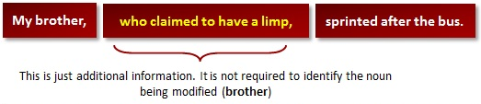

6.- Join each pair of sentences using a non-defining relative clause –between commas-.
- Sam Smith won the lottery last night. He is an electrician.

- The book is a best-seller. It is about communist Russia.

- The attic is very bright. I work there.
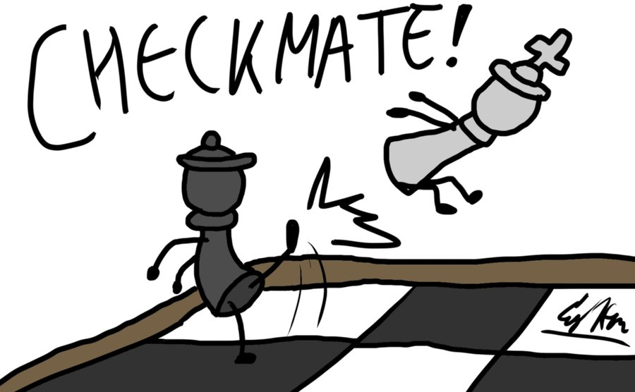
- My father taught me to play chess. He loved the game.

7.- Match the sentences with the relative clauses.
- Stephen, __________, helps me with all of my computer problems.
- He is very happy _________. He loves doing this.
- The university _________ is one of the best technical universities in Europe.
- Stephen has recommended a new computer, ______
- Stephen, ________, works very hard at university.
- I bought him a web cam, _________, to say thanks.
- which he loved
- which I will buy next month
- whose company is paying for his
degree
- who is my neighbour
- where he studies
- when he is solving
computer problems

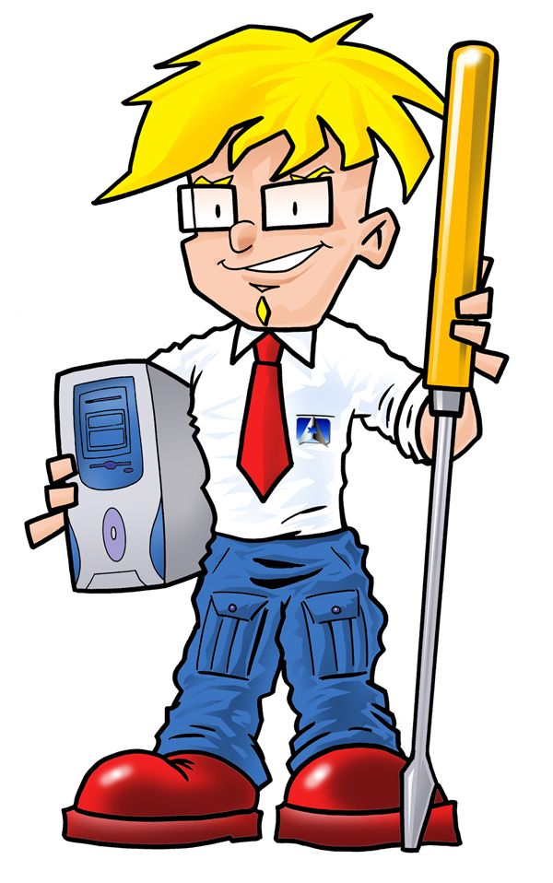

8.- Complete the text using the relative pronouns – that, when, where, which, who, whose - if necessary.

My great-aunt Dorothy is a woman ¹ _______________ doesn’t seem to realize how old she is. In fact, she’s eighty-one. She’s up-to-date on all the news and trends, and she reads science books ² ______________ are too complicated for most people to understand.
Dorothy also loves computer games, ³ _______________ some people think is really funny at her age. I think it’s great and I’ve given her some of mine, but she said the last one ⁴ _______________ I gave her was too violent. She doesn’t like anything ⁵ ________________ has guns in it.
Dorothy says good food is the secret to a long healthy life. She says someone ⁶ _______________ meals are healthy, but delicious will always love being alive! She is sure that if you don’t eat healthy food ⁷ _______________ you are young, you won’t want to later, either. She thinks the places ⁸ _______________ I sometimes go to eat with my friends are terrible. I know she is right, but I love
burgers!
Dorothy has a part-time job at the local library, ⁹ _____________ she teaches retired
people to use the internet. She’s somebody ¹⁰ ___________ everyone likes, especially
me!



