**Making a Medical Appointment**

Listen to  and read   this conversation between Anna and the receptionist.

Receptionist:  Hello, Colorado Springs Medical Offices. May I help you?

Anna:             Hello, I want to make an appointment to see Doctor Lee.

Receptionist:  OK. What's your name?

Anna:             My name is Anna Garcia. G-A-R-C-I-A.

Receptionist:  Are you a new patient?

Anna:             No, I've seen Doctor Lee before.

Receptionist:  Why do you want to see the doctor?

Anna:             I have had a very bad sore throat for five days.

Receptionist:  When can you see the doctor?

Anna:             This afternoon about 3 o'clock.

Receptionist:  I can get you in at 2:30. Will that work for you?

Anna:             Yes, I can be there at 2:30.

Receptionist:  How will you pay?

Anna:             I will pay with cash.

Receptionist:  OK, please come in this afternoon at 2:30.

Anna:             Thank you. Good bye.

[*http://www.web-esl.com/health/record.html*](http://www.web-esl.com/health/record.html)



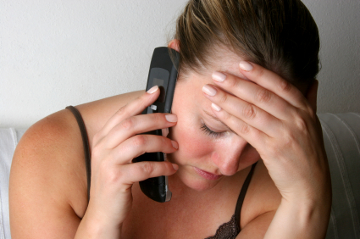

**Making a Medical Appointment**

*Listen to  and read   this conversation between Anna and the receptionist.  Fill in the blanks with the correct words or phrases provided.*

**2:30 afternoon patient cash pay Good bye**

**doctor please help an appointment sore throat name**

Receptionist:  Hello, Colorado Springs Medical Offices. May I (1) ___________ you?

Anna:             Hello, I want to make (2) ________________________________ to see Doctor Lee.

Receptionist:  OK. What's your (3) ________________?

Anna:             My name is Anna Garcia. G-A-R-C-I-A.

Receptionist:  Are you a new (4) _____________________?

Anna:             No, I've seen Doctor Lee before.

Receptionist:  Why do you want to see the (5) ___________________?

Anna:             I have had a very bad (6) ______________________ for five days.

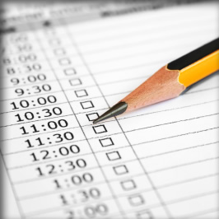Receptionist:  When can you see the doctor?

Anna:             This (7) ____________________ about 3 o'clock.

Receptionist:  I can get you in at 2:30. Will that work for you?

Anna:             Yes, I can be there at (8) _____________.

Receptionist:  How will you (9) ___________?

Anna:             I will pay with (10) ____________.

Receptionist:  OK, (11) _________________ come in this afternoon at 2:30.

Anna:             Thank you. (12) _______________________.

[*http://www.web-esl.com/health/record.html*](http://www.web-esl.com/health/record.html)



**Making a Medical Appointment**

*The conversation below is jumbled up. Arrange this conversation between Anna and the receptionist.*

|  |  |
| --- | --- |
| Receptionist: | When can you see the doctor? |
| Receptionist: | I can get you in at 2:30. Will that work for you? |
| Receptionist: | OK. What's your name? |
| Receptionist: | OK, please come in this afternoon at 2:30. |
| Anna: | This afternoon about 3 o'clock. |
| Receptionist: | How will you pay? |
| Anna: | Thank you. Good bye. |
| Anna: | My name is Anna Garcia. G-A-R-C-I-A. |
| Anna: | Yes, I can be there at 2:30. |
| Receptionist: | Are you a new patient? |
| Anna: | Hello, I want to make an appointment to see Doctor Lee. |
| Anna: | I will pay with cash. |
| Receptionist: | Why do you want to see the doctor? |
| Anna: | No, I've seen Doctor Lee before. |
| Receptionist: | Hello, Colorado Springs Medical Offices. May I help you? |
| Anna: | I have had a very bad sore throat for five days. |

1. What is the name of the clinic?
2. What is the patient’s first name?
3. What is the patient’s family name?
4. Why did Anna call the clinic?
5. What is the matter with Anna?
6. What is the name of the doctor?
7. What time did Anna say she could see the doctor?
8. What time did the receptionist book Anna in?
9. How will Anna pay?
10. Write **YES** or **NO**.
11. The receptionist called Colorado Springs Medical Offices. ________
12. Anna spelt out her first name. ________
13. Anna is a new patient. ________
14. Anna wants to make an appointment to see Doctor Lee. ________
15. Anna has a bad sore throat. ________
16. Anna has had the sore throat for five weeks. ________
17. Anna can be at the clinic at 3.30. ________
18. Anna will pay by credit card. ________

