HEALTH PROBLEMS VOCABULARY
Write the names under the correct pictures:

 | 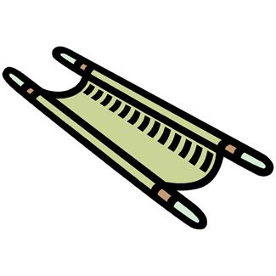 | TEMPERATURE  DOCTOR  X-RAY  HOSPITAL  EYE DROPS  PLASTER  NURSE  DRIP  SLING  THERMOMETER  HEADACHE  AMBULANCE  ORDERLY  PILLS  STRETCHER  FLU  OPERATING ROOM  CHECKUP  INHALER  SLIPPED DISC  COUGH SYRUP  EARACHE  STETHOSCOPE  CRUTCHES  PRESCRIPTION  TISANE  TOOTHACHE  TABLETS  INJECTION  STOMACHACHE  WHEELCHAIR  STICKING PLASTER | 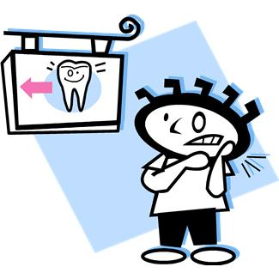 | 
1. | 2. |  | 3. | 4.
 |  |  |  | 
5. | 6. |  | 7. | 8.
 | 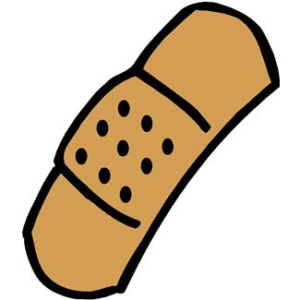 |  |  | 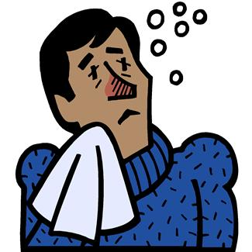
9. | 10. |  | 11. | 12.
 | 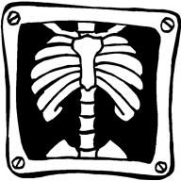 |  |  | 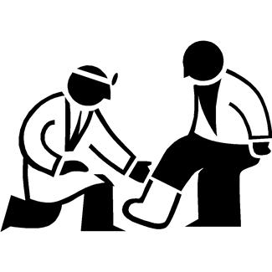
13. | 14. |  | 15. | 16.
 | 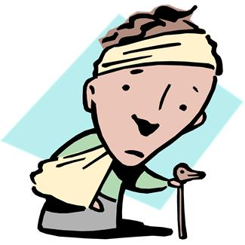 |  |  | 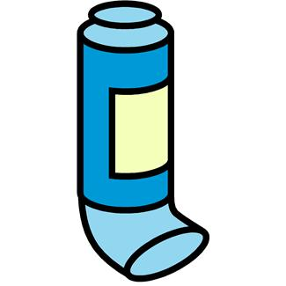
17. | 18. |  | 19. | 20.
 |  |  |  | 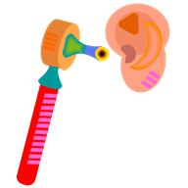
21. | 22. |  | 23. | 24.
 |  |  | 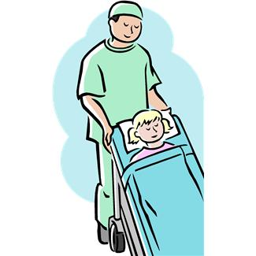 | 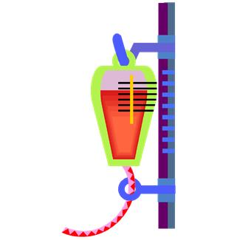
25. | 26. |  | 27. | 28.
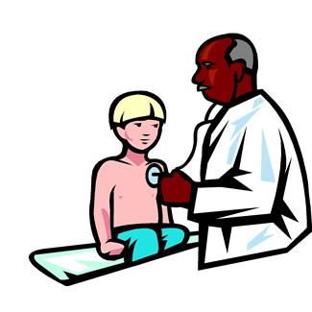 |  |  |  | 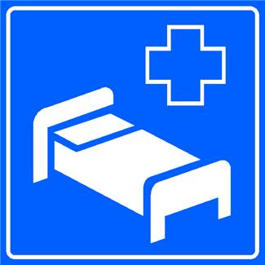
29. | 30. |  | 31. | 32.

Use 5 of the words in your own sentences

