WRITING TASKS B class
File 1 – Unit 1
- Description of a person
Write a description titled “Describe an interesting person you know or a person who makes you happy.” Include appearance, character, interests, family, how you met, and your opinion.
- Famous landmark
Choose a famous landmark, research its story, write a short text about it, and make a poster.

Research Questions Basic Information

- What is the name of the landmark?
- Where is it located?
- When was it built?
- Who built or designed it?
- Why was it built?
Description
- What does it look like?
- What materials were used?
- How big is it?
Interesting Facts
- What makes it special?
- Is there a legend or story behind it?
- How many tourists visit it every year?
Personal Opinion
- Would you like to visit it?

- Why / Why not?

Write an article (120–150 words)
Title: A Famous Landmark
Use the information you found to write a short article for the school exhibition.
Remember to:

✔ use paragraphs
✔ include historical information
✔ use descriptive adjectives
✔ include your opinion
✔ add interesting facts

Useful Vocabulary

Buildings
- monument
- landmark
- tower
- temple
- palace
- fortress
- statue
Adjectives
- famous
- ancient
- impressive
- spectacular
- magnificent
- historic
- unique
Verbs
- build
- design
- construct
- attract
- visit
- admire
- represent

- Every Building has its own Story
Look at a building and write its story. Include where it is, how old it is, who made it, why it was built, what it looks like, and the story behind it.
Acropolis of Athens
The Acropolis of Athens is an ancient citadel located on a rocky hill above the city of Athens, Greece. It contains some of the most significant architectural and artistic achievements of classical antiquity, symbolizing the cultural and political achievements of ancient Greece. Today, it stands as a UNESCO World Heritage Site and a global symbol of democracy and Western civilization.
Key facts
- Location: Athens, Greece
- Era of main construction: 5th century BCE
- Architectural style: Classical Greek
- UNESCO World Heritage designation: 1987
- Main monuments: Parthenon, Erechtheion, Propylaea, Temple of Athena Nike
Historical background
The Acropolis has been inhabited since prehistoric times but achieved its greatest splendor during the 5th century BCE under the leadership of Pericles. During this period, Athens became a major cultural and political center, and the Acropolis was transformed into a monumental complex dedicated to the goddess Athena, the city’s patron deity. The site embodied the ideals of Athenian democracy, civic pride, and artistic excellence.
Major monuments
The Parthenon, designed by Ictinus and Callicrates, is the most famous structure on the Acropolis. It served as a temple to Athena Parthenos and a treasury. Other notable buildings include the Erechtheion, known for its Porch of the Caryatids; the Propylaea, the monumental entrance; and the Temple of Athena Nike, celebrating Athenian military victories. Together, these monuments exemplify the harmony, proportion, and innovation of classical Greek architecture.
Cultural significance
The Acropolis symbolizes the artistic and philosophical achievements of ancient Athens and has influenced Western architecture and political thought for centuries. Its sculptural decorations, such as the Parthenon Marbles, express ideals of humanism, order, and beauty central to classical art. The site continues to inspire restoration, research, and debate about heritage preservation and cultural identity.

File 2 – Unit 2
- Archaeologist’s email
Imagine you are Mr Brown, a British archaeologist. Write an email to your colleagues about an interesting discovery. Use Present Perfect and archaeological vocabulary.
- Pompeii paragraph
Write a short paragraph for an art competition picture titled “A Street from the Past Comes to Life.” Describe what people were doing when Vesuvius erupted.
- Mediation email about Dispilio
Reply to your Swedish penfriend Bjorn in English. Explain the important artefacts found in Dispilio, what they tell us about the people, and the role of water.
- Life-changing story
Write a story titled “Imagine you are living in ancient Greece, or another ancient civilisation. Write your own story about a life-changing experience you had.” Use past tenses, time words, feelings and dialogue.
File 3 – Unit 3
- Local leaflet
Prepare a leaflet for exchange students from Kent who are visiting your town. Include where to stay, what to see, where/what to eat, shopping, souvenirs and entertainment.
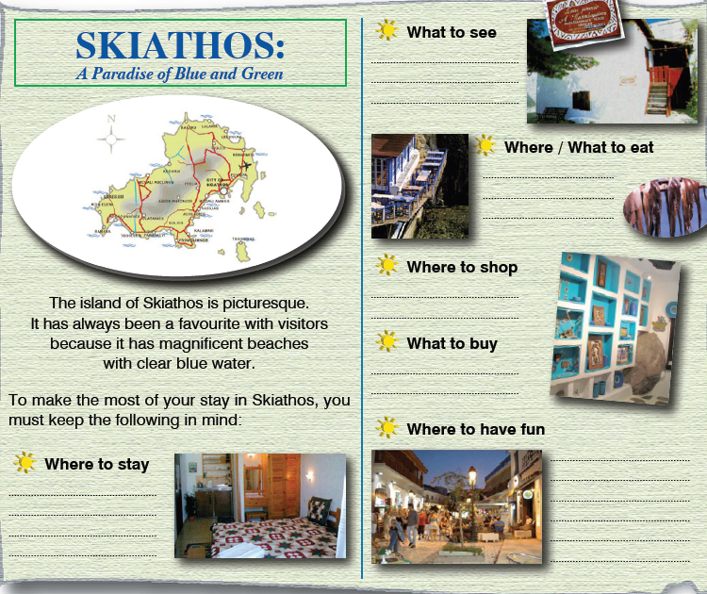
- Personal letter
Write a personal letter answering Emma’s questions about her visit to Greece. Include plans, sightseeing, shopping, weather, clothes and airport pick-up.

