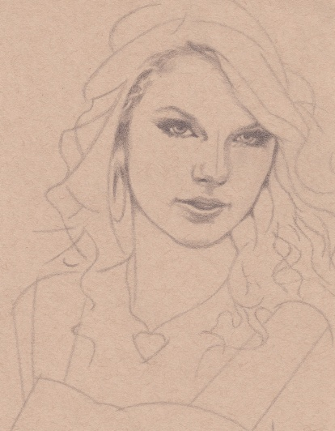
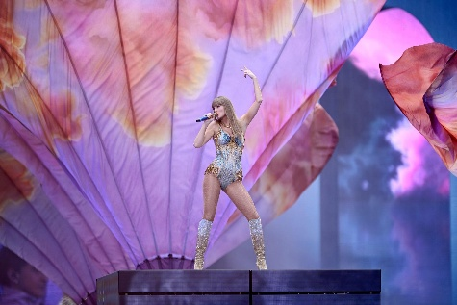
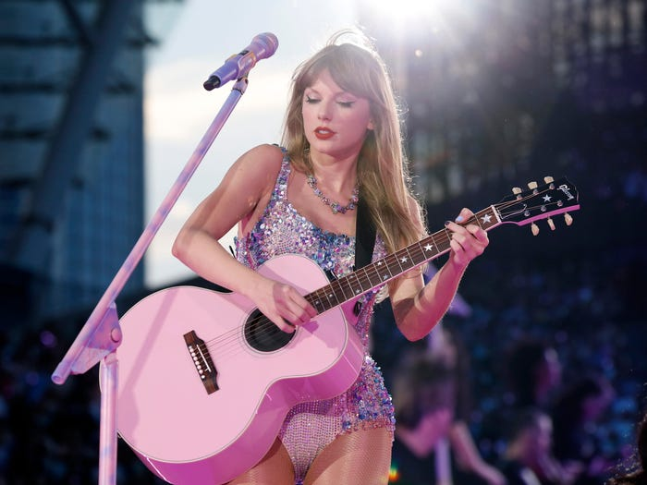
4
She is a very famous American singer. She writes her own songs.
Her music is about love, friendship, and growing up.
Many teenagers listen to her songs.
She had a very big world tour called The Eras Tour.

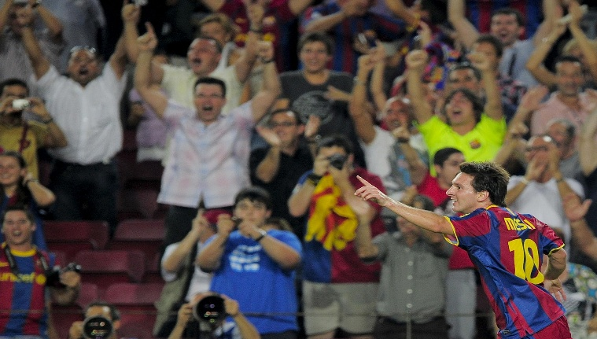
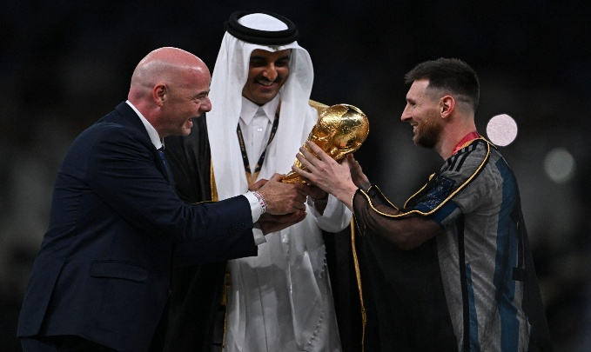

He is a famous football player from Argentina.
He won the World Cup in 2022.
Many people think he is one of the best players in the world.
He works very hard and inspires young athletes.


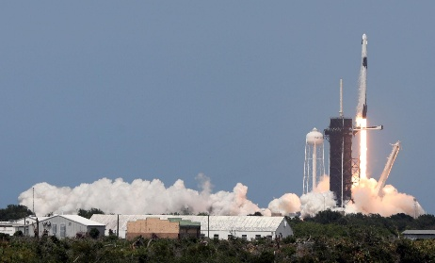
He is a businessman and inventor.
He works with electric cars and space rockets .
He wants people to travel to space in the future.
He is connected to technology and innovation.
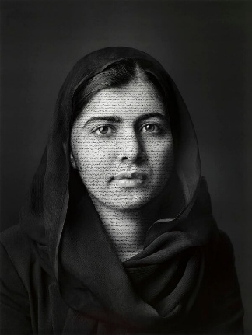
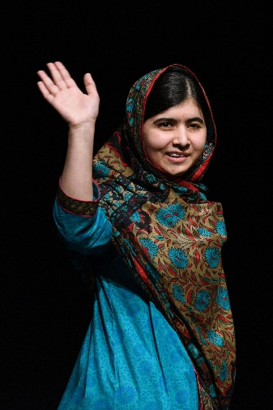
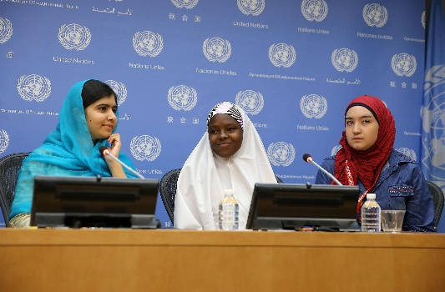

She is an activist from Pakistan.
She fights for girls’ education.
She won the Nobel Peace Prize.
She shows that young people can change the world.

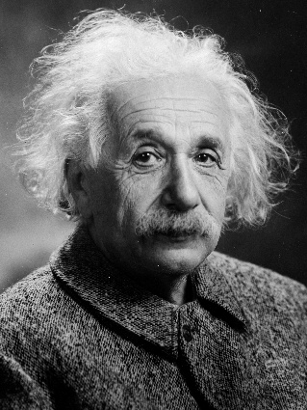
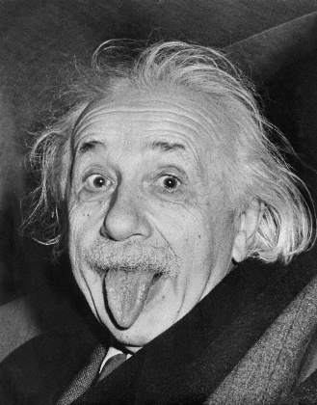
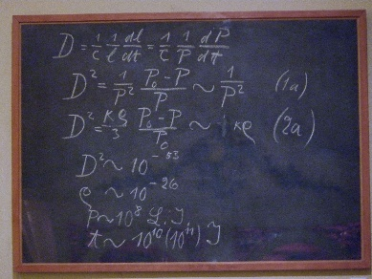

He was a scientist.
He developed the theory of relativity.
He changed modern physics.
He won the Nobel Prize.

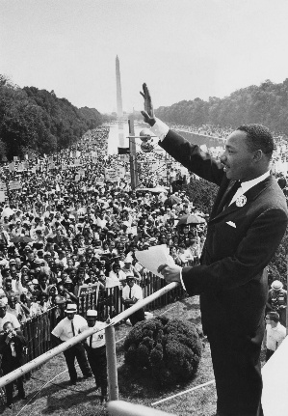
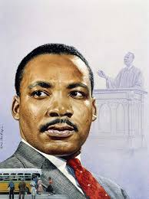
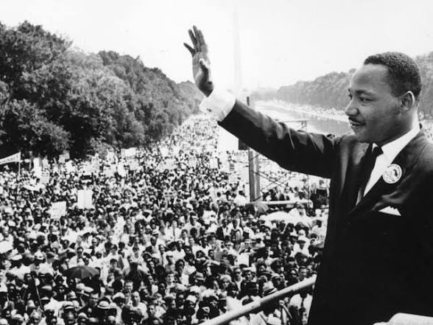

He was a leader in the USA.
He fought for equal rights for Black people.
His famous speech was “I Have a Dream.”
He wanted peace and equality.

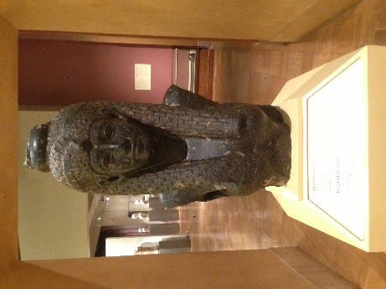
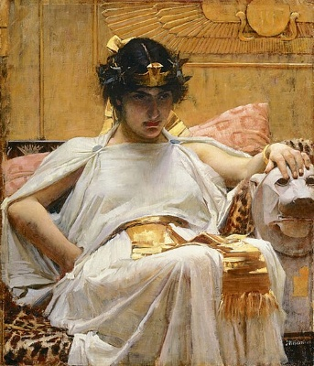
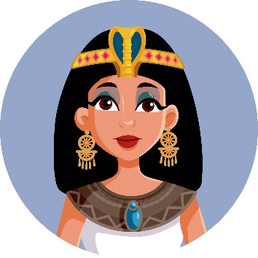

She was a queen of Egypt.
She was intelligent and powerful.
She spoke many languages.
She is one of the most famous women in history.
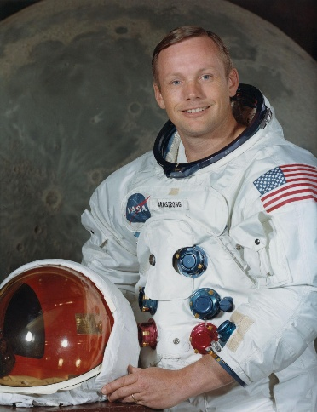
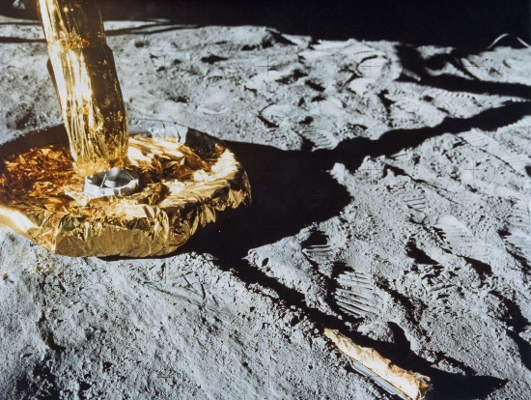
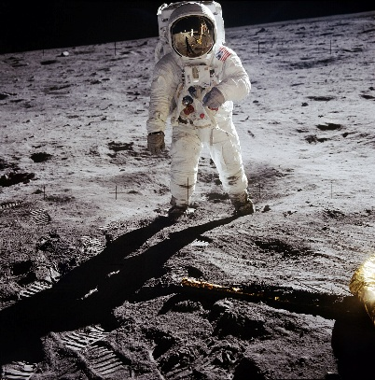

He was an astronaut.
In 1969, he became the first person to walk on the Moon.
He said, “That’s one small step for man…”
He is an important person in space history.

