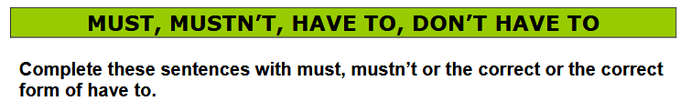

1. At our school we __________ wear a uniform.
2. You __________ cross the roads without looking. It’s dangerous.
3. You _______ turn on the central heating. It’s automatic.
4. The exams are next week. I __________ work harder.
5. You ________ forget your umbrella. It’s going to rain.
6. Students _________ listen to the teacher or they won’t understand.
7. You _____ cross the road when the red light is showing.
8. We __________ leave now or we’ll miss the plane.
9. Soldiers ____________ obey orders.
10. Sorry, I ___________ go now. I don’t want to be late.
11. Shop assistants __________ deal with the public.
12. You __________ come with us if you don’t want to.
13. I was late this morning because I _________ wait a long time for the bus.
14. In Spain, teachers __________ wear uniforms.
15. You ___________ take food in your room.
16. You __________ use the elevators in case of fire.
17. I _________ wear glasses because I can’t see very well.
18. You ___________ read this book. It’s really good.
19. You __________ go shopping today. We don’t need anything.
20. You __________ a mobile phone in class.
21. We ___________ feed the animals. It’s forbidden.
22. We _________ book the tickets before it’s too late.
23. In Spain, teachers _________ work on Saturdays.
24. In Britain you __________ drive on the left.
25. Every player in a football team __________ have a number.
26. You ___________ forget his birthday again.
27. Doctors sometimes ___________ work at the weekend.
28. Nowadays in Spain pupils ____ learn Latin at school.
29. You __________ smoke on public places.
30. My wife __________ go to work today. It’s a holiday.
31. You _________ shout. I can hear you.
32. We ___________ be quiet in the library.
33. You __________ use a computer on the plane.
34. She ___________ come to the dentist’s with me.
35. At a restaurant you _________ pay the bill but you __________ eat everything.

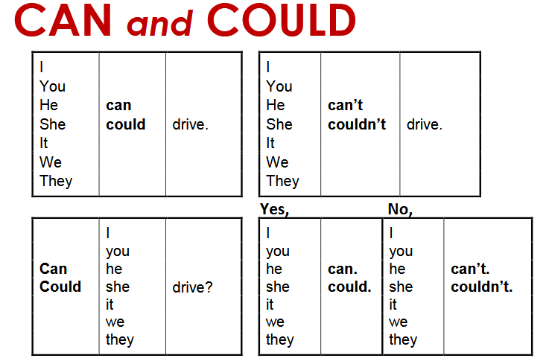

Fill in the blanks below to complete the sentences. Use the words in the above box.

1. I ___________ go to the party last nightbecause Iwassick.
2. A: ___________ Noel cook Italian food?B: Yes, he ___________.
3. My sister___________ swim last year, but now she ___________.
4. They___________go shopping yesterday because the store was closed.
5. A: ___________you read when you were four years old? B: Yes, I__________.
6. Ellie___________ride a bicycle.Sherides it to school every day.
7. I’m very tired, so I ___________ go out to the park to play.
8. A: ___________ you see the moon last night? B: No, I ___________.
9. When ___________ I talk to you about the company report?1
10. Most dinosaurs walked on land, but some ___________ flyor even swim.
11. Excuse me, I ___________ hear youright now. The music is too loud.
12. I ___________ drive a truckwhen I was only sixteen years old.
13. Douglas hit the tree because he___________stop his car.
14. How many hot dogs ___________ you eat at one time?
15. I___________ read without my reading glasses. Where are they?