**MODAL VERBS 1: MUST, MUSTN’T, DON’T HAVE TO**

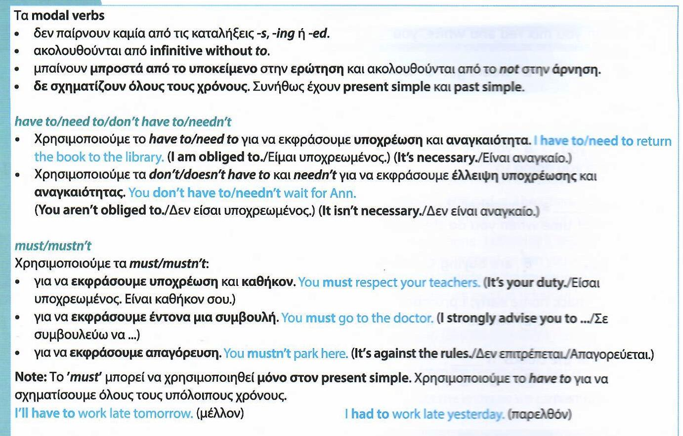

1. The Stanton Squash Club has decided that it is important for all club members to do these things:

wear sports shoes and clean clothes, have a shower, pay before you play, finish on time.

But these things are not allowed:

disturb other players, eat or drink outside the bar, take club balls home

Put **have to, don’t have to or mustn’t** in the gaps.

1. You ____________wear white clothes, but you wear sports shoes.
2. You ____________disturb other players, but you be silent.
3. You ____________finish on time, but you start on time.
4. You ____________play with club balls, but if you do, you take them home.
5. You____________ eat or drink outside the bar, but you buy your food in the bar if you don’t want to.
6. You ____________have a shower, and you wear clean clothes.
7. Put the words in the box in the gaps. Don’t add any other words.

Does she, have to, has, she has, must, mustn’t, have, does she

**Mark**: We ___________________to get up early tomorrow.

**Bob**: Why?

**Mark**: Have you forgotten? Angela ___________________ (1) to move to a new flat tomorrow, and I promised we would help her.

**Bob**: ___________________ (2) have to move out by a particular time?

**Mark**: No, there’s no rush. She doesn’t ___________________ (3)leave her old flat before the afternoon, but there are lots of things that ___________________ (4)to pack, so we___________________ (5)get there fairly early.

**Bob**: Why ___________________ (6) have to move, by the way?

**Mark**: She said that I ___________________ (7) tell you because she wants to tell you herself, when she sees you tomorrow.