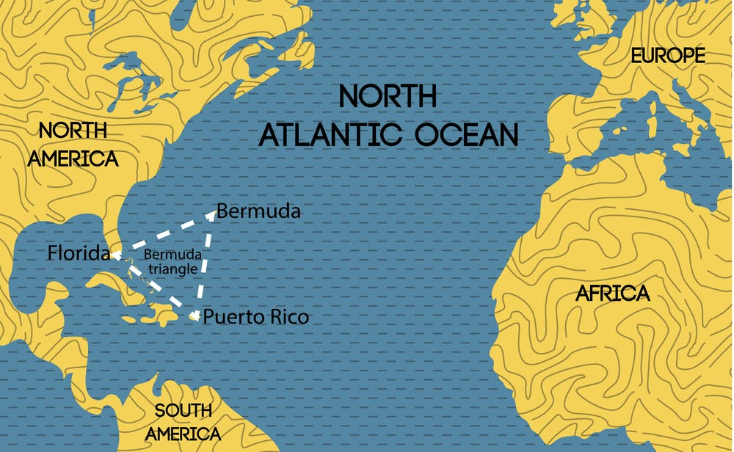   
  
For decades, the Atlantic Ocean’s fabled Bermuda Triangle has captured the human imagination with unexplained disappearances of ships, planes, and people.

Some speculate that unknown and mysterious forces account for the unexplained disappearances, such as extraterrestrials capturing humans for study; the influence of the lost continent of Atlantis; vortices that suck objects into other dimensions; and other whimsical ideas.  Some explanations are more grounded in science, if not in evidence.  These include oceanic flatulence (methane gas erupting from ocean sediments) and disruptions in geomagnetic lines of flux.

**Fabled= παραμυθένια** extraterrestrials= εξωγήινους vortices= δίνες  
   
whimsical= φαντασιόπληκτος flux= ροή

**Bermuda Triangle**, section of the North Atlantic Ocean off North America in which more than 50 ships and 20 airplanes are said to have mysteriously disappeared. The area, whose boundaries are not universally agreed upon, has a vaguely triangular shape marked by the Atlantic coast of the Florida panhandle (in the United States), Bermuda, and the Greater Antilles.

vaguely 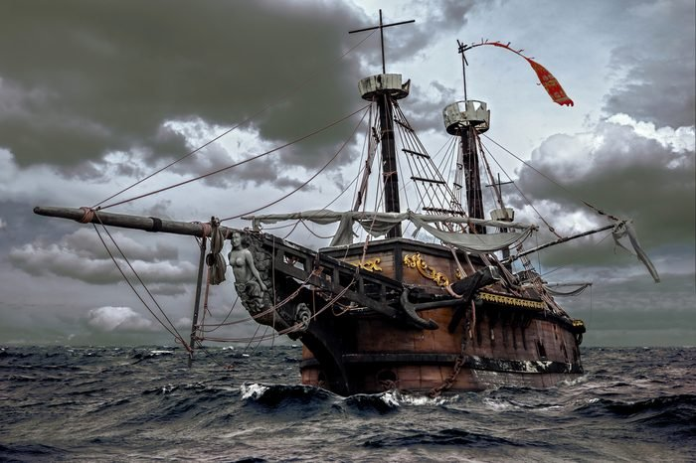= αόριστα

**Ghost Ships**  
  
A **ghost ship**, also known as a **phantom ship**, is a vessel with no living crew aboard; it may be a fictional ghostly vessel, such as the *Flying Dutchman*, or a physical derelict found adrift with its crew missing or dead, like the *Mary Celeste*. The term is sometimes used for ships that have been decommissioned but not yet scrapped, as well as drifting boats that have been found after breaking loose of their ropes and becoming carried away by the wind or the waves.

Term= όρος

**History**

It's a mystery that has endured for 76 years in a fabled area that many sailors and aviators have long said contains supernatural forces we don't understand.

On Dec. 5, 1945, 14 airmen flying five World War II torpedo bombers called Avengers took off from Naval Air Station Fort Lauderdale on a routine training mission over the Bermuda Triangle and were never seen again. The U.S. Navy even sent a Martin Mariner search plane out at the time to find the missing aircraft, and that plane and its crew of 13 also disappeared..

## Aviators= αεροπόρους torpedo=τορπίλη Who First Discovered The Triangle? If the Bermuda Triangle really has been sucking up ships for centuries, it may have been known to local sailors for a much longer time than this, but **the accepted discoverer of the Bermuda Triangle is none other than Christopher Columbus!**

The famous explorer described strange occurrences on his voyage in 1492, including mysterious compass readings and floating lights, like candles that moved up and down. Several crew members saw the lights, and so Columbus recorded the phenomenon in his journal. And so, the legend of the Triangle was born… even though the ship definitely made it through the area intact.

## Who First Named It The Bermuda Triangle?

  
Although Christopher Columbus may have been the first to report strange occurrences in this area, he wasn’t aware that this was anything more than one mysterious light on a voyage - so who was it who recognized that this area seemed to have a high proportion of such incidences, and give it a name?

That would be George Sand, who wrote about the disappearances in the area for Fate magazine in the early 1950s. Later, in the ‘60s, Vincent Gaddis gave it a slightly more out-there name of ‘The Deadly Bermuda Triangle’, and it has also been called the ‘The Devil’s Triangle’.

Occurrences=περιστατικά

## How Many Total Disappearances Have There Been?

The total number of disappearances in this area isn’t entirely clear, for several reasons. For one thing, no one knows how many ships or planes may have gone down without being recorded, or before the Bermuda Triangle became a phenomenon. In addition, because the boundaries of the Triangle are constantly shifting depending on who is talking about it, the number of incidents in it also changes.

However, **estimates put the number of disappearances in the area at around seventy five planes and one hundreds of ships** that have gone down here - with a possible total of over a thousand disappearances.  
  
**Where Do The Wrecked Ships Go?**

One of the biggest mysteries of the Triangle isn’t just that so many craft go missing here, but that the wrecks are never found. However, there are a few theories about why it’s so hard to find the wreckage of lost ships and planes - and not all of them rely on aliens and portals.

One theory is the that Gulf Stream is whisking away the remains of the ships, so that they cannot be found where they sink. Another is that the area is riddled with Blue Holes - deep underwater caves and cavities that create whirlpools to suck the debris away, never to be seen again.

## Whisking= χτυπάω ελφρά What Was The Most Recent Disappearance?

Of course, because people are still traveling through the Triangle on a regular basis, people are still going missing… and that includes a recent lost plane, which went down in 2017.

In May of last year, a small twin-engine plane went missing on a flight from Puerto Rico to Florida, carrying a US family who had spent Mother’s Day away. The plane went off radar in clear weather, about half an hour before it was due to land, and a debris field was later discovered.

It’s still not clear what, exactly, happened to the family - but those who believe in the Bermuda Triangle are sure to have their own theories.  
  
debris=συντρίμμια   
  
**Have Any Ships Reappeared?**

The wrecks of several craft have eventually been found - although often these are far from where they would be expected. However, there have also been several incidents of ghost ships in the Bermuda Triangle - cases where missing craft have reappeared, intact, but missing all the people who were originally on board.

One of the most famous ghost ships that has reappeared in the Bermuda Triangle is the Marie Celeste, which is possibly the most famous ghost ship of all time - but it’s not the only one. The cargo ship Carroll A Deering is another ghost ship of the triangle, and the Ellen Austin reported meeting another ghost ship in 1881.

## Could It Be Connected To Atlantis?

Another famous legend of the ocean is the lost city of Atlantis, said to be an advanced civilization that mysteriously sank long ago - and some believe that this may have happened in the Bermuda Triangle.

According to this theory, the Atlantean crystal technology is what is affecting the navigational equipment of craft in this area, causing ships and planes to go down. This theory has also been bolstered by underwater findings like those of Miklos - like the Bimini Road (rock formations off the island of Bimini), or the underwater ‘city’ discovered in 2001.  
  
bolstered=ενισχυμένος **Videos:**<https://www.youtube.com/watch?v=tVoQ8pGWqR8>

<https://www.youtube.com/watch?v=hKAaWJWP4HQ>

**Sources:**

* [**https://www.google.com/search?q=bermuda+triangle&sxsrf=APq-WBuwv9qePxPVzytzgxBDJROSg25BFQ:1646053004645&source=lnms&tbm=isch&sa=X&ved=2ahUKEwiOzv2kuaL2AhV6R_EDHVDMBDAQ_AUoAnoECAEQBA&biw=1680&bih=907&dpr=1#imgrc=eKeQFK2xX3sbeM**](https://www.google.com/search?q=bermuda+triangle&sxsrf=APq-WBuwv9qePxPVzytzgxBDJROSg25BFQ:1646053004645&source=lnms&tbm=isch&sa=X&ved=2ahUKEwiOzv2kuaL2AhV6R_EDHVDMBDAQ_AUoAnoECAEQBA&biw=1680&bih=907&dpr=1#imgrc=eKeQFK2xX3sbeM)
* [**https://www.worldbook.com/what-happens-in-the-bermuda-triangle.aspx**](https://www.worldbook.com/what-happens-in-the-bermuda-triangle.aspx)
* [**https://www.youtube.com/watch?v=hKAaWJWP4HQ**](https://www.youtube.com/watch?v=hKAaWJWP4HQ)
* <https://www.youtube.com/watch?v=tVoQ8pGWqR8>

**Q&A**

**Where is the Bermuda Triangle?**

Atlantic OceanPacific Ocean

Arctic OceanIndian Ocean

**What are ghost ships?**

1. Ships with ghosts
2. Ships that disappeared in the Bermuda Triangle
3. Old ships
4. Haunted ships

**George Boukouvalas**