**1. Löse das Rätsel!**

|  |  |  |  |  |  |  |  |  |
| --- | --- | --- | --- | --- | --- | --- | --- | --- |
|  |  |  |  |  | 1 F |  |  |  |
|  |  |  |  |  | Ü |  |  |  |
|  |  | 2 Z | E | H | N |  |  |  |
|  |  | W |  |  | F |  |  |  |
|  |  | E |  | 3 D |  |  |  |  |
|  | 4 V | I | E | R |  |  |  |  |
|  |  |  |  | E |  |  |  |  |
|  |  |  | 5 S | I | E | B | E | N |
|  |  |  | E |  |  |  |  |  |
|  |  | 6 A | C | H | T |  |  |  |
| 7 N |  |  | H |  |  |  |  |  |
| 8 E | I | N | S |  |  |  |  |  |
| U |  |  |  |  |  |  |  |  |
| N |  |  |  |  |  |  |  |  |

**Waagerecht**: 2. **10** 4. **4** 5. **7** 6. **8** 8. **1** **Senkrecht**: 1. **5** 2. **2** 3. **3** 5. 6 7. **9**

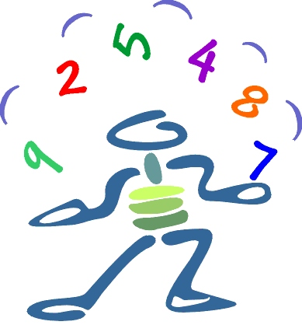

Bildquelle: www.bg-kremszeile.ac.at/.../mathematik.jpg

**1. Löse das Rätsel! Lösung**

|  |  |  |  |  |  |  |  |  |
| --- | --- | --- | --- | --- | --- | --- | --- | --- |
|  |  |  |  |  | 1 F |  |  |  |
|  |  |  |  |  | Ü |  |  |  |
|  |  | 2 Z | E | H | N |  |  |  |
|  |  | W |  |  | F |  |  |  |
|  |  | E |  | 3 D |  |  |  |  |
|  | 4 V | I | E | R |  |  |  |  |
|  |  |  |  | E |  |  |  |  |
|  |  |  | 5 S | I | E | B | E | N |
|  |  |  | E |  |  |  |  |  |
|  |  | 6 A | C | H | T |  |  |  |
| 7 N |  |  | H |  |  |  |  |  |
| 8 E | I | N | S |  |  |  |  |  |
| U |  |  |  |  |  |  |  |  |
| N |  |  |  |  |  |  |  |  |

**Waagerecht**: 2. ZEHN 4. VIER 5. SIEBEN 6. ACHT 8. EINS

**Senkrecht**: 1. FÜNF 2. ZWEI 3. DREI 5. SECHS 7. NEUN