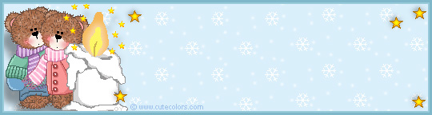

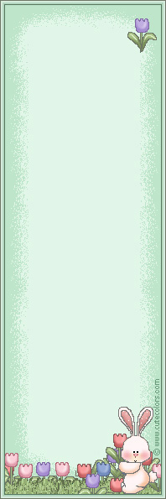  Add -s to make the plural  form.  1. snake - ___________________  2. pencil - ___________________  3. chair - ____________________  4. bag - _____________________  5. house - ___________________  6. spoon - __________________  7. plate - ___________________  8. tiger - ____________________  9. paper - ___________________  10. marker - _________________  11. pear - ___________________  12. ant - ____________________ | Add – es to the nouns that  ends with s, ss, x, ch, sh, o  to make the plural form.  1. glass - ___________________  2. dress - ___________________  3. box - ____________________  4. bench - __________________  5. toothbrush - _______________  6. tomato - __________________  7. church - __________________  8. fox - _____________________  9. dish - ____________________  10. bush - ___________________  11. princess - ________________ | For the noun that ends with  –y, change –y to -i then  add –es (ies)  1. baby - ____________________  2. country - __________________  3. bunny - ___________________  4. city - _____________________  5. candy - ___________________  6. berry - ___________________  7. cherry - __________________  8. nanny - ___________________  9. lady - ____________________  10. factory - _________________  11. pony - __________________  12. guppy - _________________ | For the noun that ends with  - f or -fe, change –f or –fe  to –v then add -es. (-ves).  1. life - ______________________  2. leaf - ______________________  3. loaf - ______________________  4. wife - ______________________  5. knife - _____________________  6. calf - ______________________  7. half - ______________________  8. elf - _______________________

Αντιστοιχίστε τον ενικό με τον πληθυντικό.  1. man ___ teeth  2. woman ___ mice  3. tooth ___ firemen  4. child ___ geese  5. mouse ___ women  6. foot ___ men  7. fireman ___ children  8. policewoman ___ policewomen  9. goose ___ feet | Aλλάξτε τις υπογραμμισμένες λέξεις στον πλυηθυντικό.  1. My friend is wearing blue shirt.  _______________________________________________________________________  2. The man is carrying a heavy box.  _______________________________________________________________________  3. Rachel loves to eat candy and chocolate.  _______________________________________________________________________  4. The student has a book.  _______________________________________________________________________  5. The cow and its calf are in the barn.  _______________________________________________________________________  6. The child cannot lift the cupboard.  _______________________________________________________________________  7. The man who is playing soccer is my uncle.  _______________________________________________________________________

