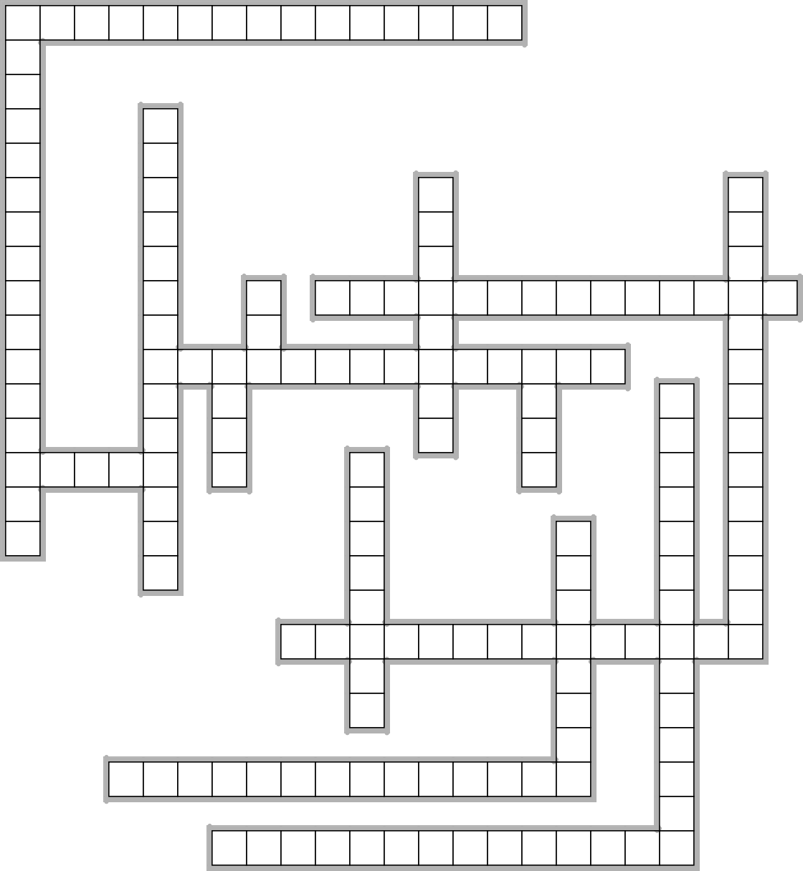
ZAHLEN 0 - 100
1

2
3
4

5
6
7
8
9

10

11
12

13

14

15
16

EclipseCrossword.com

Waagerecht →
1. 72 + 4 = 76
6. 8 X11 = 88
7. 100 - 5 = 95
11. 2 X 6 = 12
14. 4 X 11 = 44
15. 8 X 8 = 64
16. 2 X 11 = 22

Senkrecht ↑
1. 70 - 3 = 67
2. 50 + 8 = 58
3. 9 + 9 = 18

4. 60 - 7 = 53
5. 33 : 3 = 11
8. 20 - 20 = 0
9. 15 - 5 = 10
10. 21 + 2 = 23
12. 14 + 3 = 17
13. 3 X 10 = 30

© Kassiani Zavara

