The Passive Voice

Tense | Active | Passive
present simple | I make a cake. | A cake is made (by me).
present continuous | I am making a cake. | A cake is being made (by me).
past simple | I made a cake. | A cake was made (by me).
past continuous | I was making a cake. | A cake was being made (by me).
present perfect | I have made a cake. | A cake has been made (by me).
past perfect | I had made a cake. | A cake had been made(by me).
future simple | I will make a cake. | A cake will be made (by me).
future perfect | I will have made a cake. | A cake will have been made (by me).

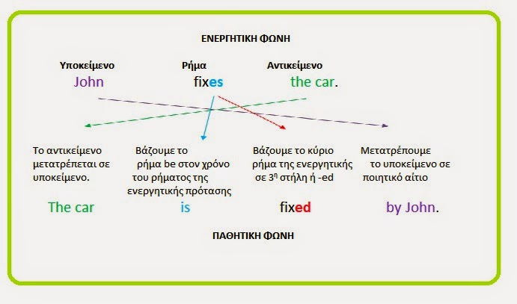

Exercise A: Fill in the blanks with the verb in brackets in the Present Passive or Past Passive
- Children under 12 ……………………………(not / allow) without an adult.
- The Mona Lisa …………………………..(paint) by Leonardo Da Vinci.
- Volkswagen cars……………………………….(produce) in Germany.
- America ………………………………(discover) by Christopher Columbus.
- Taking photos inside the museum…………………………….(not / permit).
- The Louvre ……………………….(clean) and …………………………..(lock) every evening.
- The Buckingham Palace…………………………………..(guard) by the Beefeaters.
- A great artist ……………………………(admire) for his talent.
- Bright colours ……………………………..(use) to express happiness.
- The Eiffel Tower ………………………….(design) and ……………………….(build) by Gustav Eiffel.
Exercise B: Change from Active to Passive Voice.
- People use this road very often.
…………………………………………………………………………..
- Somebody accused Jason of stealing money.
…………………………………………………………………………..
- Dangerous driving causes many accidents every year.
…………………………………………………………………………..
- Someone is using the computer at the moment!
……………………………………………………………………………
- Mary took my coat by mistake, but she returned it immediately.
……………………………………………………………………………
- Meteorologists have sent up weather balloons to take readings.
……………………………………………………………………………
- They are moving people from the coastal areas because of the hurricane.
…………………………………………………………………………………….
- They are going to water the plants in the afternoon.
…………………………………………………………………………………….
- The government will increase taxes this year.
……………………………………………………………………………………...
- When I got home, they were repairing the roof.
……………………………………………………………………………………….
Active or Passive?
- We didn’t play football yesterday. The match ________________(cancel)
- My grandfather was a builder. He _____________(build) this house years ago.
- Is the house still on sale? No, it ___________________(already/sell).
- After he __________________(arrest), he was taken to the police station.
- The castle ________________(damage) in a fire last night and the Fire Brigade _____________(announce) that many priceless paintings _______________(destroy).
- The letter _____________(post) a week ago but it _________________(arrive) yet.
- New buses _____________________(buy) by the mayor in the next few months. The buses ______________(help) people travel around the city more comfortably.
- I _____________(do) very well in my interview yesterday. I think I ___________________ (offer) a job by the end of the month!
- They _______________(call) the police to tell them that five paintings __________________ (steal) from the museum.

