**Thermopile**

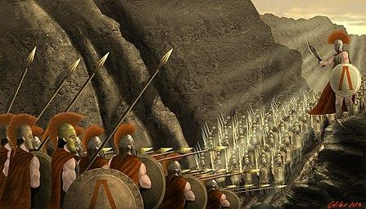

**Task 1**

Click on the following link to hear the way *Thermopile* is pronounced

[https://www.youtube.com/watch?v=GqGwbGeBA8U feature=emb_logo](https://www.youtube.com/watch?v=GqGwbGeBA8U&feature=emb_logo)

and the following link to hear how *Thermopylae* is pronounced

<https://www.youtube.com/watch?v=l2cPe64BbAY>

Then watch a short description of the history of the place by clicking on the following link

<https://www.youtube.com/watch?v=N5r9jrK0R2A>

**Task 2**

Click on the following link to read the poem *Thermopyile* by Kavafis.

<https://www.onassis.org/el/initiatives/cavafy-archive/the-canon/thermopylae>

Read an analysis of the poem

**Thermopylae**

Honor to those who in the life they lead

define and guard a Thermopylae.

Never betraying what is right,

consistent and just in all they do

but showing pity also, and compassion;

generous when they’re rich, and when they’re poor,

still generous in small ways,

still helping as much as they can;

always speaking the truth,

yet without hating those who lie.

And even more honor is due to them

when they foresee (as many do foresee)

that Ephialtis will turn up in the end,

that the Medes will break through after all.

*Constantine P. Cavafy*

The poem commemorates the famous battle of Thermopylae where the 300 Spartans and their allies stood their ground against the overwhelming numbers of Persians and through that, bought enough time for Sparta and the rest of the Greek states to muster a proper defence. The battle of Thermopylae reminds us of honour, loyalty and all the good things that a soldier should be.

The poem beautifully takes us away from the battleground and shows us a bunch of ideas that we should live by – being constant to the principle of rightness, being compassionate and generous no matter our circumstance and being truthful in all that we do. It even brings in some nice ideas of not hating those who do not live by the same principles or who wrong us

The final four lines are telling us that for all that we do, there will be setbacks and the potential for failure. Ephialtes was the goatherd who betrayed the Spartans by leading the Persians through an old trail which allowed the latter to encircle and outflank the defenders, leading to their ultimate defeat at the hands of the Persians and their allies the Medes. What he says is that while we do realise that we will encounter setbacks and defeats, we fight on anyway and prepare for them because it is part of our duty to do so.

We all have our Thermopyles but we all will resist and soldier on as the Spartans do. Why? Because we can and we choose to.

The above is taken from <https://brushheadmusings.wordpress.com/2008/06/30/thermopylae-a-poem-on-the-good-kind-of-life/>

**Task 3**

You have a foreign friend and you want to write to him/her about the tragic incident in France. You want to tell him/her about the way Kavafis treats the issue of duty in his famous poem Thermopile. Provide your foreign friend with the gist of what the great Greek poet says. Upload your piece of writing on the class padlet on the following link.

<https://padlet.com/eirigiannitsi/ilch6xgxdr8w>