**In the line of duty. An essay.**

Have you ever heard or read stories about people who died in the line of duty? You can search for such stories by clicking on the following link.

[**https://www.policememorial.org.uk/**](https://www.policememorial.org.uk/)



Have you ever heard or read stories about ordinary people who sacrificed their lives to save others? You can read such stories on the following sites.

[**https://www.foxnews.com/us/officers-killed-line-of-duty-2020**](https://www.foxnews.com/us/officers-killed-line-of-duty-2020)

[**https://www.foxnews.com/us/officers-killed-line-of-duty-2019**](https://www.foxnews.com/us/officers-killed-line-of-duty-2019)

[**https://www.foxnews.com/us/officers-killed-line-of-duty-2018**](https://www.foxnews.com/us/officers-killed-line-of-duty-2018)

**Task 1**

**Choose to write about any of the stories you have read and share your thoughts with the rest of your class. You may write any of the following:**

* **an essay narrating one of the stories**
* **a police report for one of them**
* **a script for a film scene on the incident.**

**You may include pictures to illustrate your piece of writing.**

**NOTE:**

Here are some useful ideas in terms of narrative endings to make your writing more interesting.

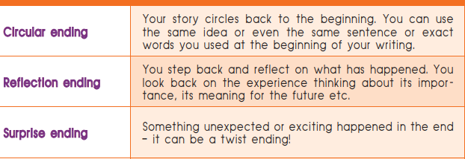

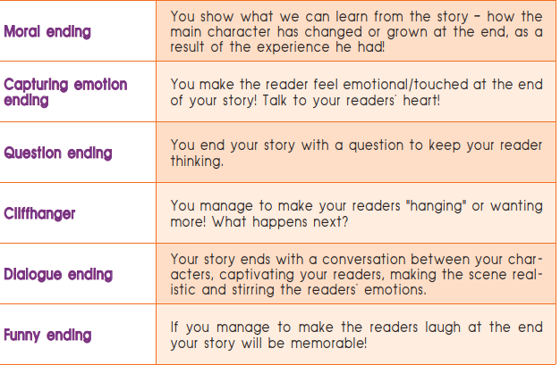

Here are some useful tips on how to develop

* **a narration of a story**

The small passenger boat was sailing down Abonnema-Bakana waterways in Rivers State, Nigeria when it suddenly crashed into an object and capsized. The 24 people on board started shouting for help as they were trying to remain on the surface of the water.

Joseph Blankson, one of the passengers, was a very good swimmer and, like most people on earth, he would have struggled to save but himself, but that’s not what he did. Instead, he went on a rescue mission and, single handedly, saved 13 souls from the sinking boat. While trying to save the 14th person, 36-year-old Blankson tragically drowned, most probably of exhaustion.

His wife and mother of two children, Mercy, described him as a selfless and loving man who will be remembered as a real-life superhero. His legacy of selflessness will continue to inspire Nigerian people.

* **a police report of an incident**

At about 01.10 hours on the 5th of October 2015, a burglary occurred in Birkenhead. During the course of that burglary, a red Mitsubishi pick-up car was stolen from the scene. The vehicle was later sighted heading towards Wallasey and Police constable David Phillips and a younger colleague engaged in pursuit of that vehicle. During the pursuit the vehicle struck PC Phillips on Wallasey Dock North Road, at about 2.08 am. Constable Phillps was rushed to Wirrals’ Arrowe Park Hospital, but passed away shortly after arrival.

* **a script for a film scene**

It is a bright, sunny day at around noon. People are walking along Westminster Bridge. Some are walking hurriedly; others are strolling along, taking photos and looking over the River Thames. Three police officers are on patrol on the bridge. Suddenly, a car appears out of nowhere and strikes into the crowd. We can hear screams, see injured people trying to run in all directions. A man comes out of the car. The camera zooms in on a sharp object he’s holding in his right hand. The man runs into the grounds of Parliament. Constable Palmer confronts him and the two men start fighting. The man hurts Constable Palmer to death and he collapses.