**Past Tenses… on duty**

**Task 1**

Study the following table.

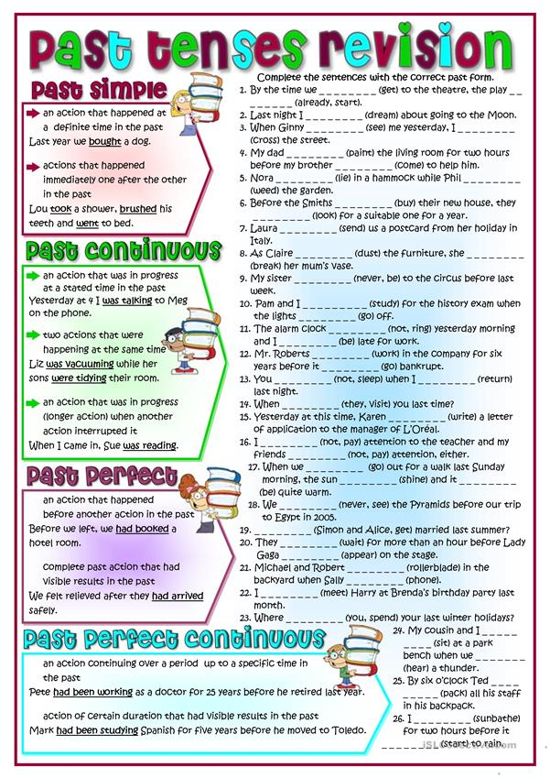

**Task 2**

Click on the following link and focus your attention on the use of past tenses in the following sentences.

<http://www.iep.edu.gr/images/IEP/EPISTIMONIKI_YPIRESIA/Epist_Monades/B_Kyklos/Humanities/2018/2018-10-12_A3_On_duty.pdf>

**Task 3**

Click on the following link for further practice.

<https://forms.gle/8yskGGU9gqTFr8Yo8>

**Task 4**

Click on the following link to read the rest of the story and do some further practice.

<https://forms.gle/a3S2dd42Gr29NWcdA>

**Task 5**

Choose any five words from the news report, look them on any of the online defined and fill in the following table.

|  |  |  |
| --- | --- | --- |
| words | definitions | synonyms |
|  |  |  |
|  |  |  |
|  |  |  |
|  |  |  |
|  |  |  |

NOTE: Here are the links to the online dictionaries.

<https://www.wordreference.com/engr/>

<https://dictionary.cambridge.org/>

<https://www.macmillandictionary.com/open-dictionary/latestEntries.html>

You can find synonyms of the words on the following link of a thesaurus.

<https://www.collinsdictionary.com/dictionary/english-thesaurus>