**Starry starry night**

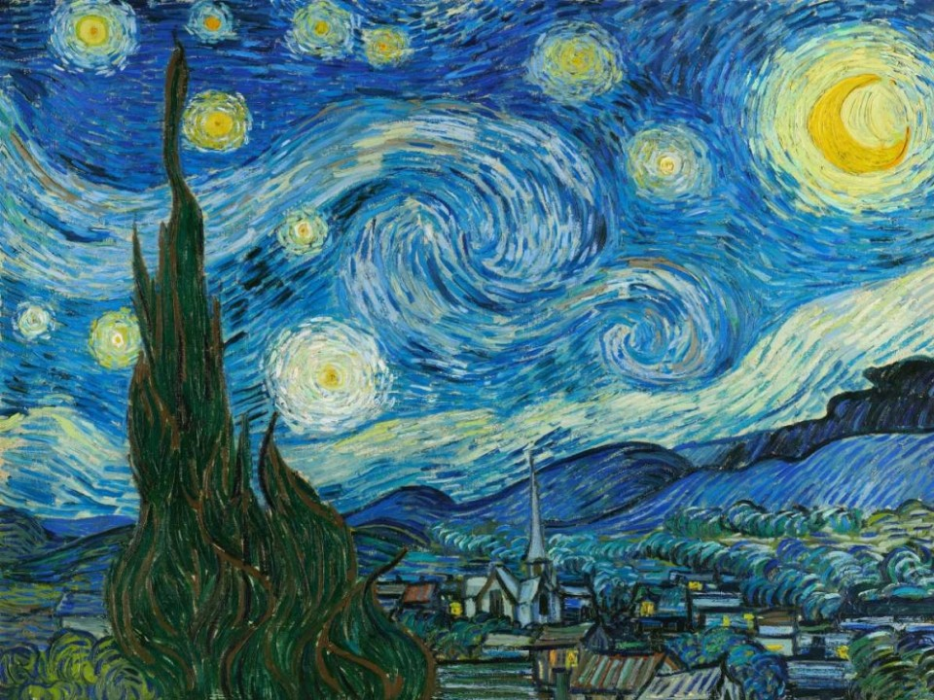

**Task 1.**

Read the lyrics, fill in the blanks, correct the wrong words or strike out the extra words.

Starry starry night

……………………………… your palette blue and grey

look out on a summer’s day

With eyes that know the darkness in my *bowl*

Shadows on the hills and cliffs

……………….the trees and the daffodils

Catch the breeze and the winter *drills*

in colours on the …………………...lined land.

Now I understand

what you tried to say to me yesterday

and how you suffered for your *vanity*

and how you tried to ………………………… them free

they would not listen they did not know how

perhaps they’ll *fasten* now.

Starry starry night sky

Flaming flowers that brightly ………………………….

swirling clouds in violet *days*

reflect in Vincent’s eyes of china blue

colours ………………………… hue

morning fields of amber grain

weathered faces lined in *rain*

are soothed beneath the artist’s loving *band*.

Now I understand well

what you tried to say to me

and how you suffered for your sanity

and how you tried to set them free

they would not listen

they did not know how to listen

perhaps they’ll listen now and forever.

For they ……………. not love you

but still your love was true

and when no hope was left beside

on that starry starry night

You took your life as lovers often do

But I …………………….have told you, Vincent,

this world was never meant for one

as *dutiful* as you are.

Starry starry night

……………………………...hung in empty halls

frameless heads on nameless *dolls*

with eyes that watch the world and can

forget them

like the strangers that you’ve met

The ragged men in ragged clothes

a silver thorn a …………………………..rose

lie crushed and broken on the virgin snow.

Now i think I know very well

what you tired to say to me

and how you suffered for your sanity

and how you tried to set them *tree*

they would not listen

they’re not listening still

………………………...they never will.

Task 2

Answer the following questions.

1. Do you think that the song reflects Van Gogh’s attitude and feelings? If so, mention specific verses.
2. How does this song make you feel?
3. Write up to 5 sentences giving facts about Van Gogh’s life, based on the song.

Make a post on the padlet with your answers. Click on the following link to get to the padlet.

<https://padlet.com/eirigiannitsi/ilch6xgxdr8w>

Task 3

Find ten (10) words in the song, whose meaning you would like to learn or go deep in and look them up in an online dictionary from the ones below. Then complete the following table and submit your assignment on the assignments’ section.

<https://www.wordreference.com/engr/>

<https://dictionary.cambridge.org/>

<https://www.macmillandictionary.com/open-dictionary/latestEntries.html>

You can find synonyms of the words on the following link of a thesaurus.

<https://www.collinsdictionary.com/dictionary/english-thesaurus>

| words | definitions | synonyms |
| --- | --- | --- |
|  |  |  |
|  |  |  |
|  |  |  |
|  |  |  |
|  |  |  |
|  |  |  |
|  |  |  |
|  |  |  |
|  |  |  |
|  |  |  |