**Michelangelo’s life in words!**

Choose any ten words which you do not know and you would like to learn from the text about Michelangelo and complete the table with definitions, synonyms and a sentence where the word is used. You can use the following links to search for the definitions and/or synonyms of the words. Make sure you include the translation, so that you ensure you know the meaning of the words.

<https://www.wordreference.com/engr/>

<https://dictionary.cambridge.org/>

<https://www.macmillandictionary.com/open-dictionary/latestEntries.html>

<https://www.oxfordlearnersdictionaries.com/definition/english/>

You can find synonyms of the words on the following link of a thesaurus.

<https://www.collinsdictionary.com/dictionary/english-thesaurus>

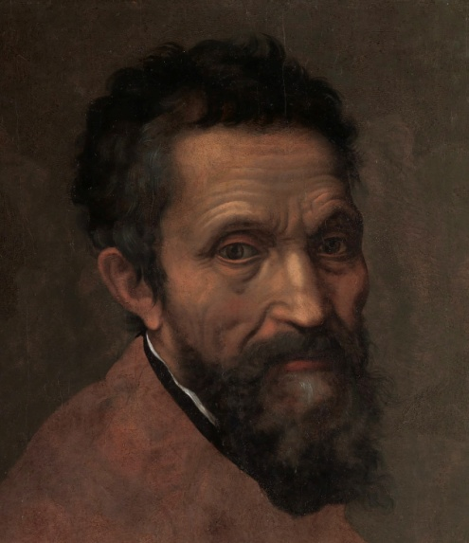

Write the words, their definitions, synonyms and a sentence in the space provided.

|  |  |  |  |
| --- | --- | --- | --- |
| words | definitions | synonyms | Sentence (the word in context) |
|  |  |  |  |
|  |  |  |  |
|  |  |  |  |
|  |  |  |  |
|  |  |  |  |
|  |  |  |  |
|  |  |  |  |
|  |  |  |  |
|  |  |  |  |
|  |  |  |  |