A Renaissance Artist and Art.

Your school is running a competition about the best article regarding a Renaissance artist and the description of a work of art he has created. You decide to take part. Write an article about any one of the Renaissance artists below and choose a work of art he has created to describe it. Your article should be about 120-150 words). The following facts may help you.

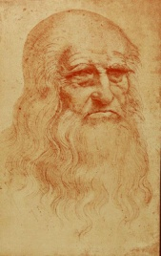 | 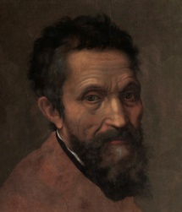 | 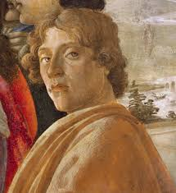 | 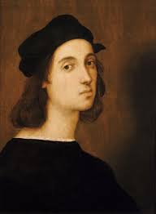 | 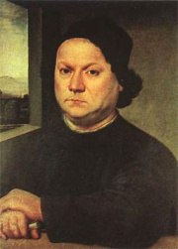
Leonardo Da Vinci (Vinci 1452 –France 1519) | Michelangelo  (Florence 1475-Rome 1564) | Sandro Botticelli  (Florence 1445-1510) | Raphael  (1483-Rome, 1520) | Andrea del Verrocchio (Florence 1435- Venice 1488)
Mona Lisa (1503-1506),  Madonna on the Rocks,  The Last Supper. | Pieta, David, The Last Judgment,  the ceiling of the Sistine Chapel in the Vatican. | The Primavera, Pallas and the Centaur,  Venus and Mars,  The Birth of Venus,  The Nativity. | The School of Athens,  Parnassus, The Disputation of the Sacrament,  Saint Catherine. | The statue of Bartolomeo Colleoni,  Tobias (statue),  The Baptism of Christ (painting).

