WRITING TASK

Young Planet, an international youth magazine, runs a regular feature on topical issues. This month the magazine has asked readers to send in essays on the following topic:

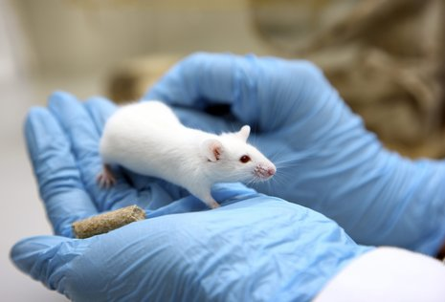
There is nothing basically wrong with
using animals for human purposes,
such as food, clothing, entertainment,
and research.

You have decided to send in an essay arguing for or against this topic. You should:

- outline the value of animals for people’s lives
- discuss the necessity of animal use by mentioning specific examples, the terms/conditions under which animals should be used to the benefit of human beings, in which cases their use is justified and in which cases their treatment becomes unethical
- suggest how the issue of animal use should be treated in the future both by researchers and civilians

Give your essay a title. Write around 200-250 words.

