***Unit 5 Animal rights***

***Scientists told to stop wasting animal lives***

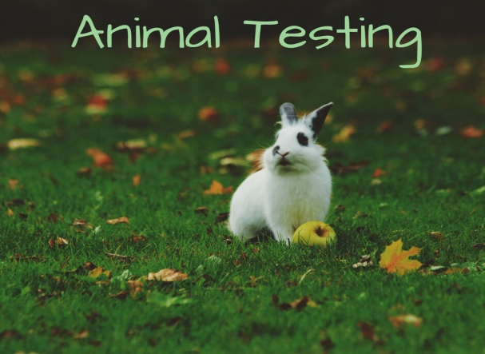

*Read the text on p. 51 of your textbook or at the following link* <http://www.iep.edu.gr/images/IEP/EPISTIMONIKI_YPIRESIA/Epist_Monades/B_Kyklos/Humanities/2018/2018-10-12_A5_Animal_Rights.pdf> *and answer the following questions.*

*Comprehension Questions*

1. This text addresses
2. the general public b. scientists c. research agencies
3. The main purpose of the text is to
4. present a problem b. argue in favour of or against the issue

c. to suggest solutions

1. Certain projects designed to test new medicines have produced insignificant results leading to a complete waste of animals’ lives.

TRUE FALSE

1. According to the text, poorly designed studies
2. have led to the complete cease of funding by the UK Research Councils
3. have forced scientists to guarantee in advance the success of their research in order to get their funding
4. have made the Research Councils to completely stop research using animals
5. The neuroscientist claims that animal experiments should be more robust, that is:
6. reliable b. cruel c. better designed
7. Drugs are tested on humans without the need of their being tried on genetically modified or unmodified animals.

TRUE FALSE

1. According to Mark Prescott it is ethical to use just the right number of animals to minimise the unnecessary loss of animals and ensure the positive pharmacological effect of the drugs tested.

TRUE FALSE

1. What is the writer’s opinion about animal testing experiments?
2. they should be carefully designed
3. they should be forbidden
4. they should respect animals’ lives
5. The phrase ***under scrutiny*** in the second paragraph means
6. under investigation b. under thorough examination c. under control
7. Why has the writer written this article?
8. to inform the public about useful facts b. to divide the public opinion

c. to raise awareness



### ***The three Rs***

The three Rs are a set of principles that scientists are encouraged to follow in order to reduce the impact of research on animals.

The three Rs are: Reduction, Refinement, Replacement.

* Reduction:
* Reducing the number of animals used in experiments by:
  + Improving experimental techniques
  + Improving techniques of data analysis
  + Sharing information with other researchers
* Refinement:
* Refining the experiment or the way the animals are cared for so as to reduce their suffering by:
  + Using less invasive techniques
  + Better medical care
  + Better living conditions
* Replacement:
* Replacing experiments on animals with alternative techniques such as:
  + Experimenting on cell cultures instead of whole animals
  + Using computer models
  + Studying human volunteers
  + Using epidemiological studies

*Source*: <http://www.bbc.co.uk/ethics/animals/using/experiments_1.shtml>