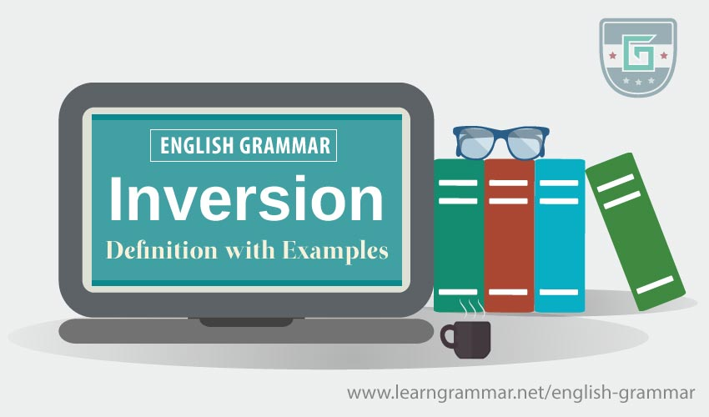

***Write the following sentences using inversion.***

* If I had known how difficult the course was, I would never have started it.

_____________________________________________________________

* If you practiced more often, you would improve much more quickly.

Were_________________________________________________________

* If it hadn’t been for Sally’s advice, I would have lost my job.

But__________________________________________________________

* If anyone loses their key, they will have to pay 5 euros for a new one.

Should_______________________________________________________

* We had no idea that so many people were looking for us.

Little_________________________________________________________

* As soon as the sun rose, Graham jumped out of bed.

Hardly _______________________________________________________

* Travelling by train is comfortable, and it’s also fairly cheap.

Not _________________________________________________________

* It was the first time that I had heard such a talented singer.

Never _______________________________________________________

* The second that we arrived, Josh and Carrie started to argue.

No _________________________________________________________

* It is now the time to deal with the problem

____________________________________________________________