**READING COMPREHENSION**

**Read the text and answer the following questions.**

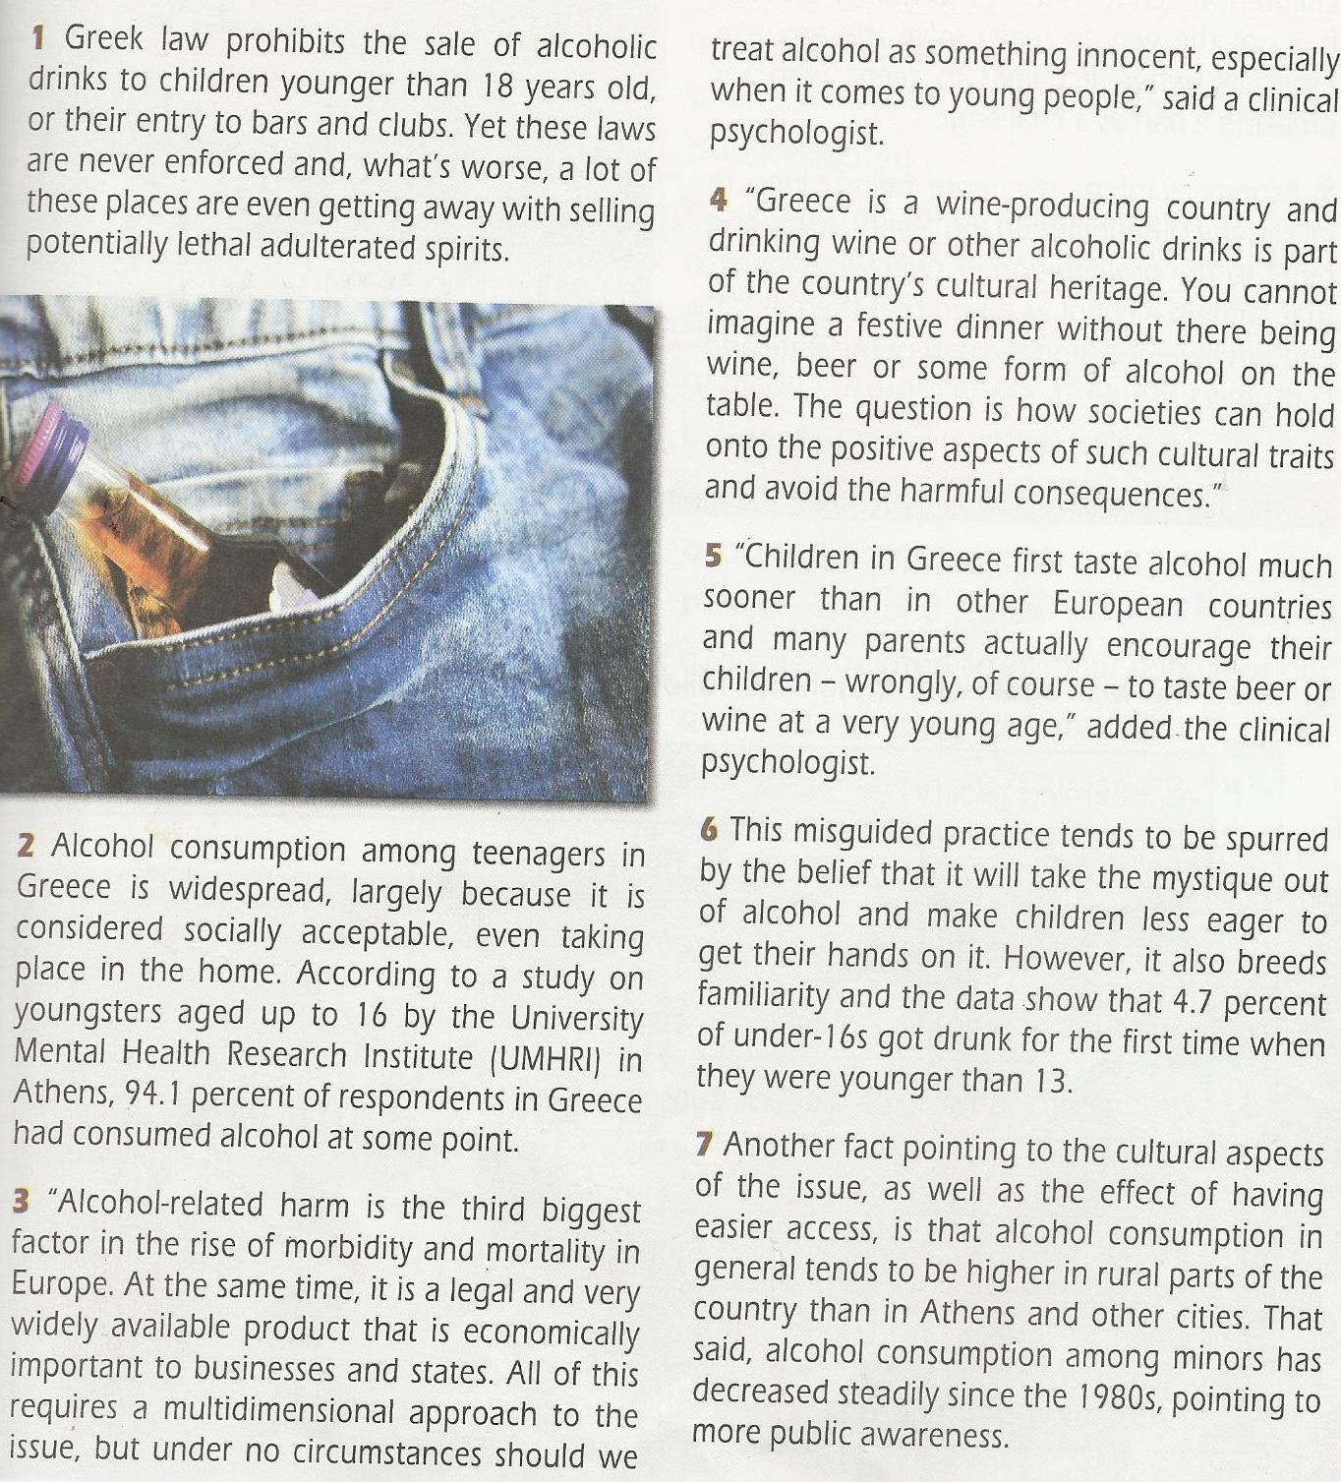

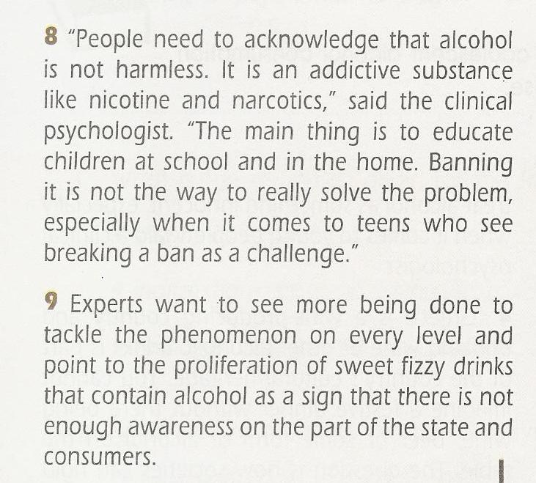



1. **This text addresses**
2. **researchers b) parents and teenagers c) general public**
3. **The problem of adolescent alcohol consumption is mainly enhanced by**
4. **the lack of law enforcement b) parents who encourage their kids to drink c) teenagers’ curiosity to taste alcohol**

**3. One reason teenagers consume alcohol in Greece is that it is legal and easily accessible.**

**TRUE FALSE**

1. **The root of the problem of alcohol addiction lies at the fact that**
2. **alcohol is an integral part of the Greek tradition b) the Greek family environment supports alcohol consumption c) alcohol is an important financial factor both for states and businesses**
3. **Keeping a balance between the positive aspects of certain cultural traits and their negative effects is not always easy.**

**TRUE FALSE**

1. **Greek parents’ tendency to encourage their children to taste alcohol**
2. **is motivated by their belief to make them less willing to taste the forbidden b) doesn’t actually make them more familiar with alcohol c) is justified due to the country’s rich cultural heritage.**
3. **Alcohol consumption tends to be higher in rural parts of Greece because alcohol is easier to find there and the circumstances of festive gatherings favor its use.**

**TRUE FALSE**

1. **The clinical psychologist argued that**
2. **alcohol is not as harmful as other substances b) raising teenagers’ awareness at school and in the home is necessary c) prohibiting teenagers from drinking alcohol is a good solution to the problem of addiction**
3. **What does the word *proliferation* mean in the last paragraph?**
4. **motivation b) prohibition c) rapid increase**
5. **What does the verb *spur* mean in the 6th paragraph?**
6. **encourage b) accept c) discourage**