STAYING HOME DUE TO THE COVID-19: WEEK 1…..

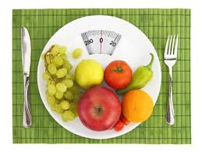

WEEK 1: I will get my weight down below 80.

WEEK 2: I will track my calories until I get below 90.

WEEK 3: I will follow my new diet religiously until I get below 100.

WEEK 4: I will try to develop a realistic attitude about my weight.

WEEK5: I will work out 5 days a week.

WEEK 6: I will work out 3 days a week.

WEEK 7: I will try to walk past a gym at least once a week.

WEEK 8...

