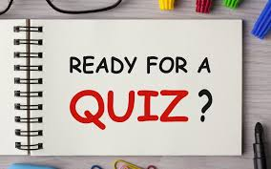

(passing requires 5 correct answers)

1. How long did the Hundred Years War last?

2. Which country makes Panama hats?

3. Which month do Russians celebrate the October Revolution in?

4. What is a camel’s hairbrush made of?

5. What animal are the Canary Islands named after?

6. What was King George VI’s first name?

7. Where are Chinese gooseberries from?

8. What is the colour of the black box in a commercial airplane?

All done? Check your answers in the Answer Sheet that follows……



