ORIGINS OF IDIOMS

You probably use tons of expressions, idioms and slang phrases every day that don’t make literal sense. If you ever thought long and hard about why you say something a certain way, you could probably make a guess. However, some English expressions are so crazy and unusual that it is impossible to guess where on earth they originated from. Unless you know the story…….

It’s Raining Cats and Dogs

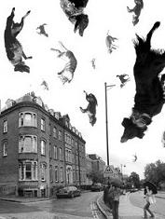

Meaning: raining heavily

Origin: There are a lot of things we have seen falling from the sky, but cats and dogs aren’t one of of them. So, how did this expression come about?
It's quite simple, really. It originated in England in the 1500's, when houses had thatched roofs. A thatched roof consisted of straw piled high, with no wood underneath. In cold, foggy England this was sometimes the only place for an animal to get warm. Cats, other small animals and the occasional dog would end up on the roofs.
When it rained really hard, some of the animals would slip off the roof and wash up in the gutters on the street. Hence, the saying, "It's raining cats and dogs" ended up referring to a particularly heavy rain.

Cost an arm and a leg



Meaning: extremely expensive

Origin: The story goes that this phrase originated from 18th-century paintings, when famous people like George Washington would have their portraits done without certain limbs (arms, legs) showing. Having limbs showing is said to have cost more.

In stitches

Meaning: laughing so hard that your sides hurt
Origins: It probably has to do with comparing the physical pain of intense laughter with the prick of a needle. “In stitches” was first used in 1602 by Shakespeare in Twelfth Night. After this, the expression isn’t recorded again until the 20th century, but it’s now commonplace.

Close but no cigar
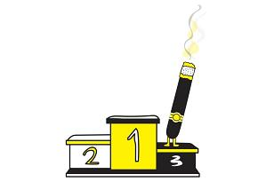

Meaning: almost, but not quite successful

Origins: Carnival games nowadays give out stuffed animals as prizes, but in the late 19th century, the games were targeted to adults, not kids. Instead of getting a giant teddy bear, winners might get a cigar. If they almost won but didn’t earn that prize, they’d be “close, but no cigar.” By the 1930s, the phrase extended beyond fairgrounds to everyday close shots.

Bite the bullet
Meaning: To accept something difficult or unpleasant
Origin: In the old days, when doctors offering their services during a battle were short on anaesthesia, they would ask the patient to bite down on a bullet to distract from the pain. The first recorded use of the phrase was in 1891.

Caught red-handed
Meaning: To be caught in the act of doing something wrong
Origin: This originates from an old English law that ordered any person to be punished for butchering an animal that wasn’t his own. The only way the person could be convicted is if he was caught with the animal’s blood still on his hands.

Break the ice

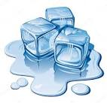
Meaning: To break off a conflict or commence a friendship
Origin: Back when road transportation was not developed, ships would be the only transportation and means of trade. At times, the ships would get stuck during the winter because of ice formation. The receiving country would send small ships to “break the ice” to clear a way for the trade ships. This gesture showed affiliation and understanding between two territories.

Give a cold shoulder
Meaning: Being unwelcoming or antisocial toward someone
Origin: In medieval England, it was customary to give a guest a cold piece of meat from the shoulder of mutton, pork, or beef chop when the host felt it was time for the guest to leave. This was a polite way to communicate, “You may leave, now.”

So… now that you know the meaning and origins of some of the most interesting idioms and it’s time to practise, don’t…..

Turn a blind eye


Meaning: pretend that you don’t see, ignore situations, or reality
Origin: The British Naval hero, Admiral Horatio Nelson, had one blind eye. Once when the British forces signaled for him to stop attacking a fleet of Danish ships, he held up a telescope to his blind eye and said, “I do not see the signal.” He attacked, nevertheless, and was victorious.

