WRITING

LINKING WORDS and PHRASES

Linking words and phrases in English (also called 'connective' or 'transition' words) are used to combine two clauses or sentences presenting contrast, comparison, condition, supposition, purpose, etc.
They enable us to establish clear connections between ideas.
Most linking words can either connect clauses within a sentence, or start a sentence to form
a link with the previous statement.
♦Note : A clause is a group of words that includes a subject and a verb.
The following sentence contains two clauses:
She lives in Mexico because she likes the climate.
Below you will find some examples of linking words and how to use them. This is not a comprehensive list.
You may want to add your own linking words and phrases.
Examples of linking words within one sentence:
Linking Words | Examples of Use
As long as  provided (that)  providing | You can take my car as long as/provided (that)/providing  you don't damage it.  (I will lend you my car on condition that you don't damage it.)
Although/even though | Although/even though he is rich, he lives in a small house.  (In spite of the fact that he is rich, he lives in a small house.)
Even if | He is poor and has no house, but even if he had money, he wouldn't buy a house.  (Supposing he had the money, he still wouldn't buy a house.)
In case | Take an umbrella in case it rains.  (It might rain, so it's a good idea to take an umbrella.)
In spite of/Despite | In spite of/despite the rain, she walked to the station.  In spite of/despite being blind, he walked to the station.  (without being affected by the rain or by being blind.)
So that | She arrived early so that she could help her colleagues.  (She arrived early for the purpose of helping her colleagues.)
Whatever | You can count on me whatever you decide to do.  (No matter what your decision is, you can count on me.)
Whereas | Tom is rich, whereas Jack is poor.  (Tom is rich; in contrast Jack is poor.)
Whenever | I will lend you my car whenever you need it.  (No matter when you need my car, I will lend it to you.)
Wherever | My thoughts will be with you wherever you go.  (No matter where you go, my thoughts will be with you.)

Examples of linking words that connect two separate sentences or two clauses:
♦Note :
If linking words start a sentence, they are followed by a comma.
When they are used to connect two clauses, a semi-colon is used at the end of the first clause, and a comma is often used after the linking word(s).
Linking Words | Examples of Use
As a result  Consequently  Therefore | Prices were reduced by 20%.As a result, sales increased.  The company is expanding. Consequently,there are jobs on offer.  A hurricane has been announced. Therefore, air traffic will be disrupted.
Besides  Furthermore  In addition  Moreover | The trip is too expensive. Besides, I don't really like hot weather.  Computers are cheaper nowadays; furthermore, they are lighter.  You haven't paid the rent yet. In addition, you owe me money.  The report is badly presented. Moreover, it contains inaccuracies.
For instance  For example | There are several problems to consider;  for instance/for example, there is a lack of public transport.
Conversely  On the contrary  On the other hand | Northern European countries had a great summer.  On the contrary/conversely, southern Europe had poor weather.  Laptops are convenient; on the other hand, they can be expensive.
However  Nevertheless  Nonetheless | The hotel was open. However, nobody came to the reception desk.  He had severe injuries; nevertheless, he completely recovered.  The weather was bitterly cold. He went hiking nonetheless.
In the same way  Likewise  Similarly  By the same token | Alex enjoys telling jokes;  in the same way /similarly / likewise, his son adores funny stories.  Teenagers should be more respectful;  by the same token, parents should be more understanding.
To sum up  Briefly  To conclude  In conclusion | I've covered the main events of the year.  To sum up / briefly, our team is now one of the best in the world.  To conclude / in conclusion, I want to wish you all a very happy holiday season.

FORMAL vs INFORMAL EXPRESSIONS
Formal English expressions are used in formal letters or in situations involving people you do not know very well. The tone is respectful and polite.
Informal English expressions are used in everyday conversations and emails exchanged with friends, colleagues or people you know well. The tone is casual and friendly.

FORMAL | INFORMAL
▪I regret to inform you that ... | ▪I hate to have to tell you this but ...
▪I am writing to inform you that ... | ▪Just a quick line to say ...
▪It is a pleasure to meet you. | ▪Nice to meet you.
▪Upon your arrival ... | ▪As soon as you get here …
▪At your earliest convenience | ▪As soon as you can
▪I regret that I will be unable to attend ... | ▪Sorry I can’t make it.
▪I would appreciate being kept informed … | ▪Please keep me posted/updated.  ▪Keep me in the loop!
▪I would like to remind you that ... | ▪Don't forget ...
▪Would you be available on ..... ? | ▪I suggest we get together on .....
▪I really appreciate your assistance | ▪Thanks a lot!
▪Please accept my apologies for ... | ▪Sorry for ...
▪It will not be necessary for you to ... | ▪You won’t have to ...
▪It would be of great benefit to you to ... | ▪It would do you good to ...
▪We have a vast amount of information at your disposal. | ▪I have lots of information for you.
▪We were hoping you could ... | ▪Could you ...?
▪It is my opinion that ... | ▪I think ...
▪Please remember me to Alex. | ▪Say hello to Alex for me.
▪I'd like to express my gratitude for... | ▪Thanks a million. I owe you one!

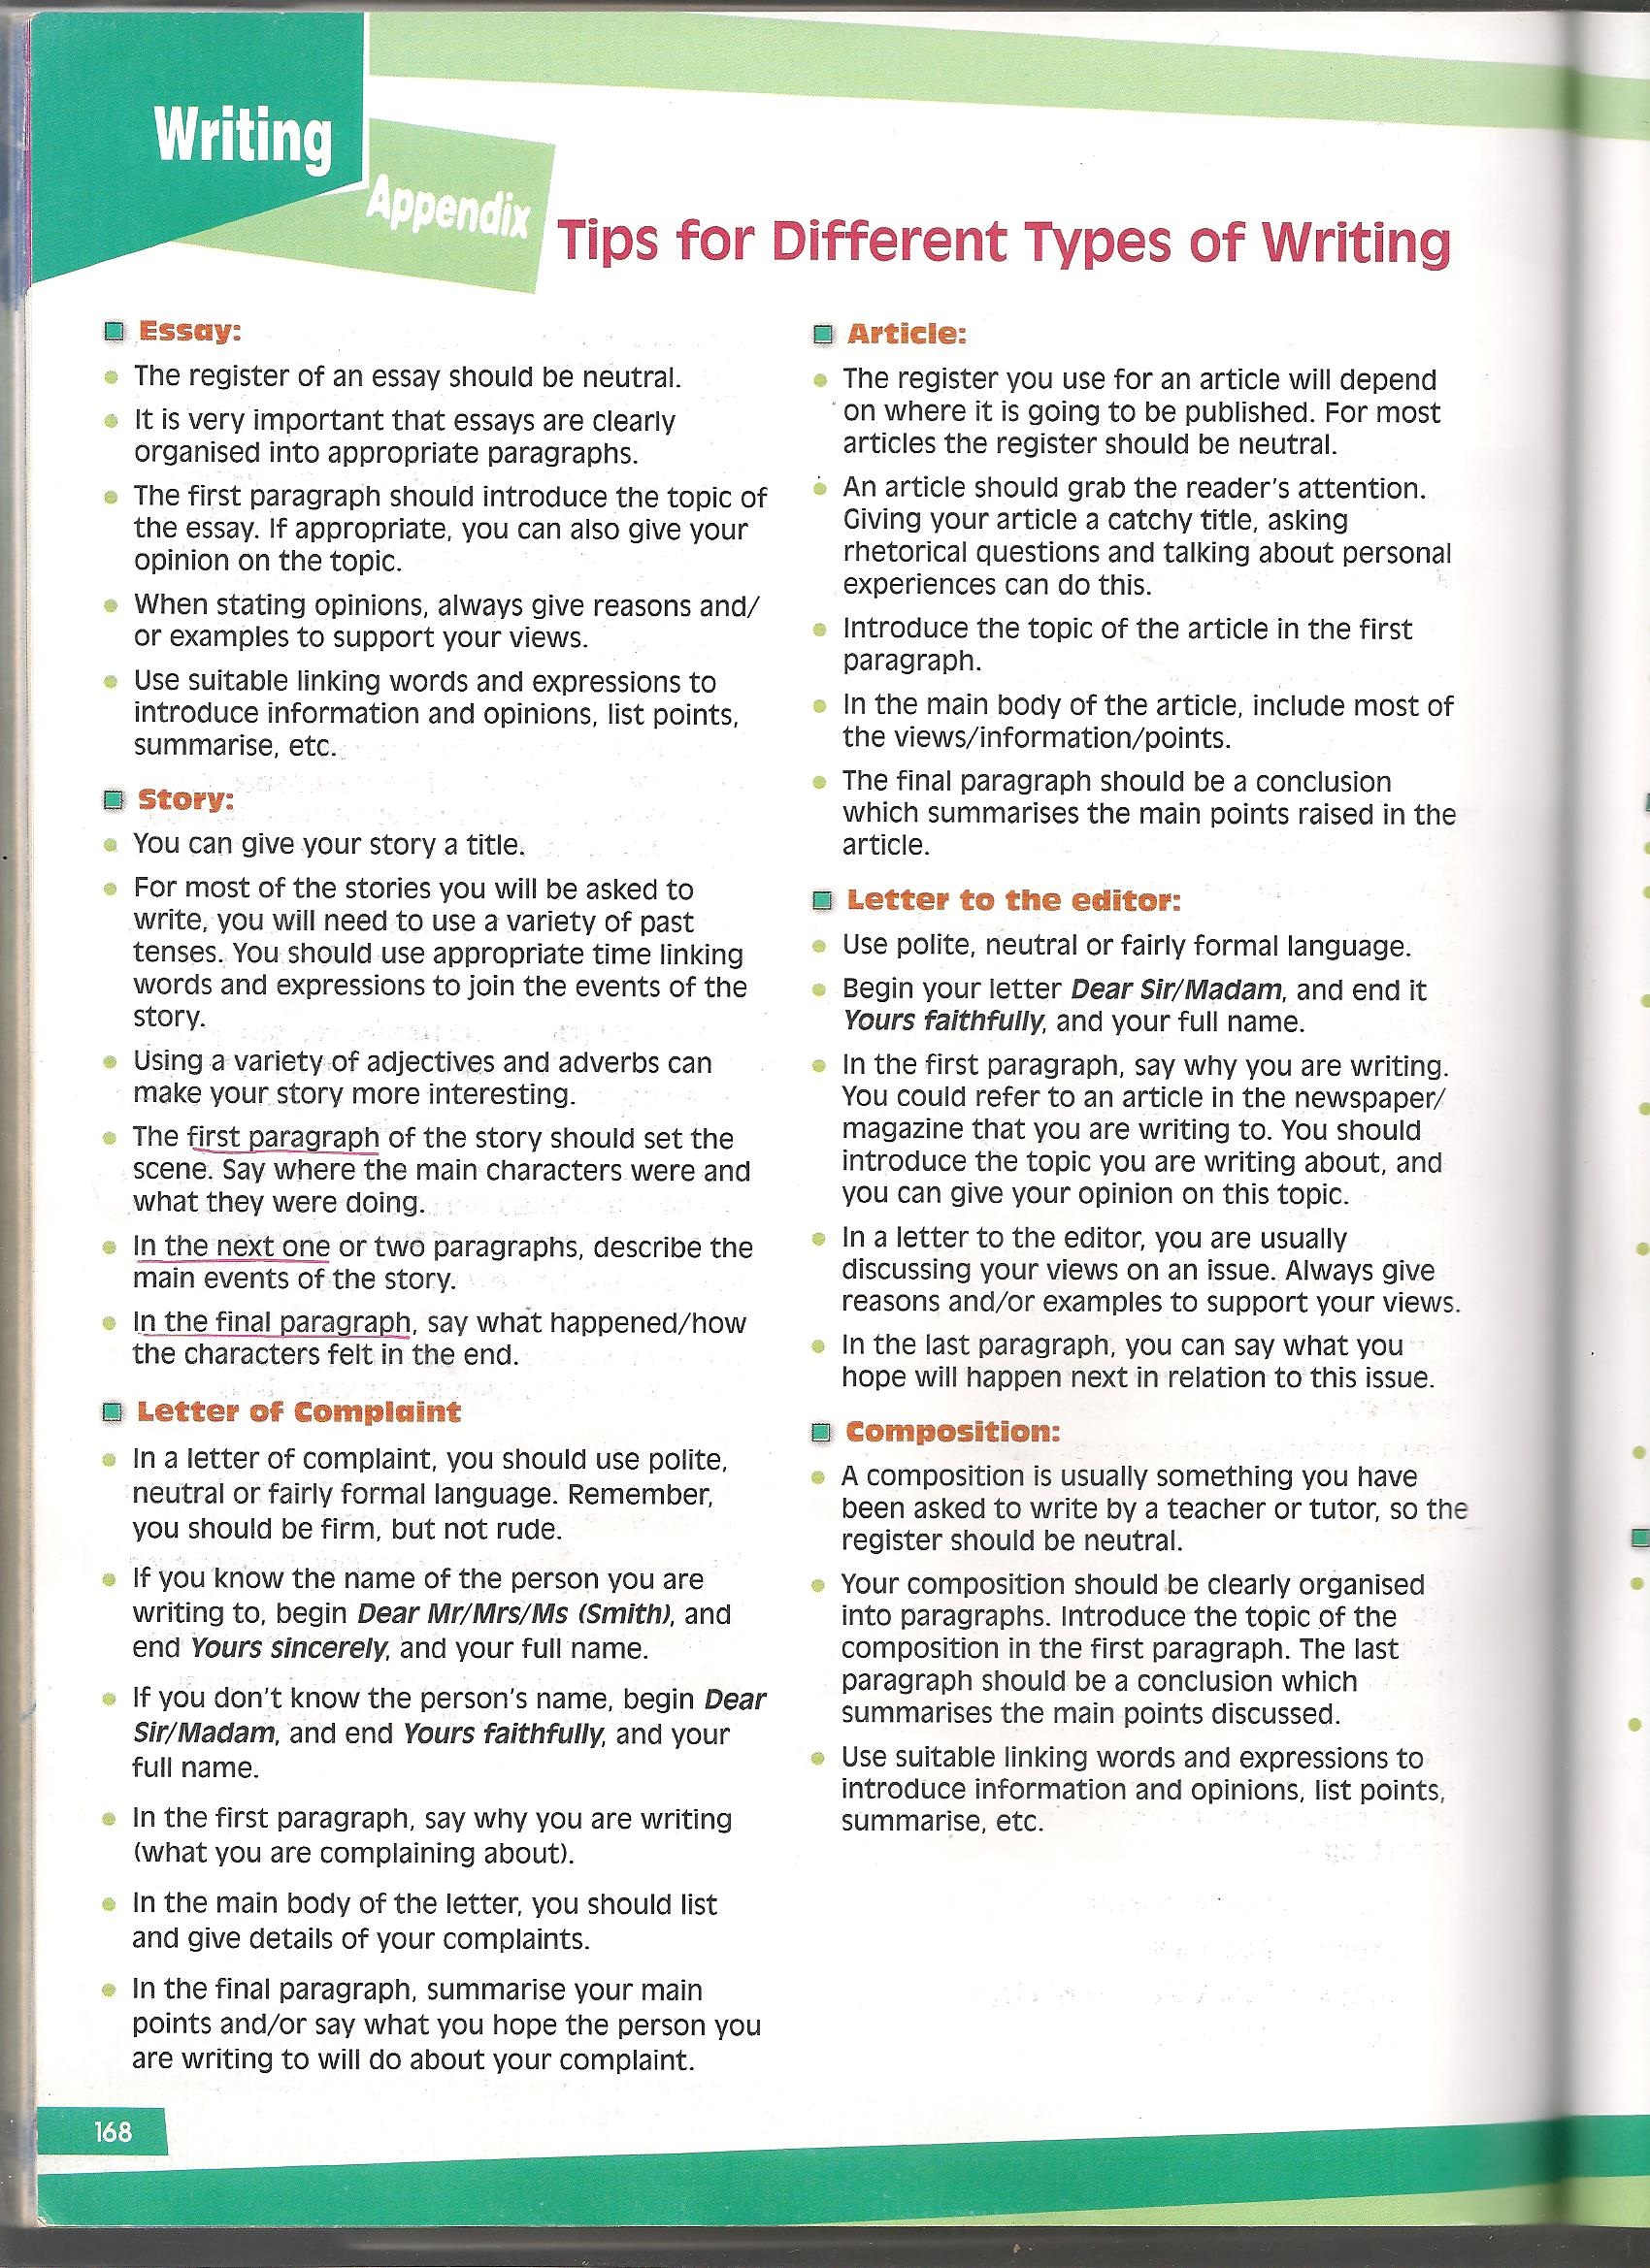

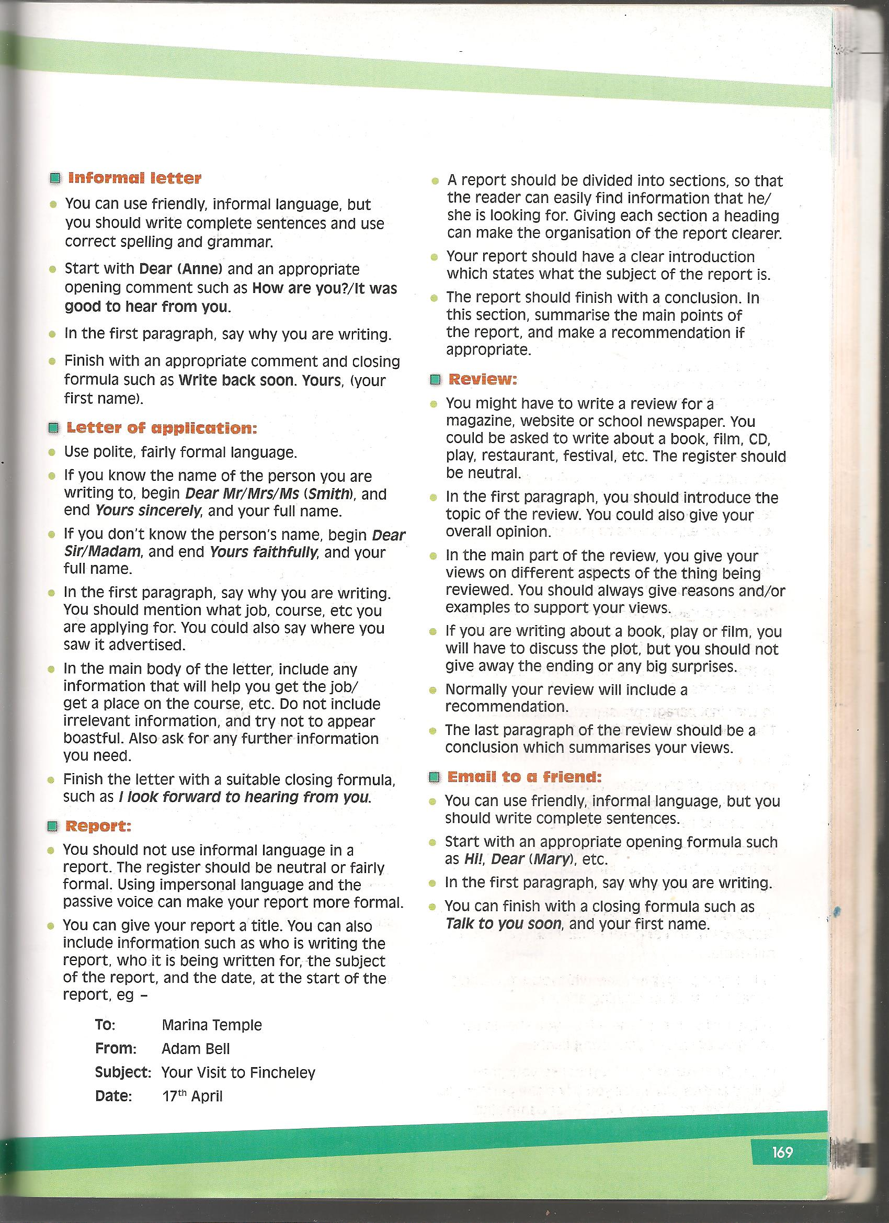

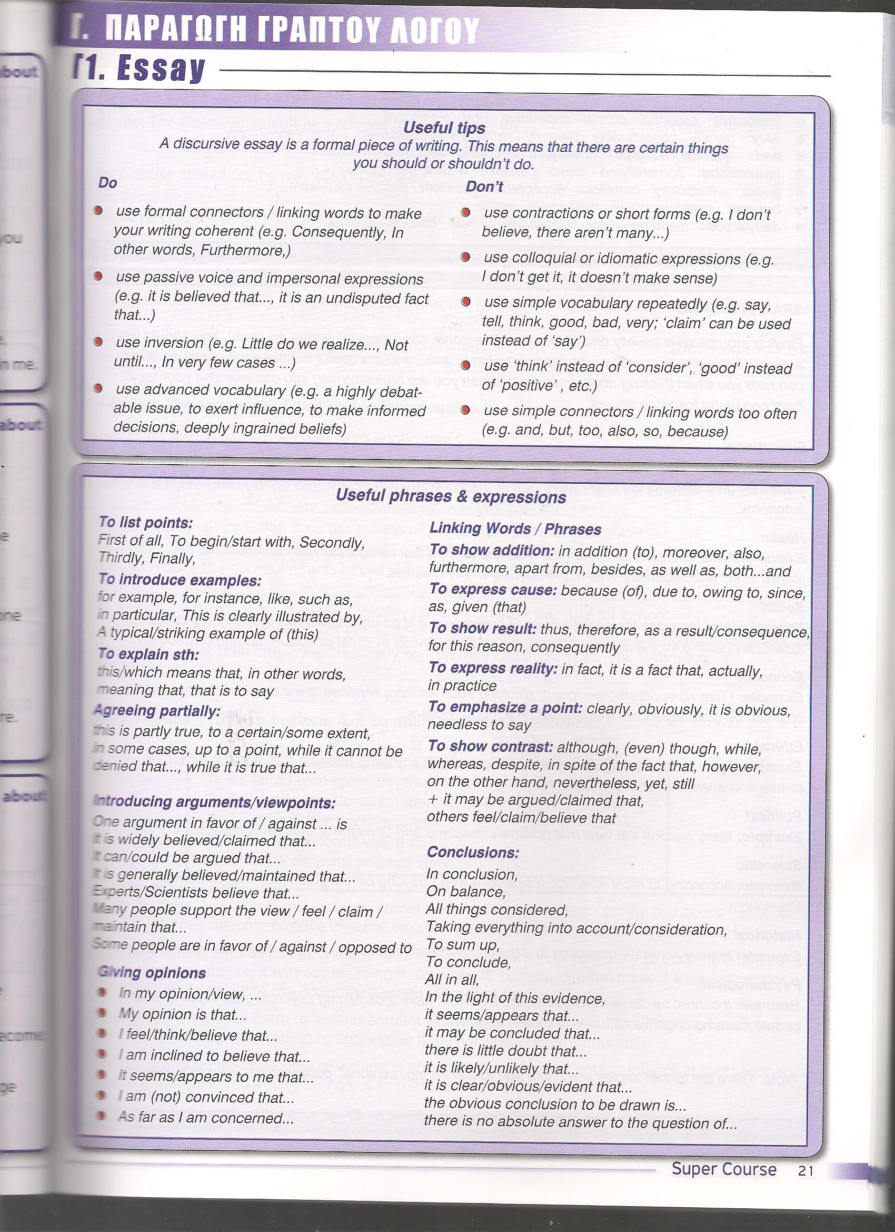

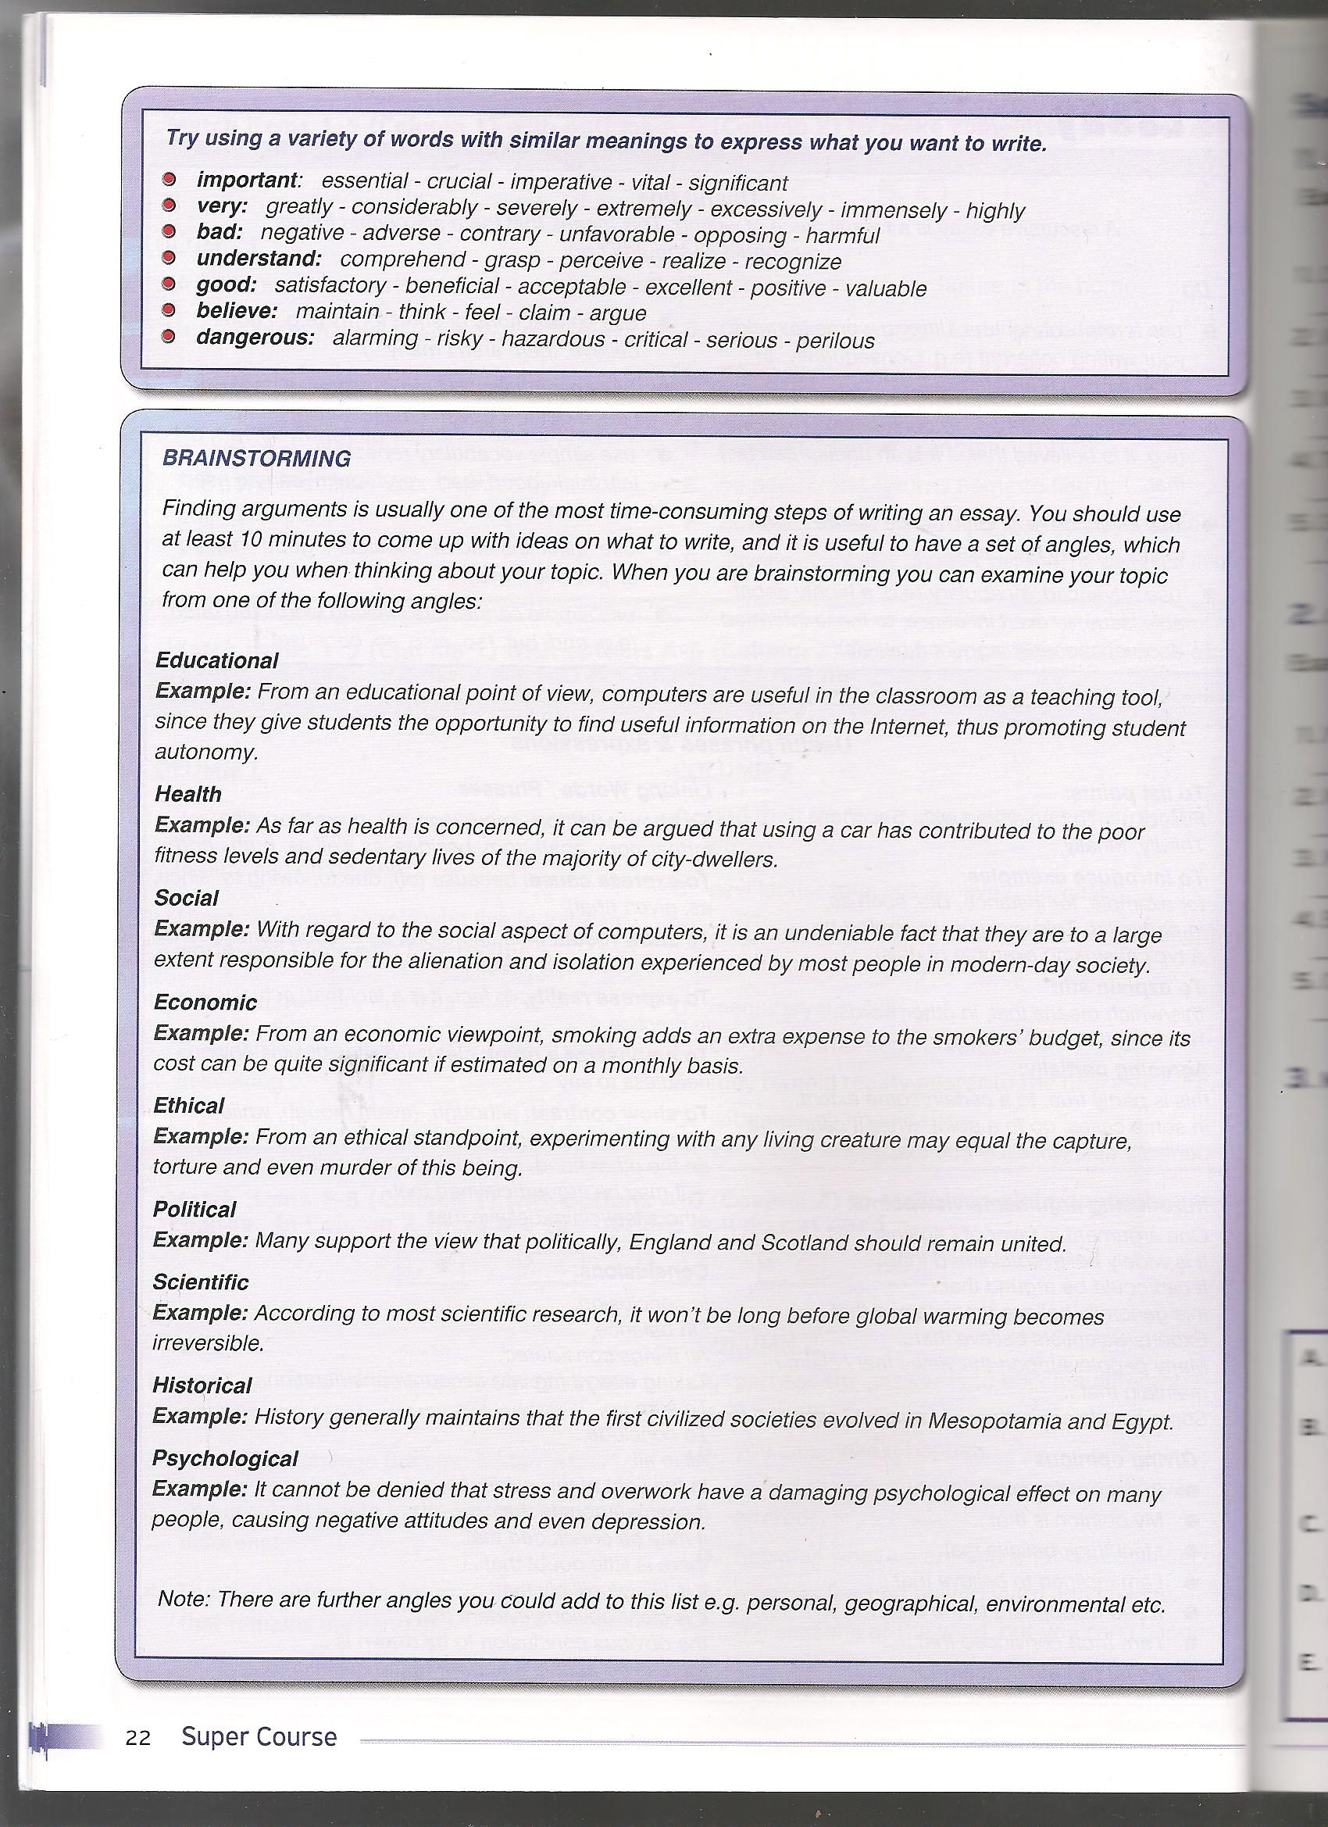

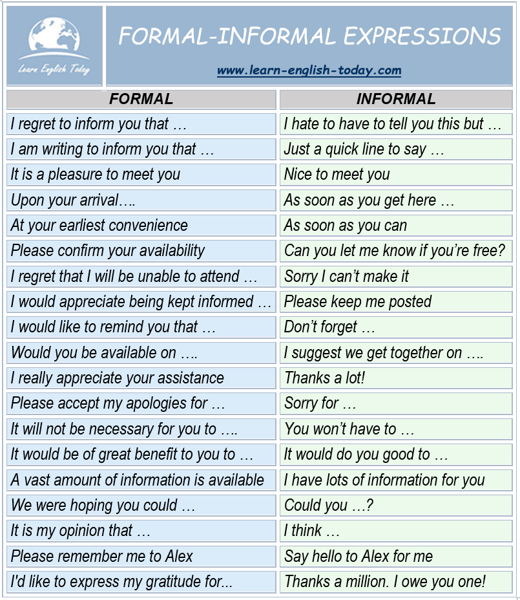

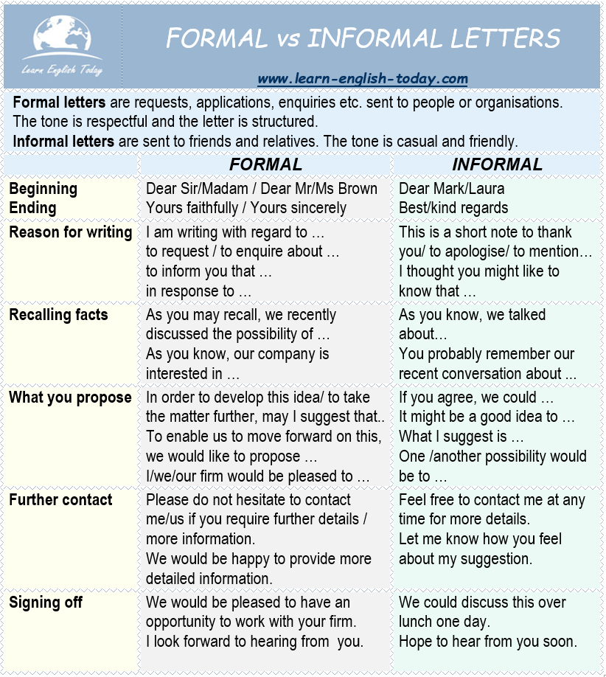

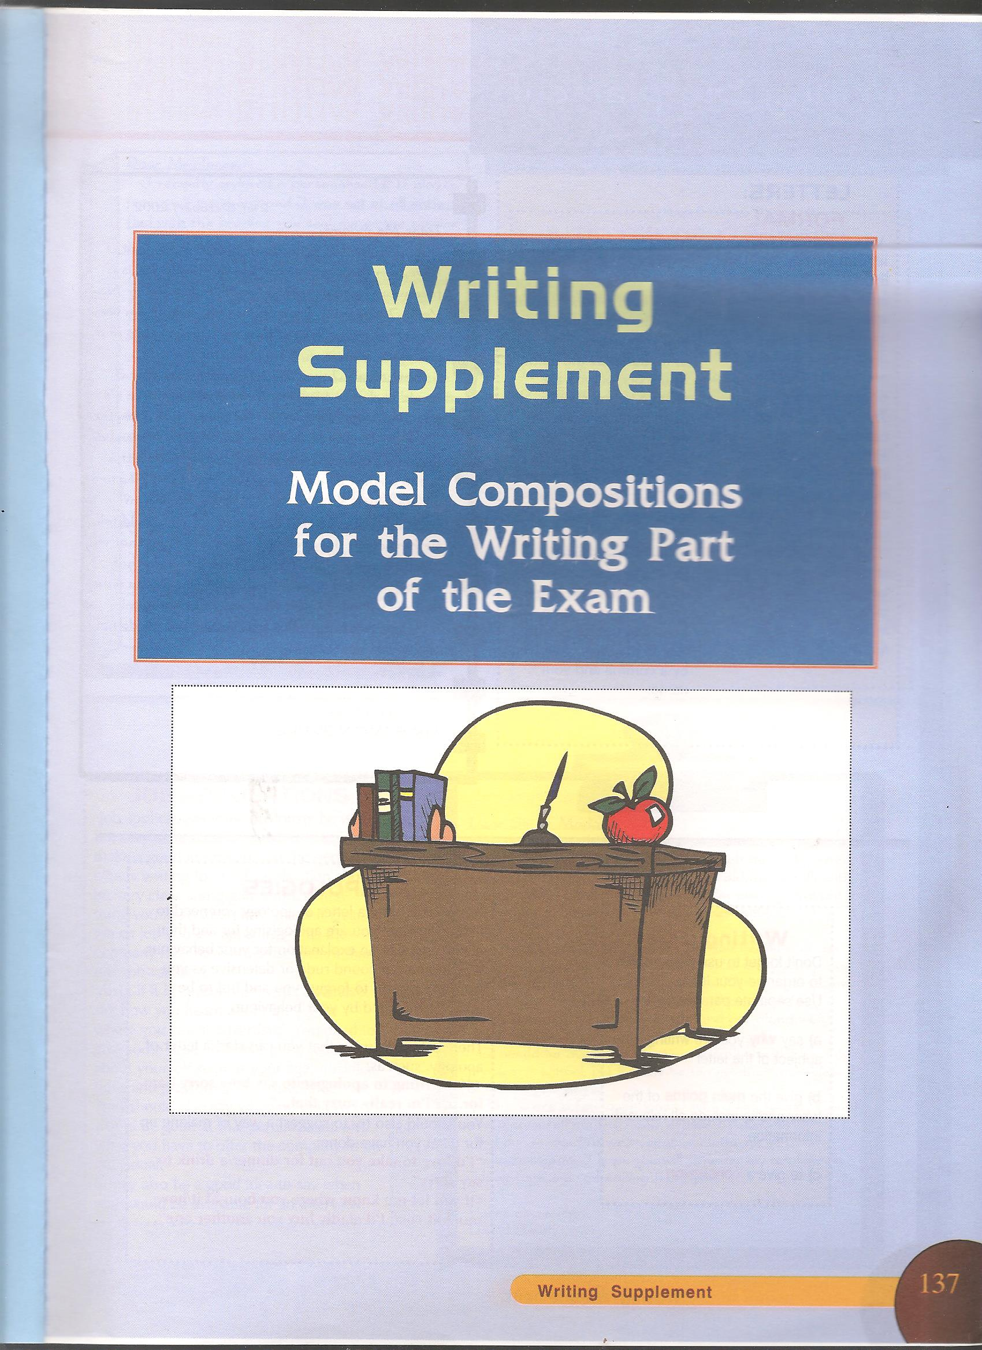

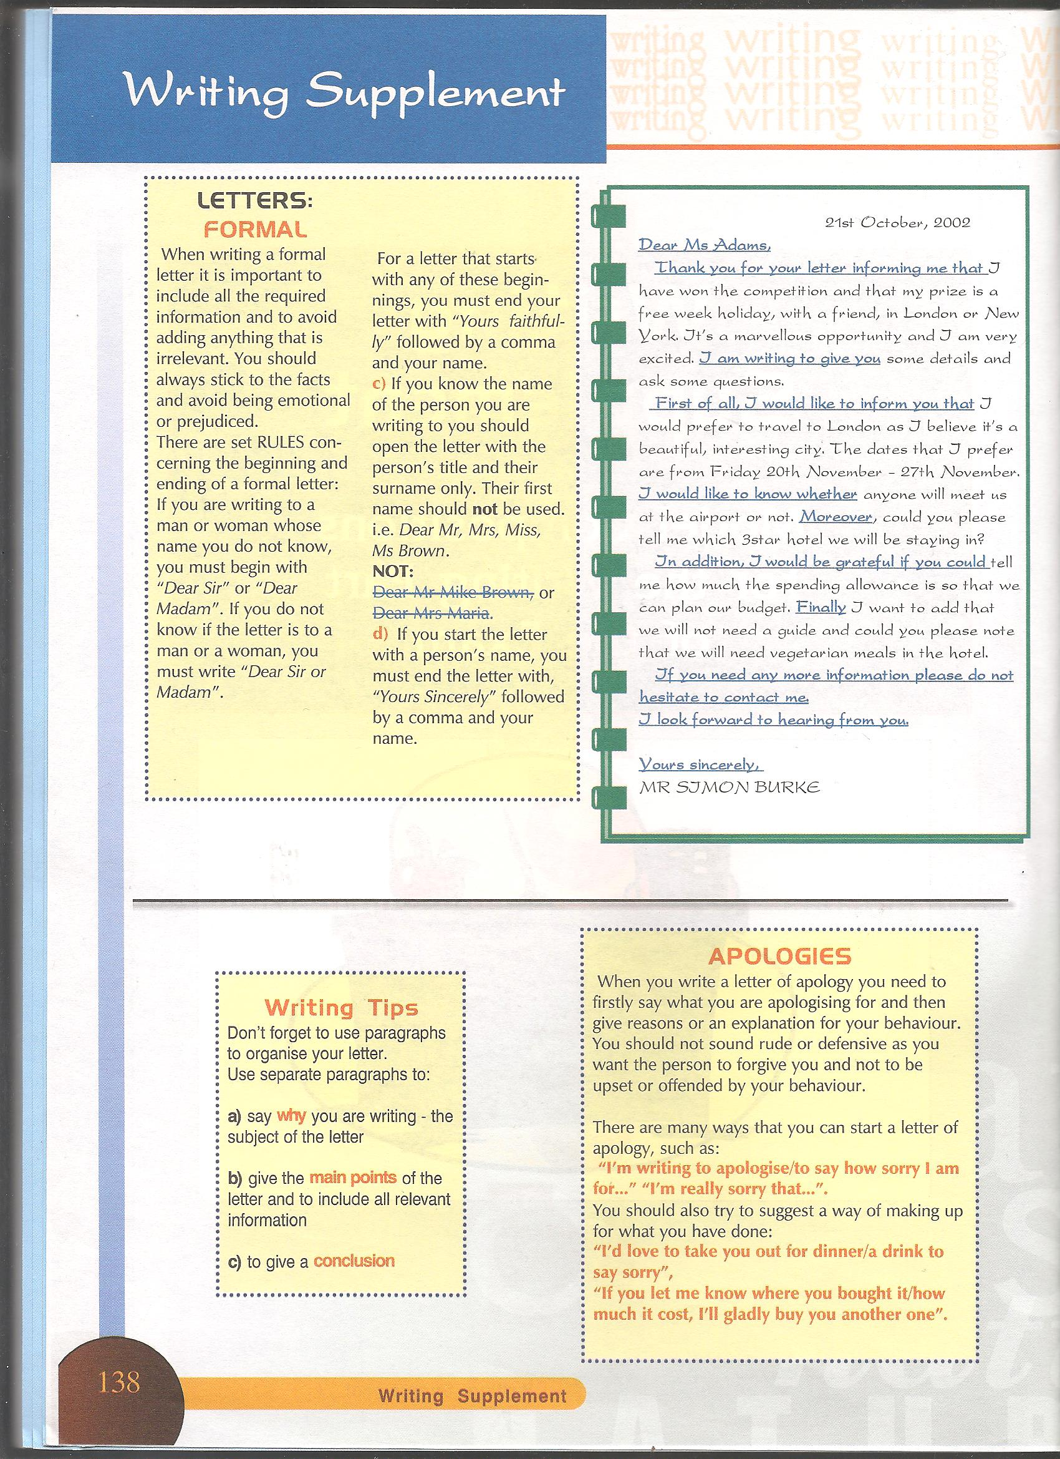

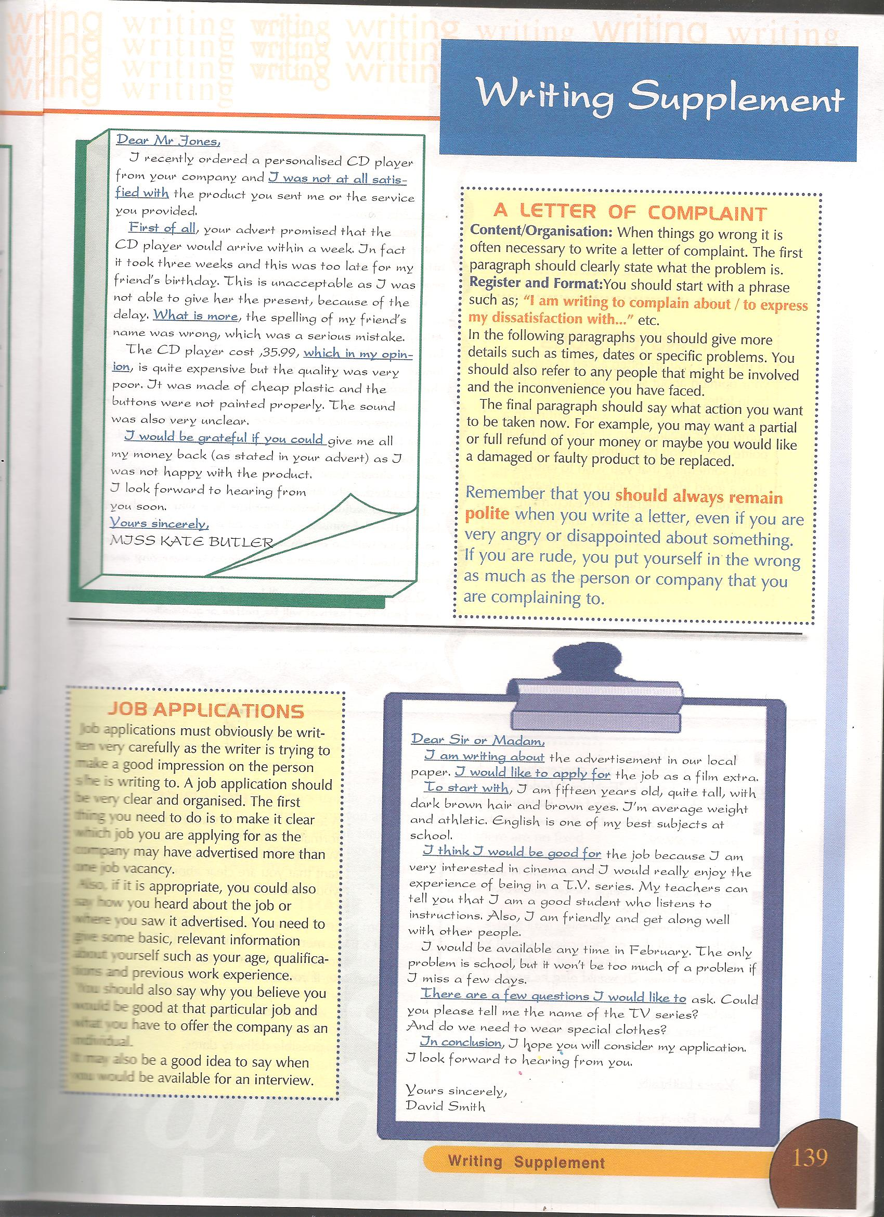

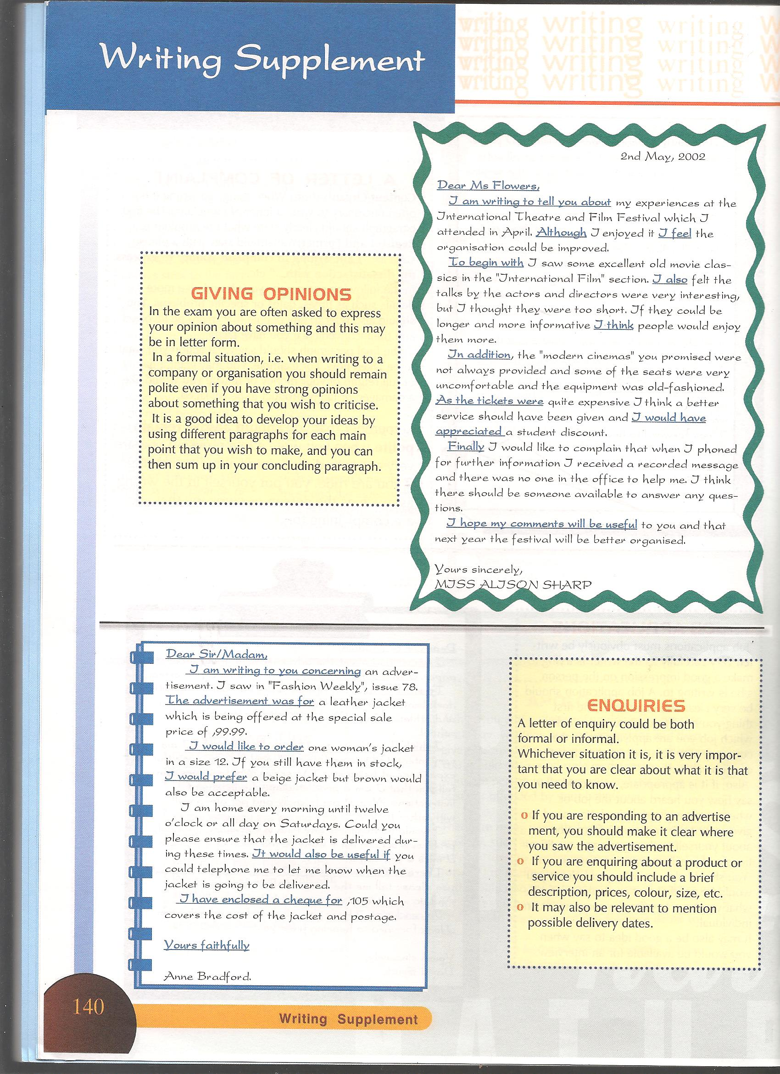

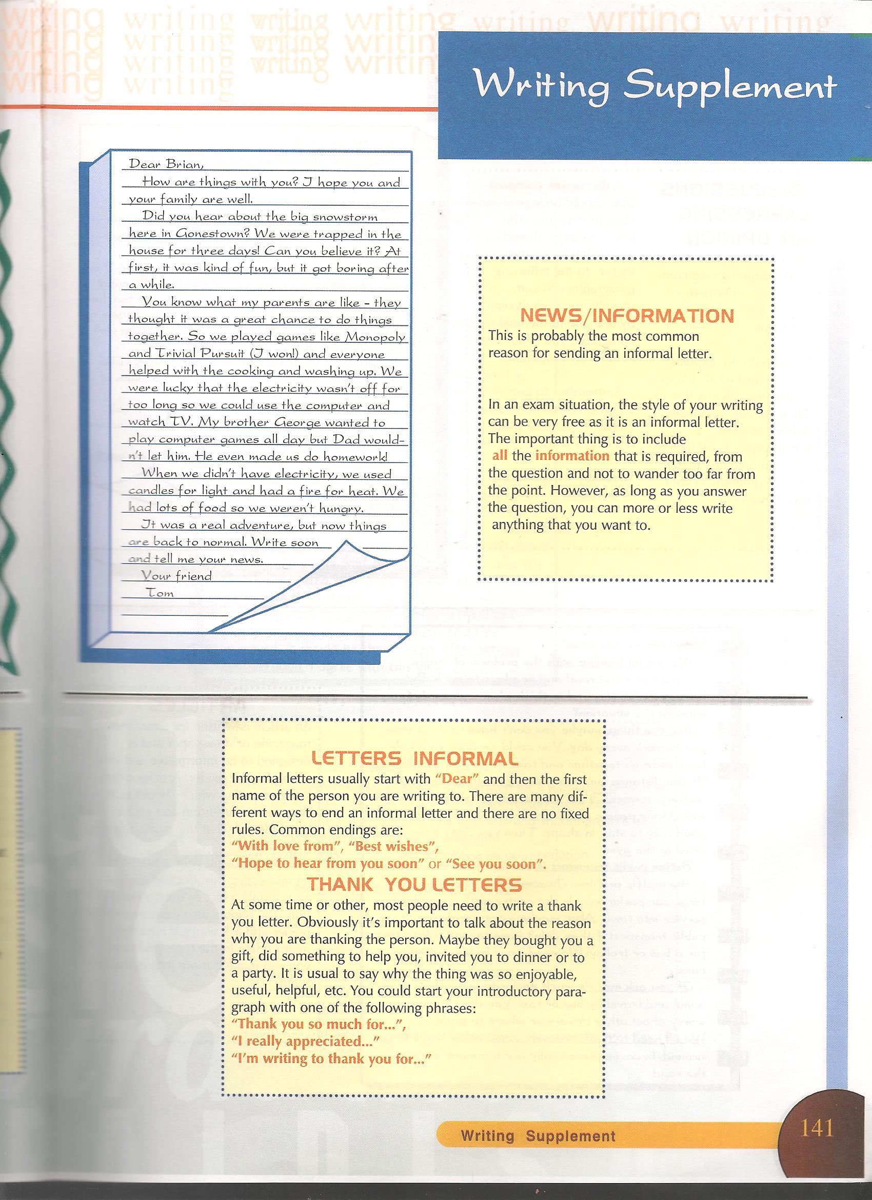

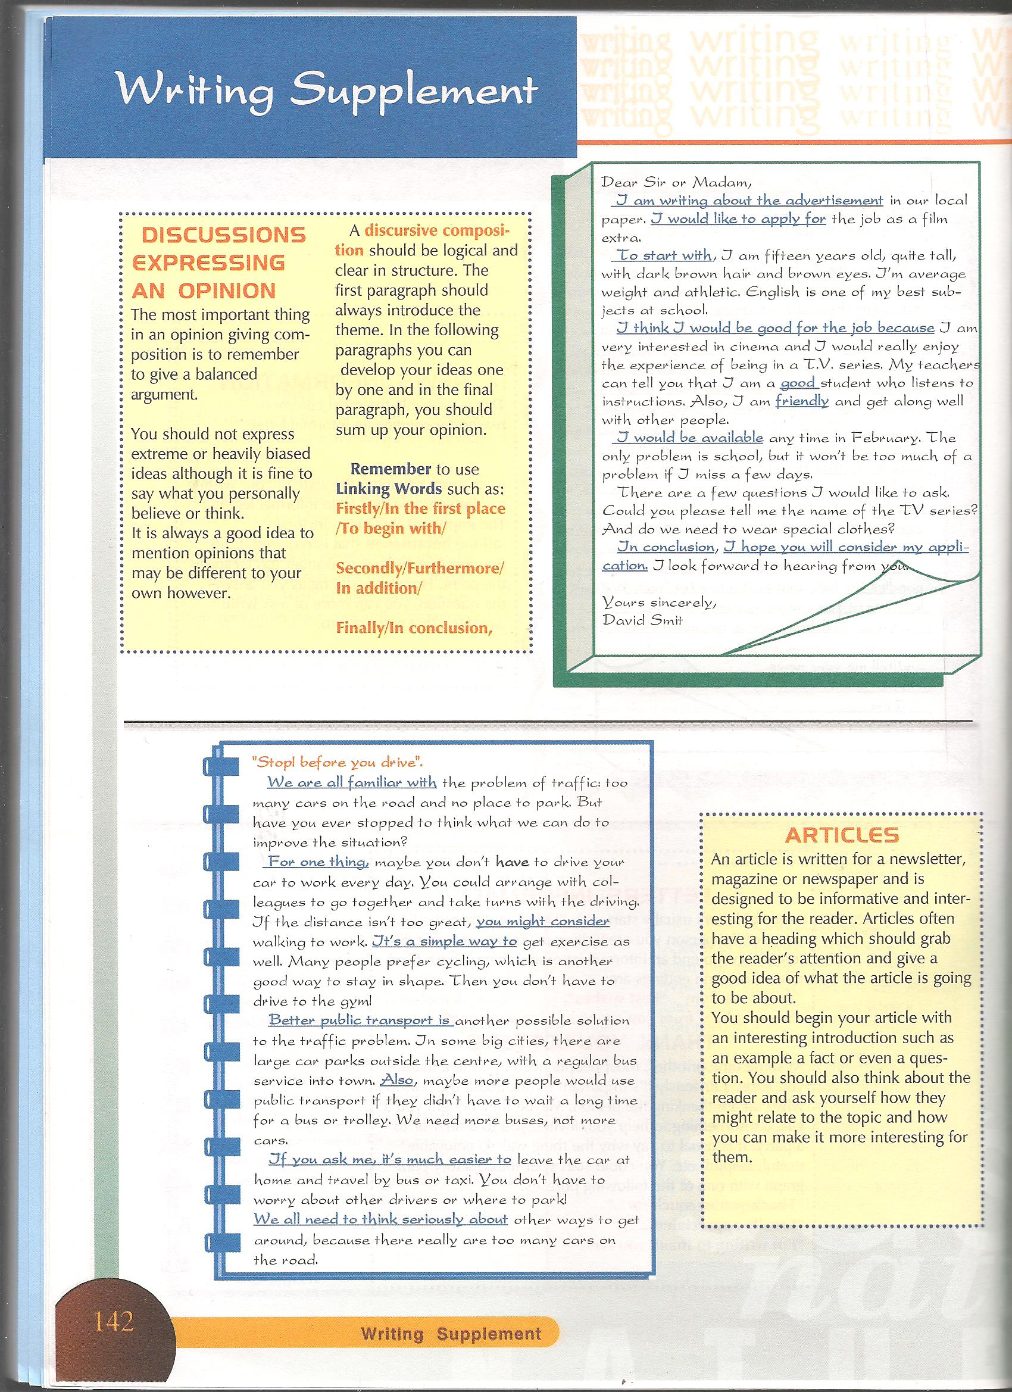

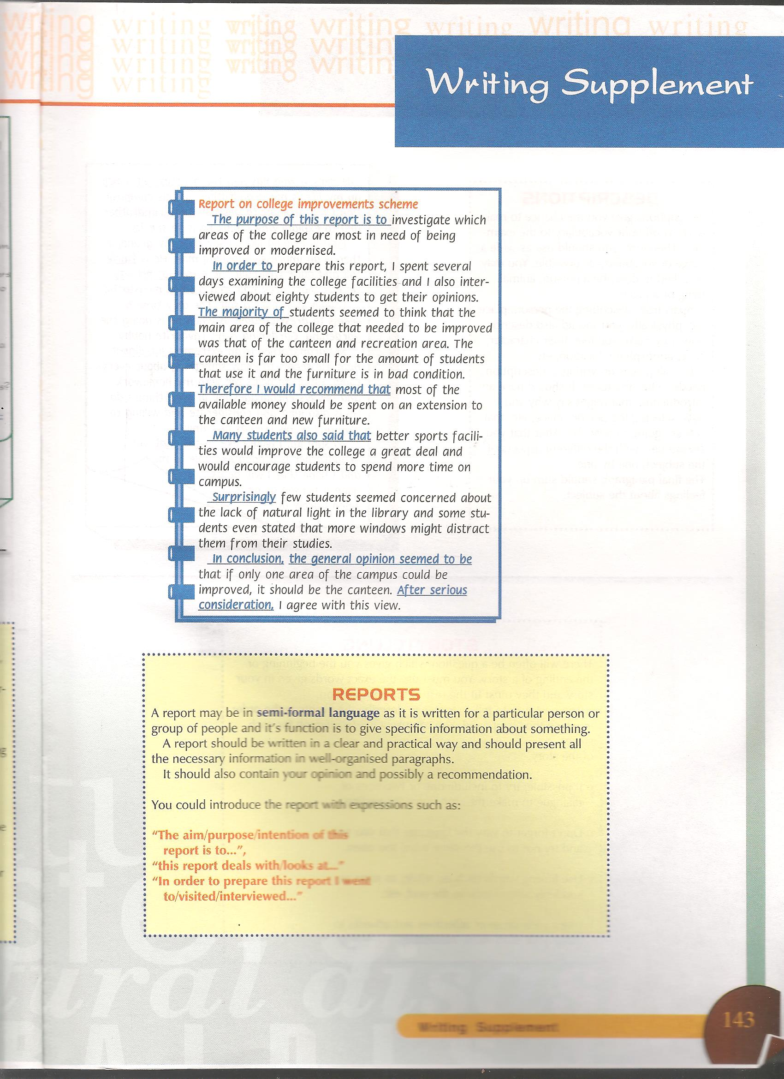

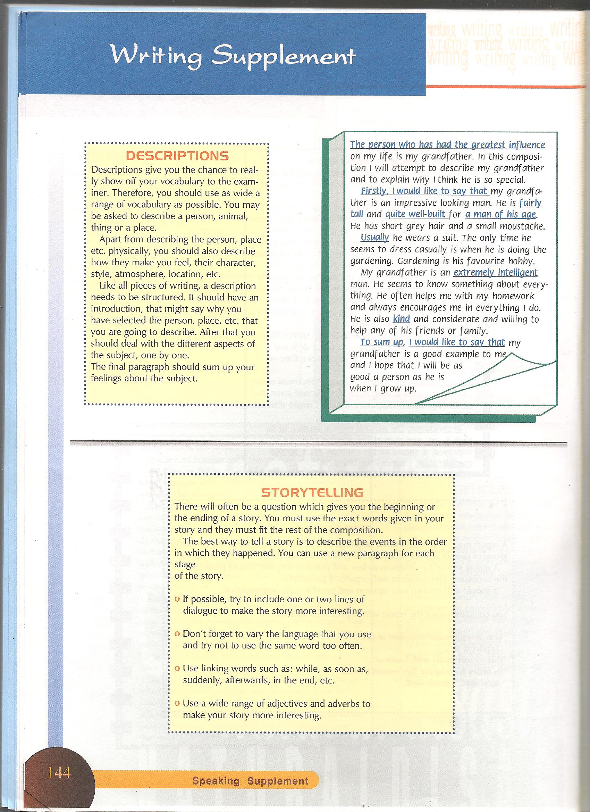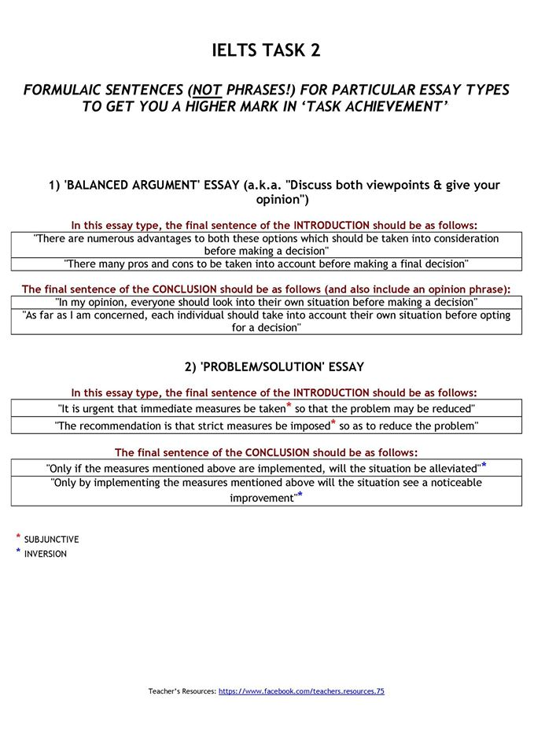
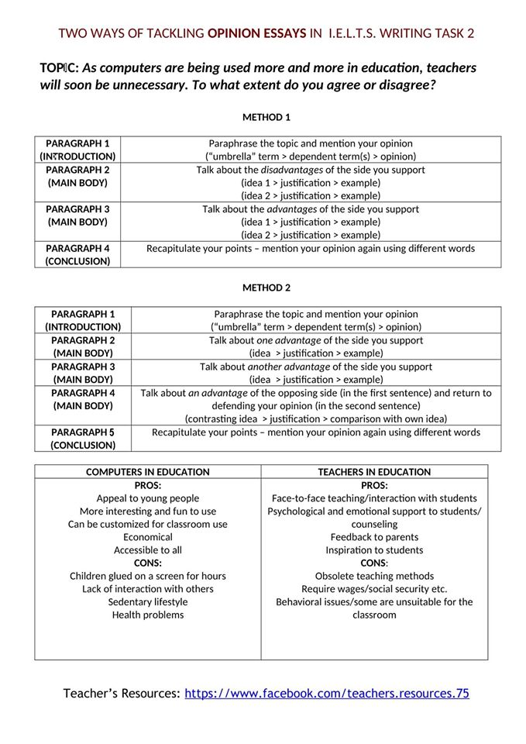
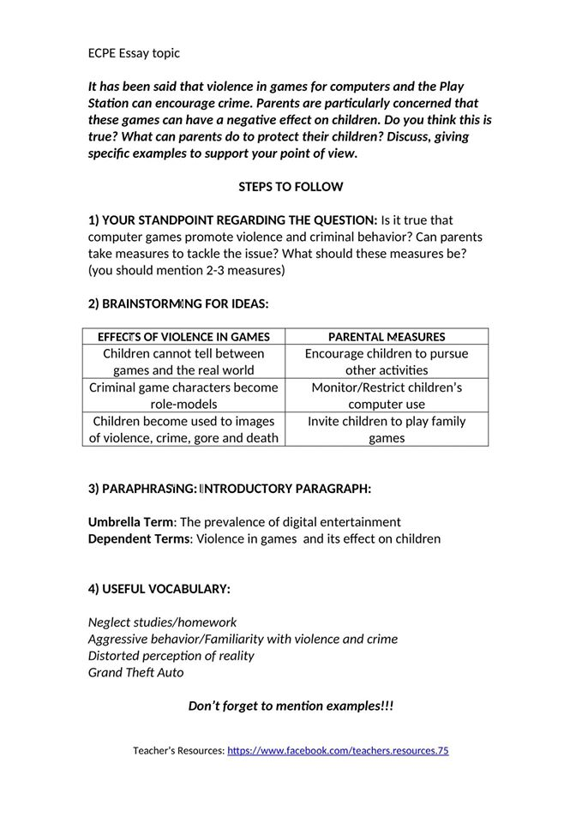
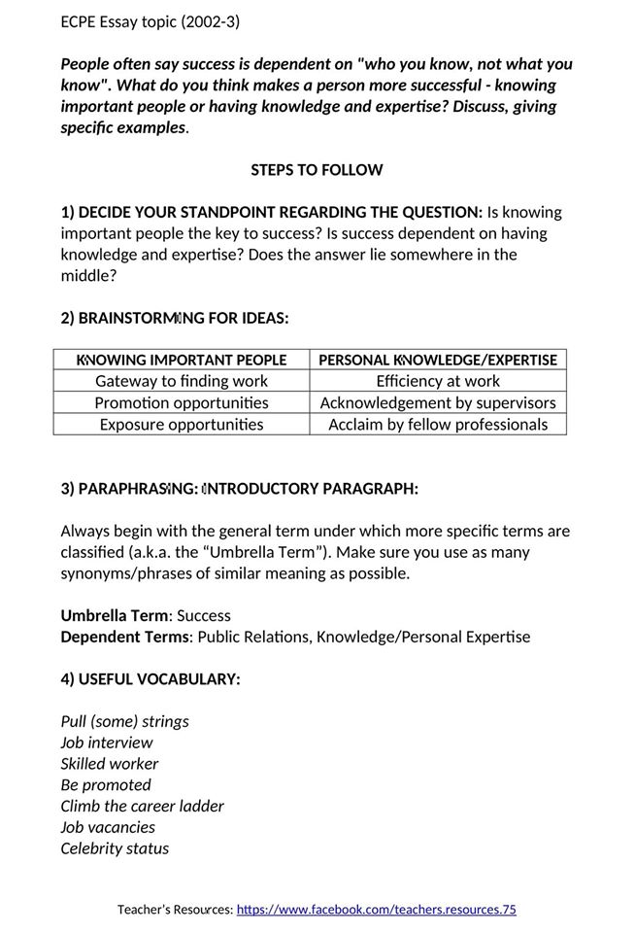
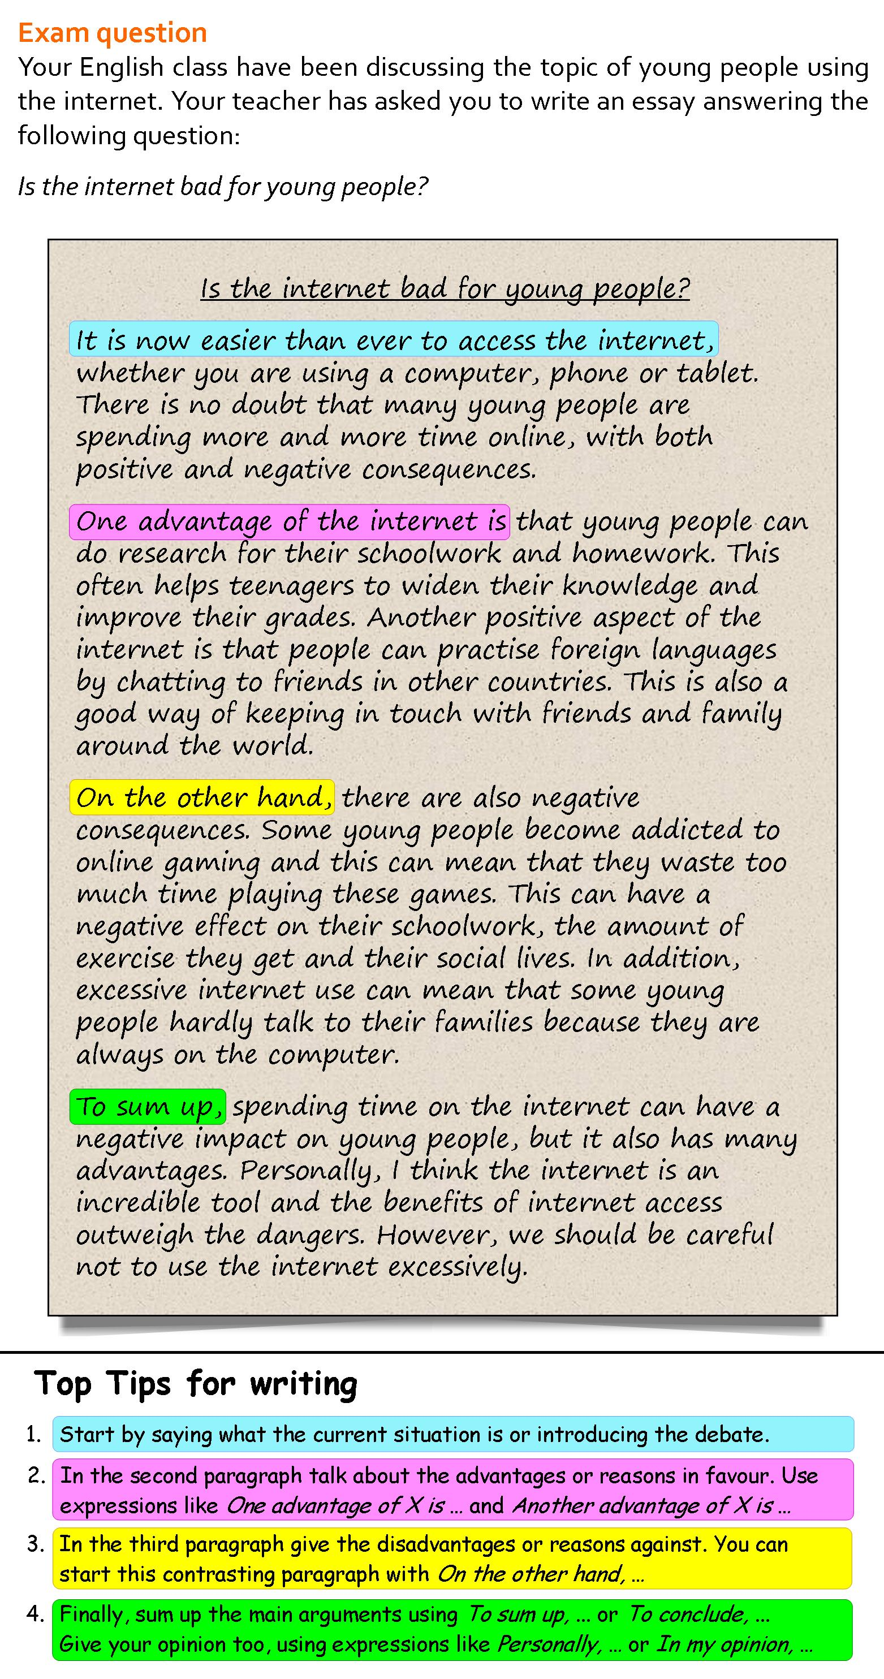
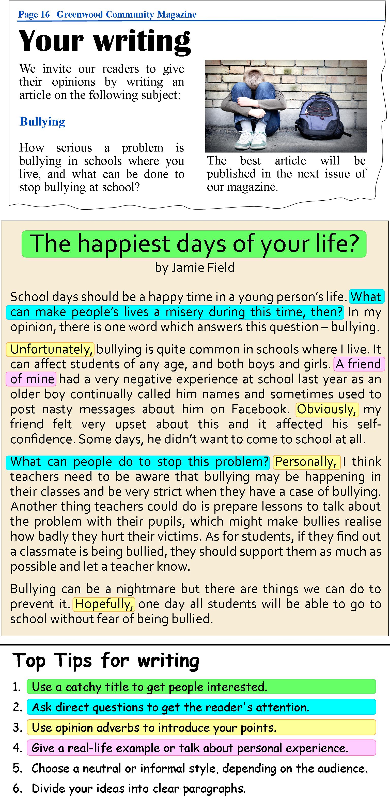
A Report
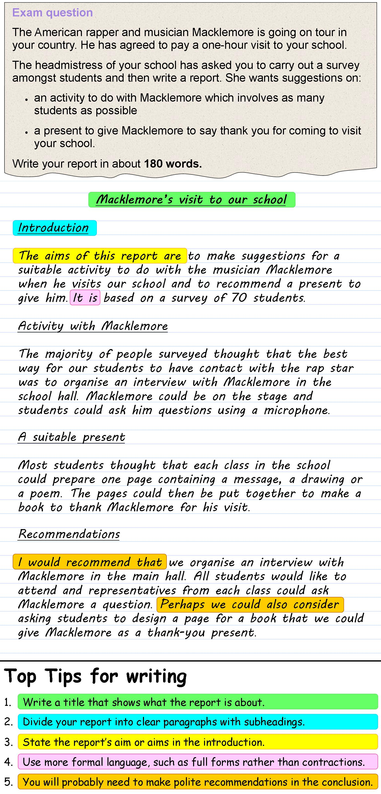

An informal email
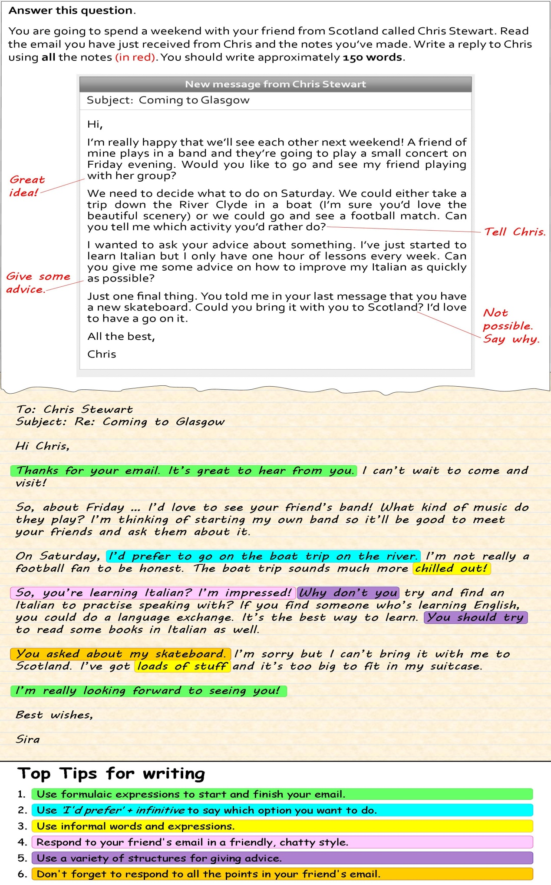

A more formal email
