Unit 5 – Animal Rights: Factory Farms (p. 56)
- Complete the following sentences using the passive voice.
In the U.S:
- Over 99% of farm animals _________ (raise) in factory farms.
- Approximately 8.5 million chickens ___________ (kill) for their meat every year.
- 300 million chickens __________(use) in egg production.
- All birds ____________ (protect) by federal animal protection laws.
- Chickens used for egg production ___________ (not use) for meat production.
- Each type of chicken __________ (breed) for hyperproduction.

- Now read the text on p. 56 and see if the statements in ex. 1 are True (T) or False (F).

- Read the text again and answer the questions.
  - What is a factory farm?
  - What is the problem with factory farms?
  - Why are birds in need of protection?
  - What is the difference between chicken raised for meat and those used for egg production?

- Underline all the examples of passive voice in the text and try to rewrite them in the active. Which form (active or passive) is better in this text and why?

- Vocabulary – Match the synonyms in the two columns.
- abuse a. well-being
- efficiency b. productiveness
- trumps c. type, variety
- welfare d. control
- at the expense of e. female chicken
- hen f. at the cost of
- breed g. ill-treatment
- manipulation h. beats

- Complete the following sentences with the correct prepositions.

- Everyone has the right to be safe and to live free ________ fear.
- The majority ______ high school students in Greece feel stressed.
- You need to focus ________ your exams if you want to succeed.
- Students who break the school rules will be excluded ______ school trips.
- Animals in captivity often suffer _________ depression.
- She bought fame _______ the expense of her happiness.

Video Lesson – Speaking: Factory Farming
Lead in: Look at these pictures of factory farms and describe them. What are the living conditions of these animals?
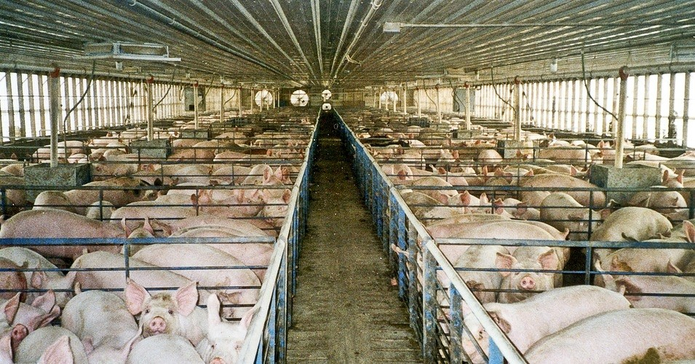

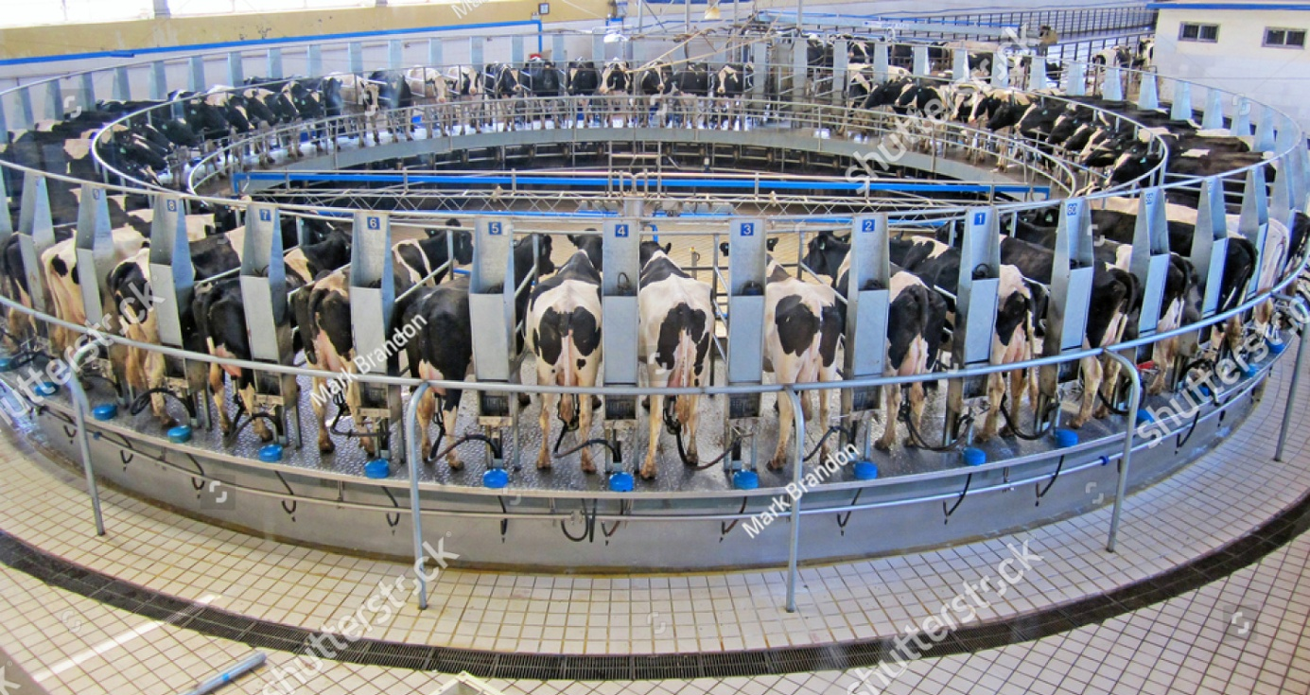

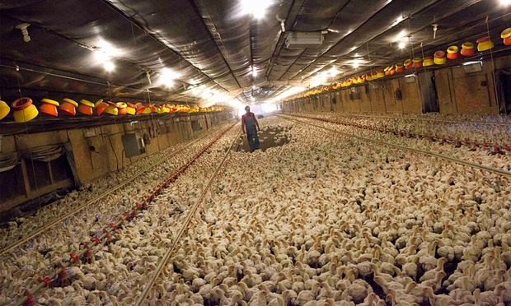

- Watch the video “What is factory farming? US and the planet” and keep notes to answer the questions below. *
https://www.youtube.com/watch?v=7I0v3LhKhQg

- How can eating fewer animal products help save:
  - the planet?
  - food resources?
  - our health?

- Watch the video “Life on a factory farm”. Keep notes and answer the questions below.
https://www.youtube.com/watch?v=oRIvr5aI6bs

- What is life like for animals raised in factory farms? What problems do they face?

- * Watch the video “Why is factory farming such a big deal?” and keep notes to answer the questions below.
https://www.youtube.com/watch?v=GLhjzSm5rG4

- What are the negative effects of factory farming on:
  - the planet?
  - food resources?
  - our health?

Class discussion
- What do you think about factory farming? Justify your opinion.
- What can we do to reduce the negative effects of factory farming?

