C c
Magic Letterland!!!
C_________________________________________________________________________________
c_________________________________________________________________________________
Cc________________________________________________________________________________
cat CAT
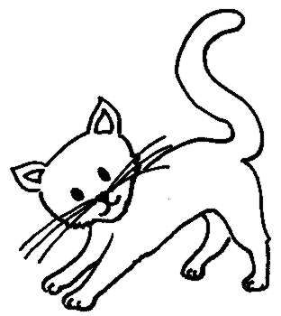
1.______ ___________
2.______ ___________
3.______ ___________
4.______ ___________

5.______ ___________

computer COMPUTER
1.______ ___________
2.______ ___________
3.______ ___________
4.______ ___________
5.______ ___________

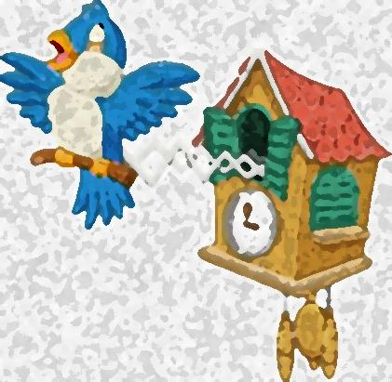
clock CLOCK
1.______ ___________
2.______ ___________
3.______ ___________
4.______ ___________
5.______ ___________
O o
O_________________________________________________________________________________
o_________________________________________________________________________________
Oo________________________________________________________________________________
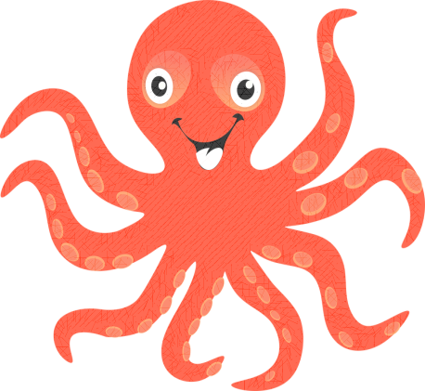
octopus OCTOPUS
1.______ ___________
2.______ ___________
3.______ ___________
4.______ ___________
5.______ ___________

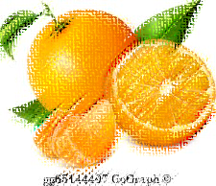
orange ORANGE
1.______ ___________
2.______ ___________
3.______ ___________
4.______ ___________
5.______ ___________

on ON
1.______ ___________
2.______ ___________
3.______ ___________
4.______ ___________
5.______ ___________

A a
A_________________________________________________________________________________
a_________________________________________________________________________________
Aa________________________________________________________________________________

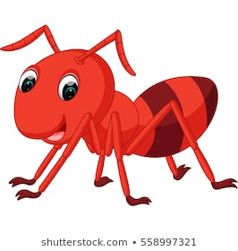
ant ANT
1.______ ___________
2.______ ___________
3.______ ___________
4.______ ___________
5.______ ___________


apple APPLE
1.______ ___________
2.______ ___________
3.______ ___________
4.______ ___________
5.______ ___________

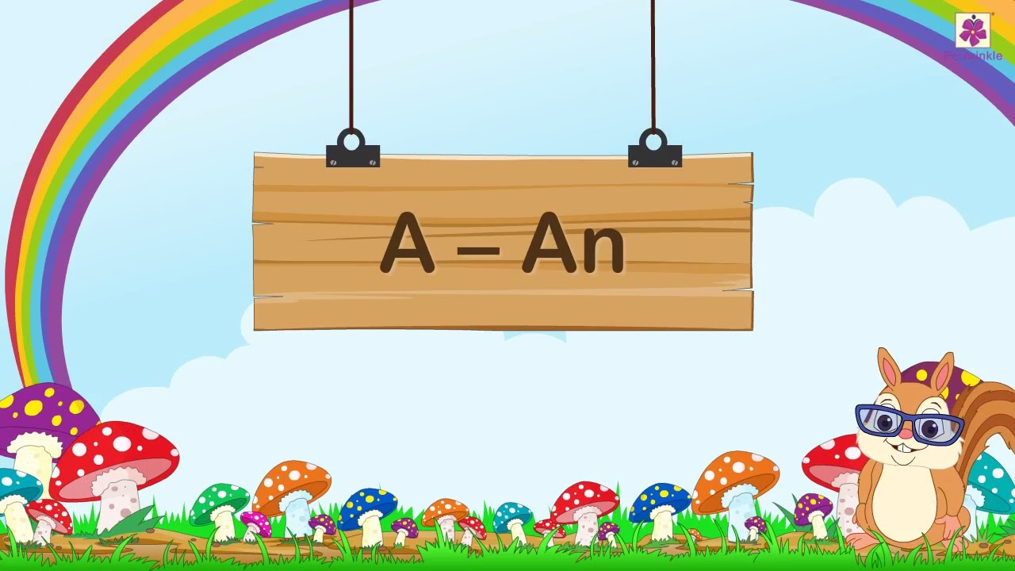
an AN
1.______ ___________
2.______ ___________
3.______ ___________
4.______ ___________
5.______ ___________

B b
B_________________________________________________________________________________
b_________________________________________________________________________________
Bb________________________________________________________________________________
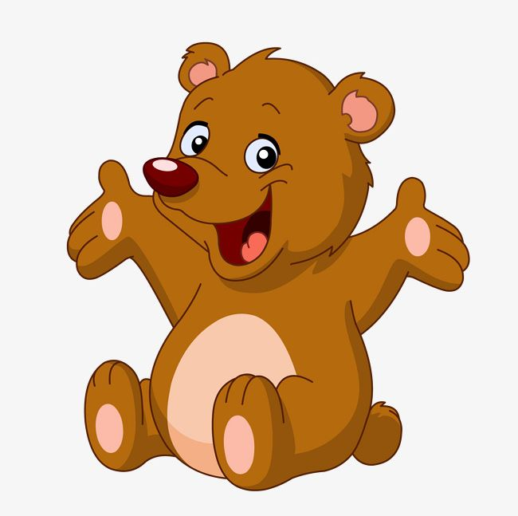
bear BEAR
1.______ ___________
2.______ ___________
3.______ ___________
4.______ ___________
5.______ ___________

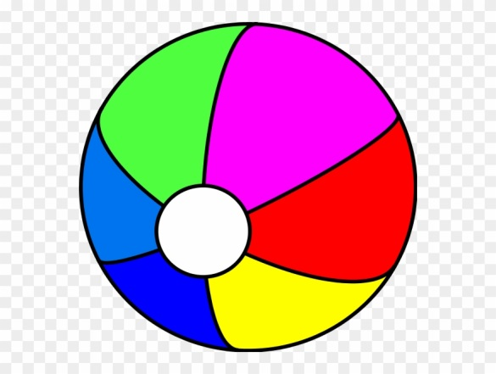
ball BALL
1.______ ___________
2.______ ___________
3.______ ___________
4.______ ___________
5.______ ___________


boom BOOM
1.______ ___________
2.______ ___________
3.______ ___________
4.______ ___________
5.______ ___________

F f
F_________________________________________________________________________________
f_________________________________________________________________________________
Ff________________________________________________________________________________
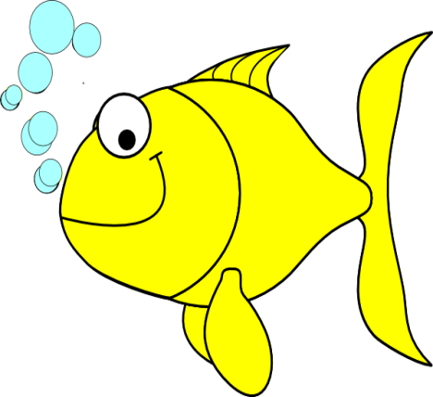
fish FISH
1.______ ___________
2.______ ___________
3.______ ___________
4.______ ___________
5.______ ___________

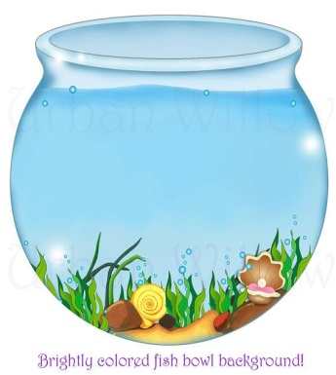
fishbowl FISHBOWL
1.______ ___________
2.______ ___________
3.______ ___________
4.______ ___________
5.______ ___________

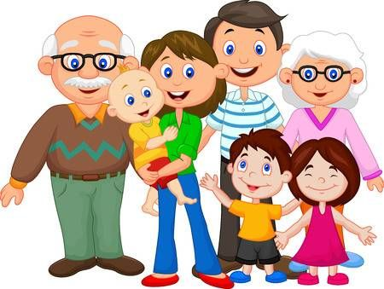
family FAMILY
1.______ ___________
2.______ ___________
3.______ ___________
4.______ ___________
5.______ ___________

H h
H_________________________________________________________________________________
h_________________________________________________________________________________
Hh________________________________________________________________________________
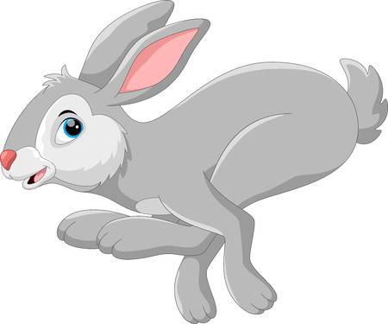
hare HARE
1.______ ___________
2.______ ___________
3.______ ___________
4.______ ___________
5.______ ___________


hat HAT
1.______ ___________
2.______ ___________
3.______ ___________
4.______ ___________
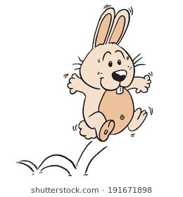
5.______ ___________

hop HOP
1.______ ___________
2.______ ___________
3.______ ___________
4.______ ___________
5.______ ___________

K k
K_________________________________________________________________________________
k_________________________________________________________________________________
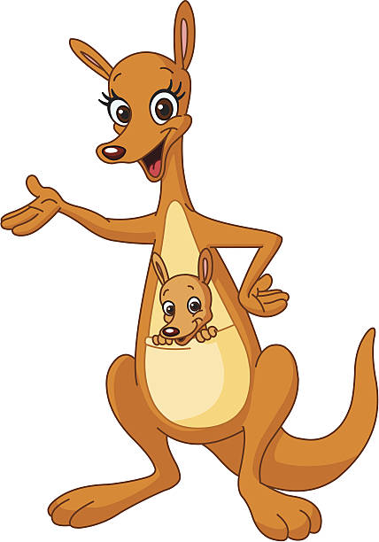
Kk________________________________________________________________________________

kangaroo KANGAROO
1.______ ___________
2.______ ___________
3.______ ___________
4.______ ___________
5.______ ___________


kite KITE
1.______ ___________
2.______ ___________
3.______ ___________
4.______ ___________

5.______ ___________

kick KICK
1.______ ___________
2.______ ___________
3.______ ___________
4.______ ___________
5.______ ___________
L l
L_________________________________________________________________________________
l_________________________________________________________________________________
Ll_________________________________________________________________________________

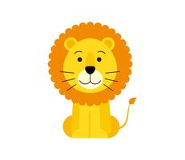
lion LION
1.______ ___________
2.______ ___________
3.______ ___________
4.______ ___________
5.______ ___________

lizard LIZARD
1.______ ___________
2.______ ___________
3.______ ___________
4.______ ___________
5.______ ___________

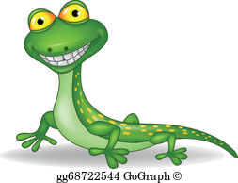

T t
T_________________________________________________________________________________
t_________________________________________________________________________________
Tt________________________________________________________________________________
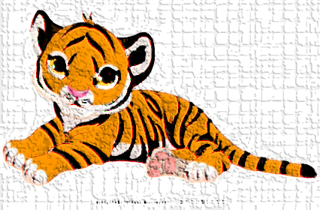
tiger TIGER
1.______ ___________
2.______ ___________
3.______ ___________
4.______ ___________
5.______ ___________


telephone TELEPHONE
1.______ ___________
2.______ ___________
3.______ ___________
4.______ ___________
5.______ ___________



the THE
1.______ ___________
2.______ ___________
3.______ ___________
4.______ ___________
5.______ ___________
D d
D_________________________________________________________________________________
d_________________________________________________________________________________
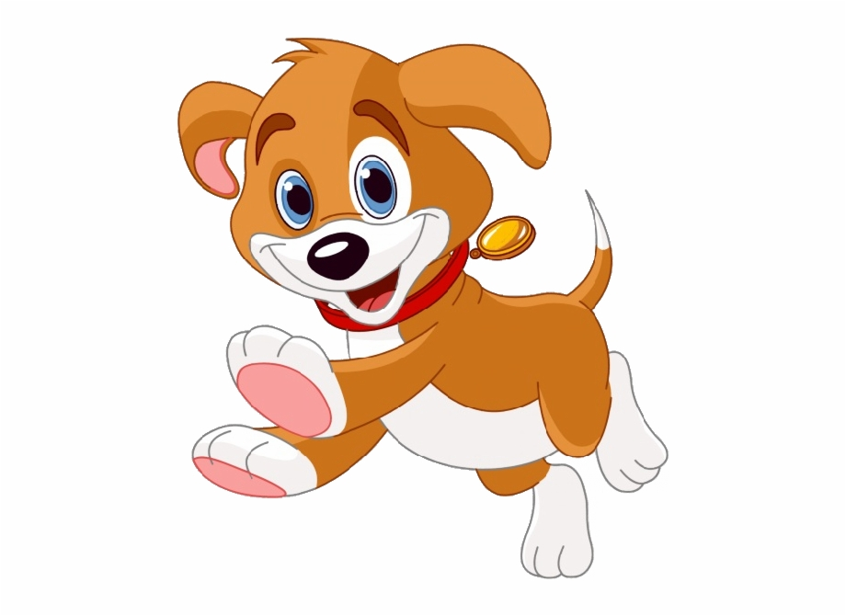
Dd________________________________________________________________________________

dog DOG
1.______ ___________
2.______ ___________
3.______ ___________
4.______ ___________
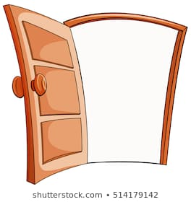
5.______ ___________

door DOOR
1.______ ___________
2.______ ___________
3.______ ___________
4.______ ___________
5.______ ___________

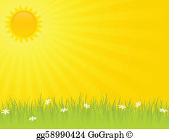
day DAY
1.______ ___________
2.______ ___________
3.______ ___________
4.______ ___________
5.______ ___________

G g
G_________________________________________________________________________________
g_________________________________________________________________________________
Gg________________________________________________________________________________
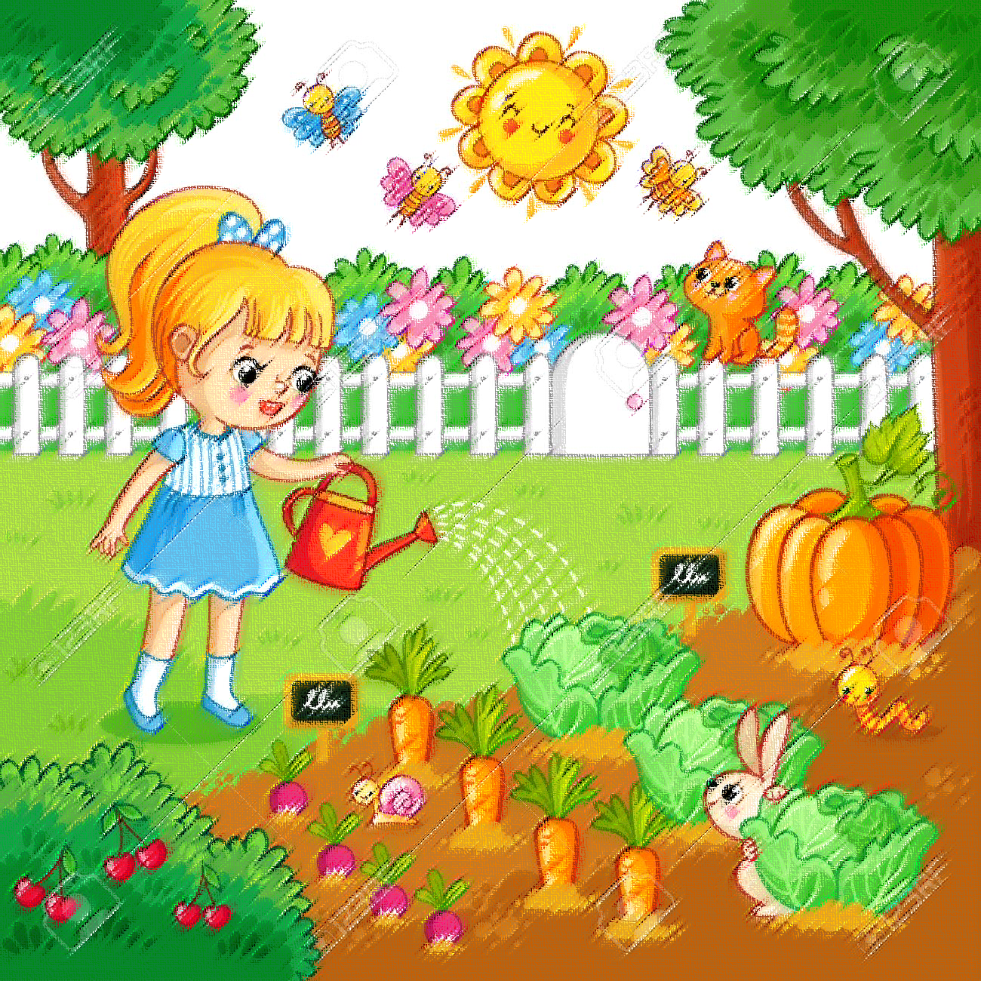
gate GATE
1.______ ___________
2.______ ___________
3.______ ___________
4.______ ___________
5.______ ___________

garden GARDEN
1.______ ___________
2.______ ___________
3.______ ___________
4.______ ___________
5.______ ___________

I i
I_________________________________________________________________________________i_________________________________________________________________________________
Ii_________________________________________________________________________________
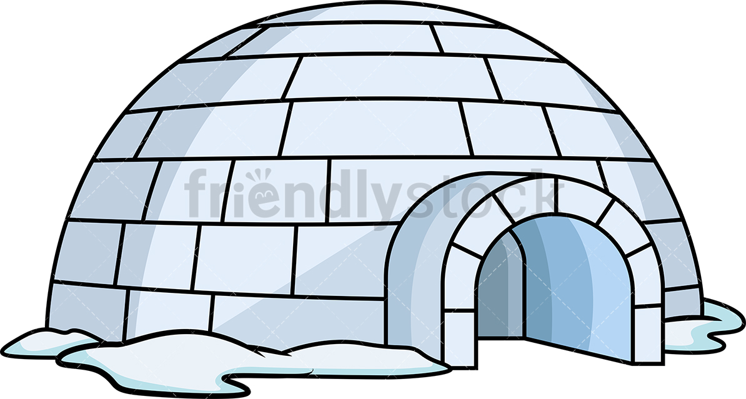

igloo IGLOO
1.______ ___________
2.______ ___________
3.______ ___________
4.______ ___________
5.______ ___________

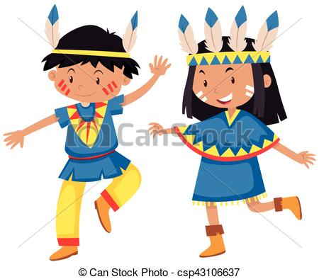
Indian INDIAN
1.______ ___________
2.______ ___________
3.______ ___________
4.______ ___________
5.______ ___________

E e
E_________________________________________________________________________________
e_________________________________________________________________________________
Ee________________________________________________________________________________
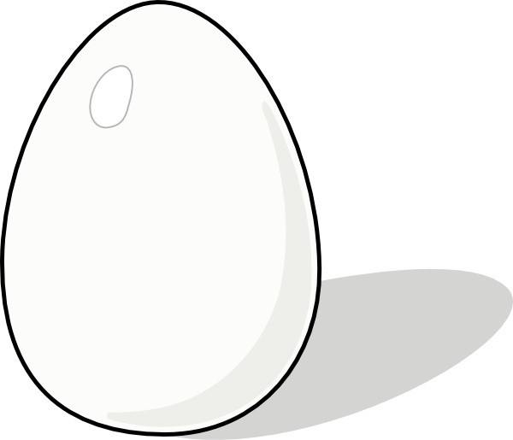
egg EGG
1.______ ___________
2.______ ___________
3.______ ___________
4.______ ___________
5.______ ___________

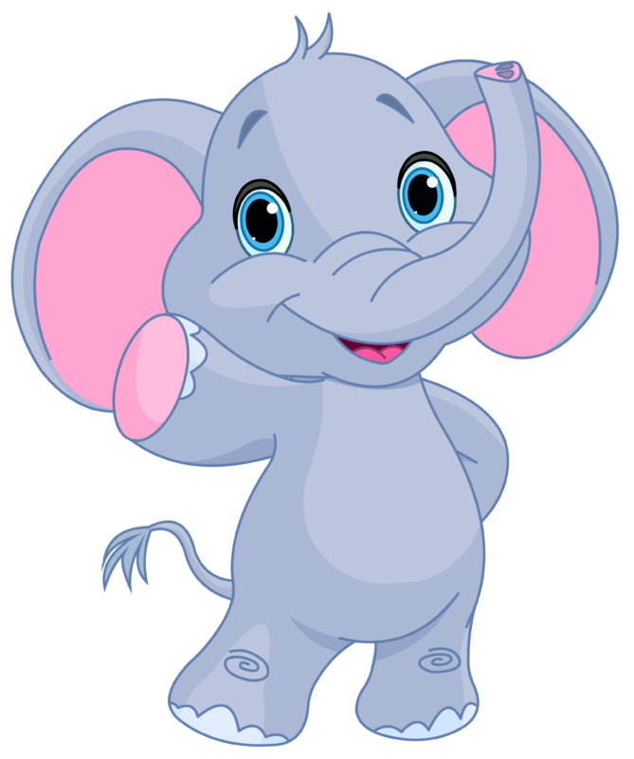
elephant ELEPHANT
1.______ ___________
2.______ ___________
3.______ ___________
4.______ ___________
5.______ ___________

ear EAR
1.______ ___________
2.______ ___________
3.______ ___________
4.______ ___________
5.______ ___________

J j
J_________________________________________________________________________________
j_________________________________________________________________________________
Jj________________________________________________________________________________

jam JAM
1.______ ___________

2.______ ___________
3.______ ___________
4.______ ___________
5.______ ___________

jar JAR
1.______ ___________
2.______ ___________
3.______ ___________
4.______ ___________
5.______ ___________

N n
N_________________________________________________________________________________
n_________________________________________________________________________________
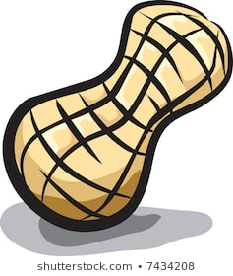
Nn________________________________________________________________________________

nut NUT
1.______ ___________
2.______ ___________
3.______ ___________
4.______ ___________
5.______ ___________

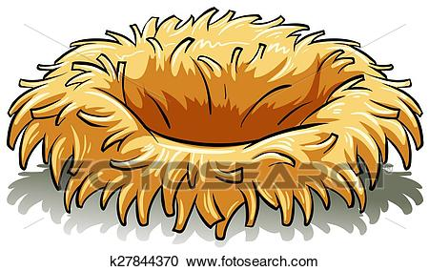
nest NEST
1.______ ___________
2.______ ___________
3.______ ___________
4.______ ___________
5.______ ___________

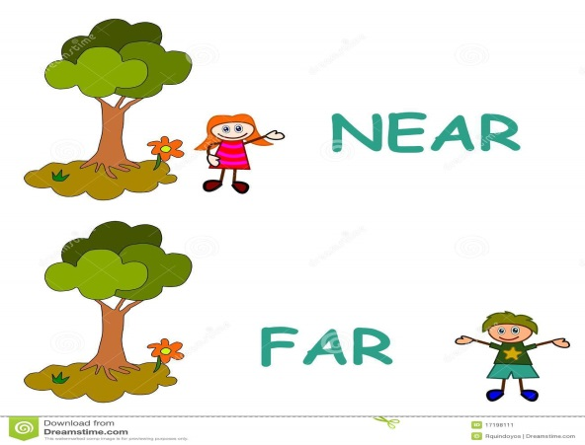
near NEAR
1.______ ___________
2.______ ___________
3.______ ___________
4.______ ___________
5.______ ___________
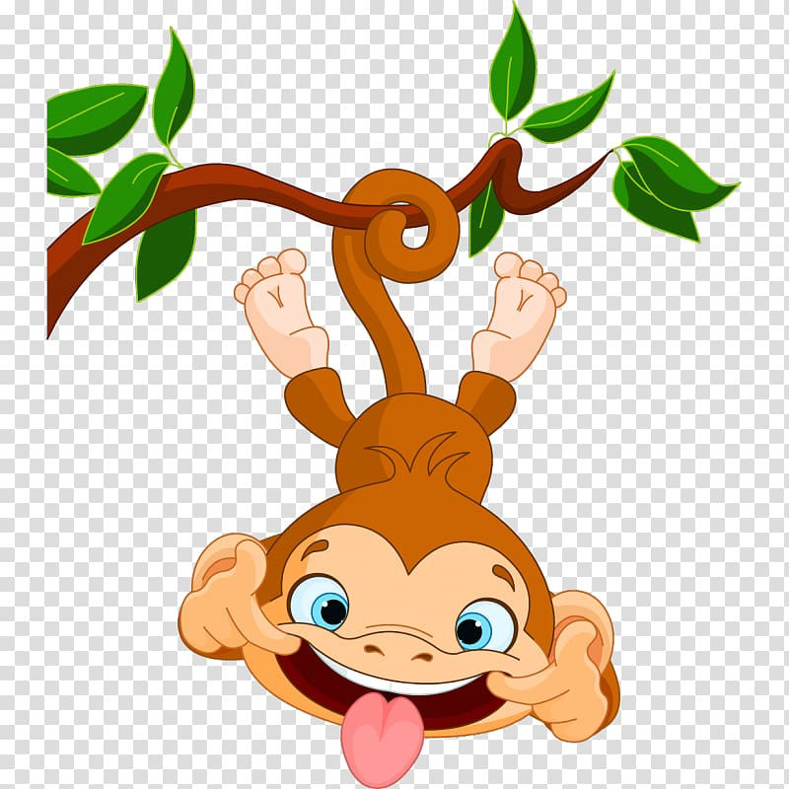
M m
M________________________________________________________________________________
m_________________________________________________________________________________
Mm_______________________________________________________________________________
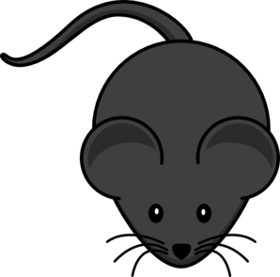
mouse MOUSE
1.______ ___________
2.______ ___________
3.______ ___________
4.______ ___________
5.______ ___________

monkey MONKEY
1.______ ___________
2.______ ___________
3.______ ___________
4.______ ___________
5.______ ___________

mad MAD
1.______ _________
2.______ _________
3.______ _________
4.______ _________
5.______ _________

P p
P_________________________________________________________________________________
p_________________________________________________________________________________
Pp________________________________________________________________________________

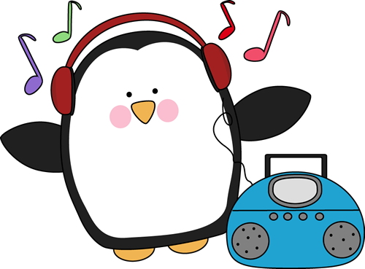
penguin PENGUIN
1.______ ___________
2.______ ___________
3.______ ___________
4.______ ___________
5.______ ___________

park PARK
1.______ ___________
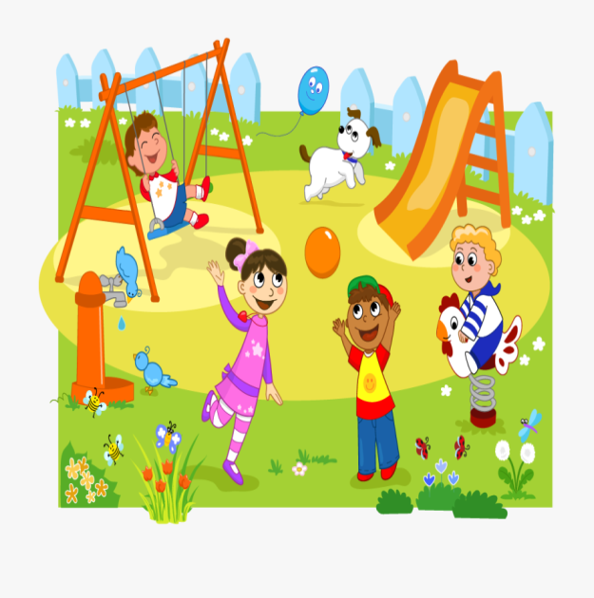
2.______ ___________
3.______ ___________
4.______ ___________
5.______ ___________

play PLAY
1.______ ___________
2.______ ___________
3.______ ___________
4.______ ___________
5.______ ___________

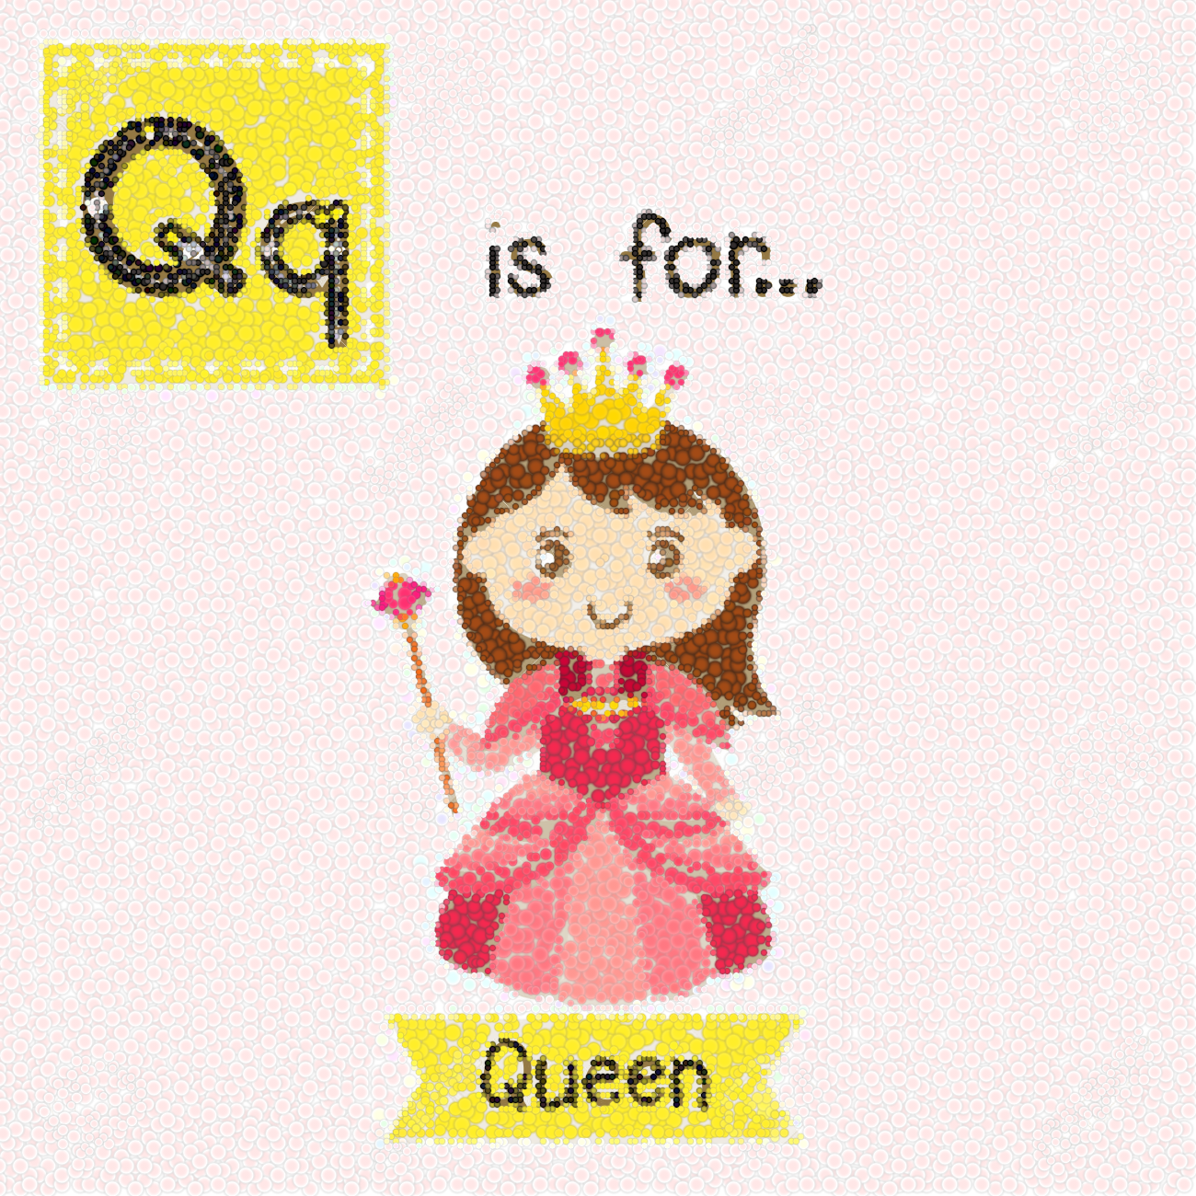
Q_________________________________________________________________________________
q_________________________________________________________________________________
Qq________________________________________________________________________________

queen QUEEN
1.______ ___________
2.______ ___________
3.______ ___________
4.______ ___________
5.______ ___________


quilt QUILT
1.______ ___________
2.______ ___________
3.______ ___________
4.______ ___________
5.______ ___________
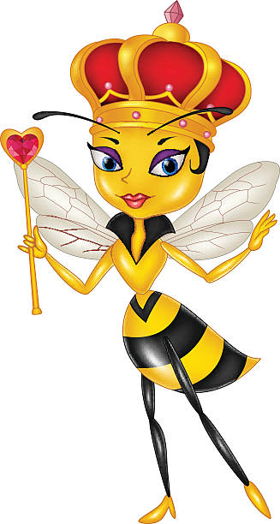

queen bee QUEEN BEE
1.______ ___________
2.______ ___________
3.______ ___________
4.______ ___________
5.______ ___________

R r

R_________________________________________________________________________________
r_________________________________________________________________________________
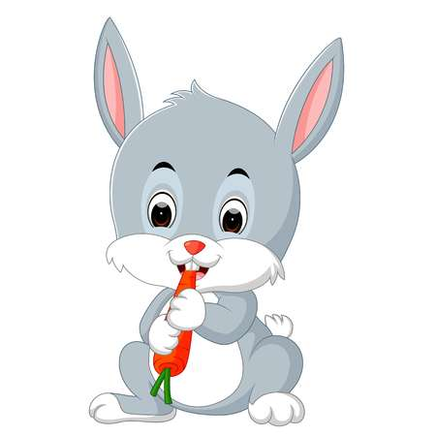
Rr________________________________________________________________________________

rabbit RABBIT
1.______ __________
2.______ ___________
3.______ ___________
4.______ ___________
5.______ ___________

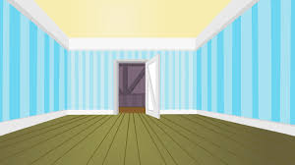
room ROOM
1.______ ___________
2.______ ___________
3.______ ___________
4.______ ___________
5.______ ___________
S s
S_________________________________________________________________________________
s_________________________________________________________________________________
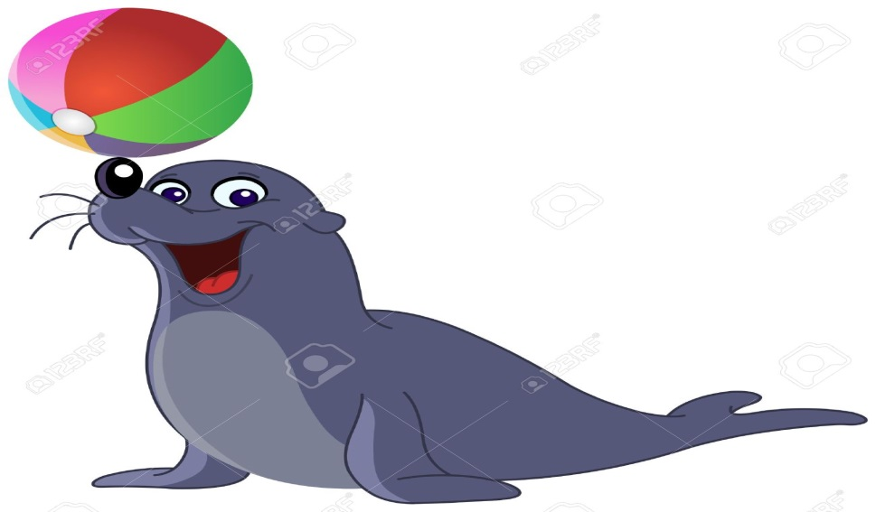
Ss________________________________________________________________________________

seal SEAL
1.______ ___________
2.______ ___________
3.______ ___________
4.______ ___________
5.______ ___________

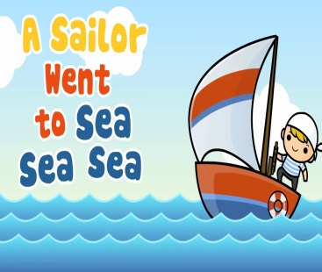
sea SEA

1.______ ___________
2.______ ___________
3.______ ___________
4.______ ___________
5.______ ___________

sing SING
1.______ ___________
2.______ ___________
3.______ ___________
4.______ ___________
5.______ ___________

U u
U_________________________________________________________________________________
u_________________________________________________________________________________
Uu________________________________________________________________________________

umbrella UMBRELLA
1.______ ___________
2.______ ___________
3.______ ___________

4.______ ___________
5.______ ___________

under UNDER
1.______ ___________
2.______ ___________
3.______ ___________
4.______ ___________
5.______ ___________

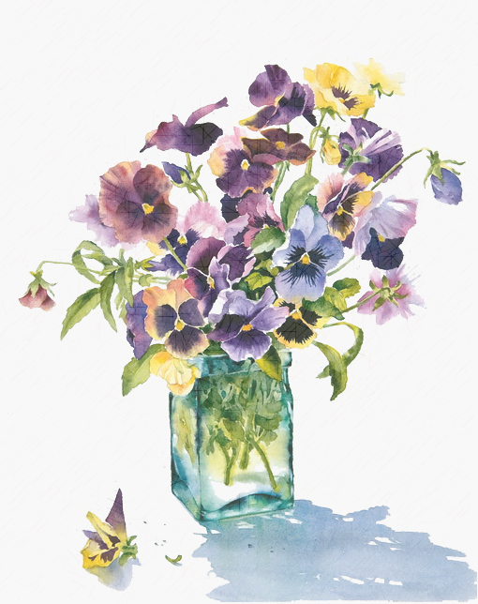
V v
V_________________________________________________________________________________
v_________________________________________________________________________________
Vv________________________________________________________________________________

violet VIOLET
1.______ ___________
2.______ ___________
3.______ ___________
4.______ ___________
5.______ ___________

vase VASE
1.______ ___________
2.______ ___________
3.______ ___________
4.______ ___________
5.______ ___________

velvet VELVET
1.______ ___________
2.______ ___________
3.______ ___________
4.______ ___________
5.______ ___________

W w
W________________________________________________________________________________
w_________________________________________________________________________________
Ww_______________________________________________________________________________

wave WAVE
1.______ ___________
2.______ ___________
3.______ ___________
4.______ ___________
5.______ ___________



window WINDOW
1.______ ___________
2.______ ___________
3.______ ___________
4.______ ___________
5.______ ___________

X x
X_________________________________________________________________________________
x_________________________________________________________________________________
Xx________________________________________________________________________________


fox FOX
1.______ ___________
2.______ ___________
3.______ ___________
4.______ ___________
5.______ ___________

box BOX
1.______ ___________
2.______ ___________
3.______ ___________
4.______ ___________
5.______ ___________

Yy
Y_________________________________________________________________________________
y_________________________________________________________________________________
Yy________________________________________________________________________________
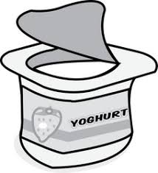
yoghurt YOGHURT
1.______ ___________
2.______ ___________
3.______ ___________
4.______ ___________
5.______ ___________

yellow YELLOW
1.______ ___________
2.______ ___________
3.______ ___________

4.______ ___________
5.______ ___________

yum YUM
1.______ ___________
2.______ ___________
3.______ ___________
4.______ ___________
5.______ ___________

Z z
Z_________________________________________________________________________________
z_________________________________________________________________________________
Zz________________________________________________________________________________

zoo ZOO
1.______ ___________
2.______ ___________
3.______ ___________
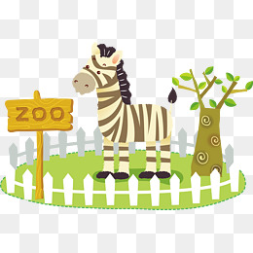
4.______ ___________
5.______ ___________

zebra ZEBRA
1.______ ___________
2.______ ___________
3.______ ___________
4.______ ___________
5.______ ___________

1.Fill in the missing letter!!! (Συμπλήρωσε τα γραμματάκια που λείπουν)

_ at, _ ear, _ nt, _ ctopus,
_all, _ omputer, _ range, _ pple

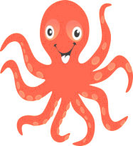
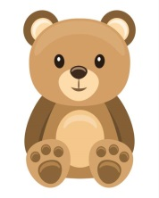
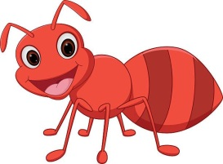

2.Match the words with the pictures (Ένωσε τις λέξεις με τις εικόνες )
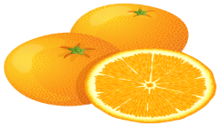
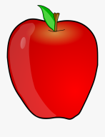
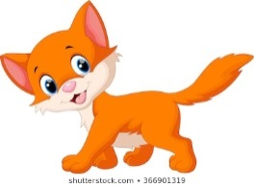

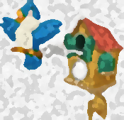
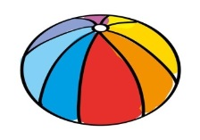
ant, apple, ball, bear, cat, computer, clock

3. Write !!! (Γράψε!!)

cat ……………..
……….. BEAR
octopus …………………
clock …………………….
……………… ORANGE
…………….BALL
computer ……………………..
ant………………….
apple…………………
4. Match!!! (Ένωσε)

c_t
a _pple
b_ll
o _ct_pus
b_ar
e _nt
c_mputer
cl_ck
5. Match!!
h_re
f_sh
a kangar_ _
e f_shbowl
i li_n
o kit_
f_mily
h_t
h_p
l_zard

6. Match!!
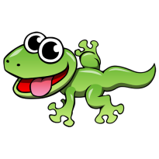
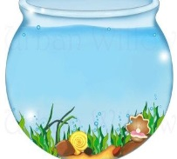
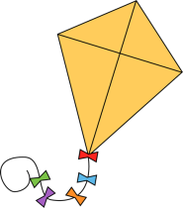
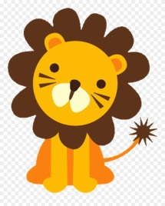
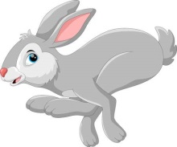
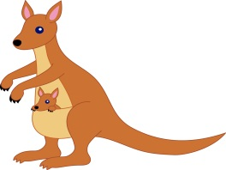
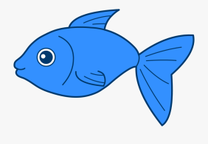

-

fishbowl, fish, hat, lion, kangaroo, kite, lizard, hare
8.Write!!!

hare…………………
……………LION
fish……………….
hat…………………
…………………..KANGAROO
fishbowl………………………..
kite………………………..
……………………….LIZARD

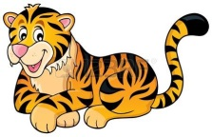
7. Match!!!!

tiger
telephone
dog
door
day
gate
garden
igloo
Indian

8.Fill in!!!
D__
__ g
DOOR
IGLOO
TIGER
GARDEN
INDIAN
TELEPHONE
GATE
DOG
DAY

T __
__ i

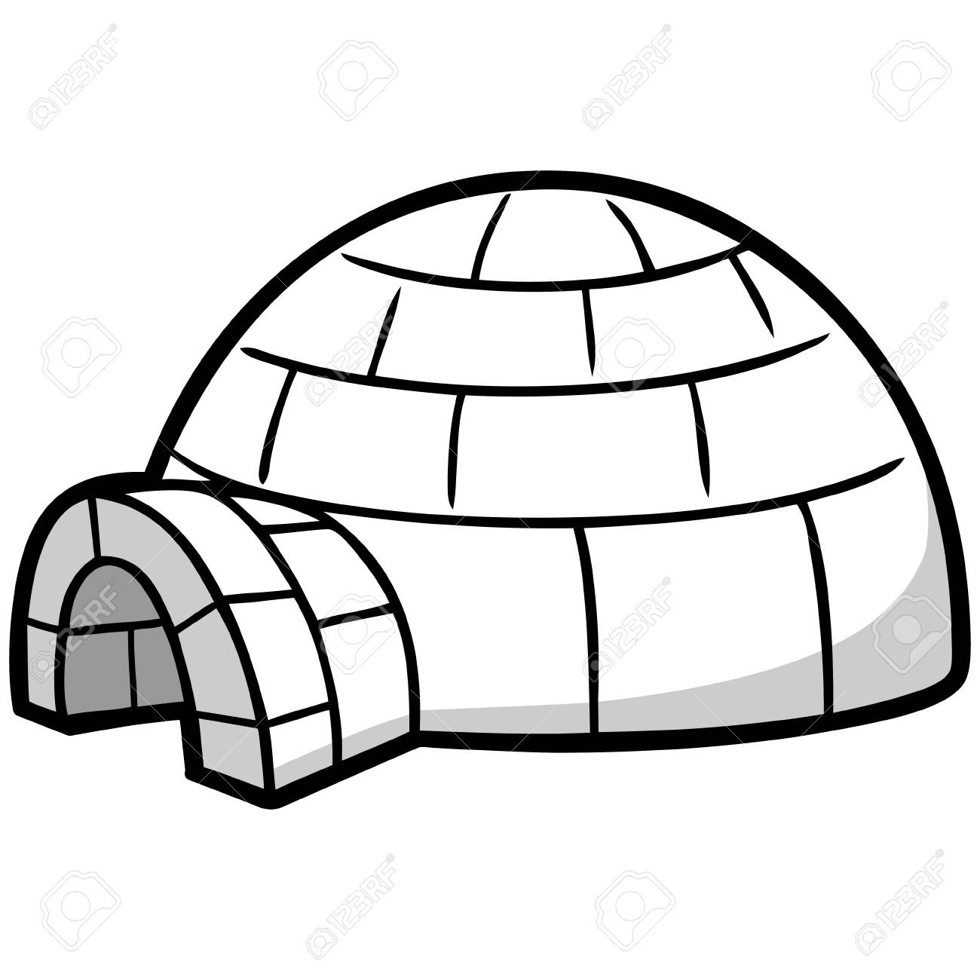
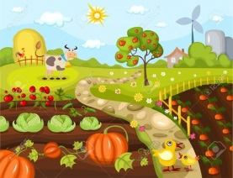
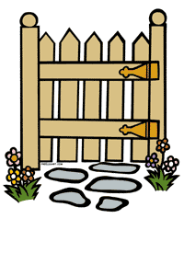
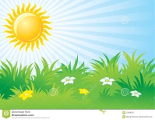

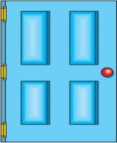
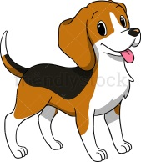
9. Fill in!!!
_ gg
m_use
e_r
_ ar
n_ t
m_nk_y
j_m
_l_phant
n_st
m_d
n_ar

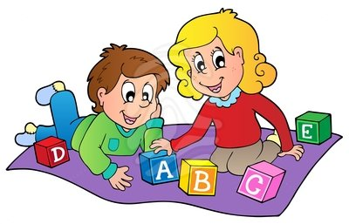

_GG
M_OUSE
E_R
_AR
N_T
M_NK_Y
J_M
_L_PHANT
N_ST
M_D
N_AR

c_t
cl_ck
_ct_pus
a_t
ap_le
or_nge
b_ar
f_sh
_all
h_t
k_te
k_ngar_ _
l_on
li_ard
d_g
t_lephon_
igl_o
g_rden
Ind_an

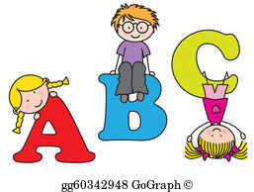


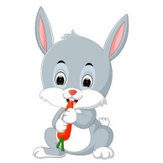

10.Write the words!

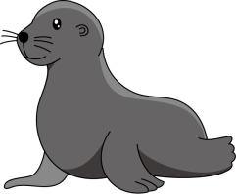
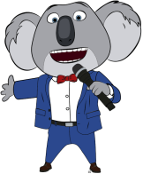

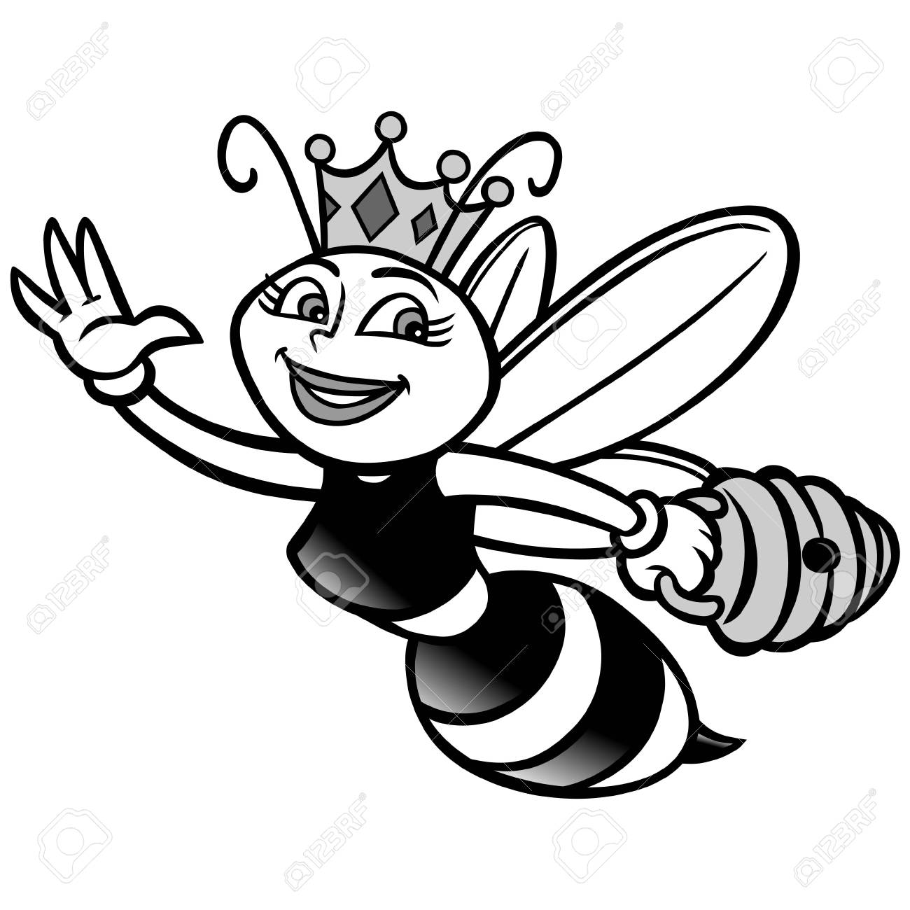
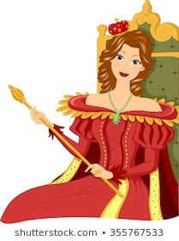
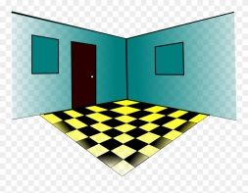

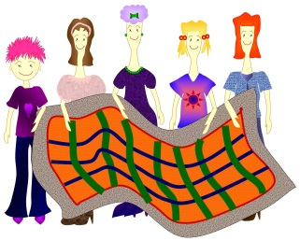

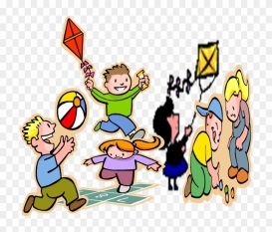
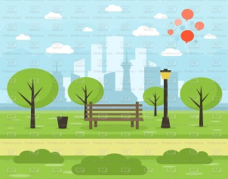

11. Fill in!!!

P __
__ r
Q__
G __
__ s
A __
__ c
O __
B __
__ k
L __
I __
__ n
__ m
F __
H __

J __



12. Match!!

umbrella
under
violet
vase
wave
window
fox
box
yoghurt
yellow
zebra
zoo

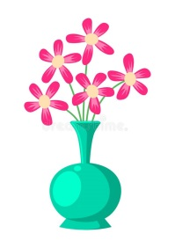
YELLOW
YOGHURT
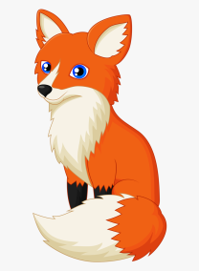
FOX
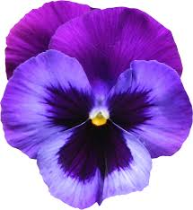
UMBRELLA
WINDOW
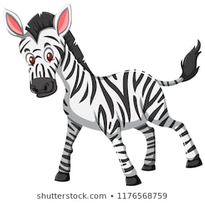
BOX

ZOO
VASE
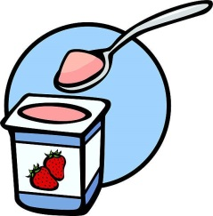
WAVE
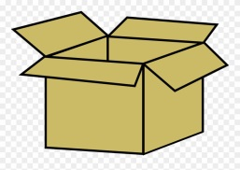
ZEBRA
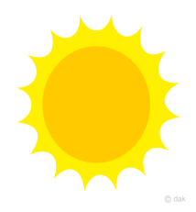
UNDER
VIOLET
