[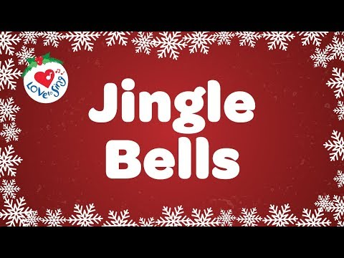](https://www.youtube.com/embed/3CWJNqyub3o?feature=oembed) [Verse 1]   
Dashing through the snow  
In a one-horse open sleigh  
O'er the fields we go  
Laughing all the way  
[Bells on bobtails ring](https://genius.com/13313102/Christmas-songs-jingle-bells/Bells-on-bobtails-ring)  
Making spirits bright  
[What fun it is to ride and sing  
A sleighing song tonight](https://genius.com/27418958/Christmas-songs-jingle-bells/What-fun-it-is-to-ride-and-sing-a-sleighing-song-tonight)  
  
[Chorus]  
[Oh! Jingle bells, jingle bells  
Jingle all the way](https://genius.com/27398212/Christmas-songs-jingle-bells/Oh-jingle-bells-jingle-bells-jingle-all-the-way)  
Oh, what fun it is to ride  
In a one-horse open sleigh, hey  
Jingle bells, jingle bells  
Jingle all the way  
Oh, what fun it is to ride  
In a one-horse open sleigh