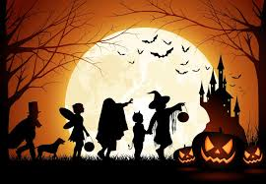
Halloween

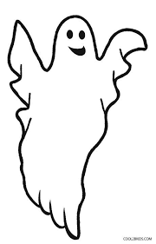
ghost pumpkin witch
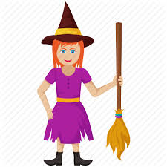
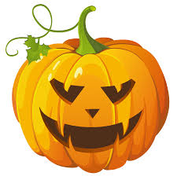

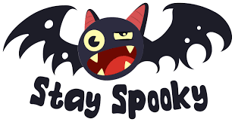
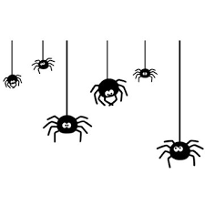
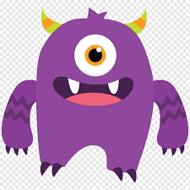
monster spider bat

Five little monsters jumping on the bed
https://video.link/w/8Wrsb

Knock knock, Trick or Treat
https://video.link/w/lVrsb

skeleton dance
https://video.link/w/NWrsb

create
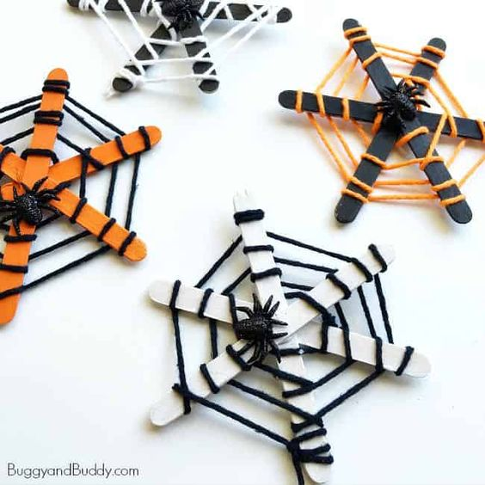

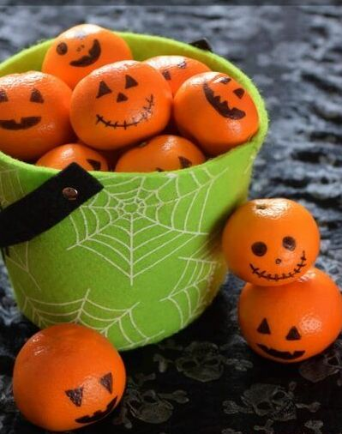
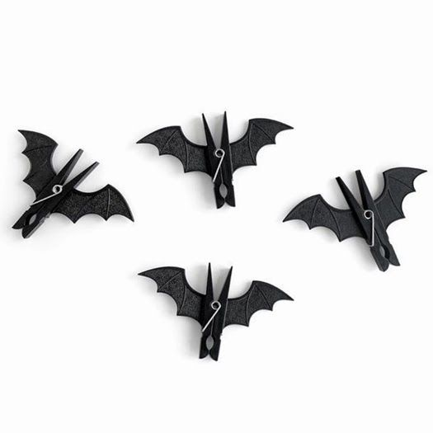
https://conservamome.com/the-best-round-up-of-halloween-toilet-paper-roll-crafts-around/

have a spooky Halloween BOO

