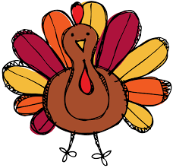
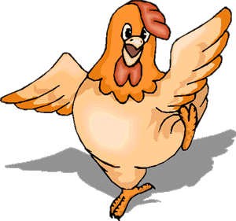
Farm Animals

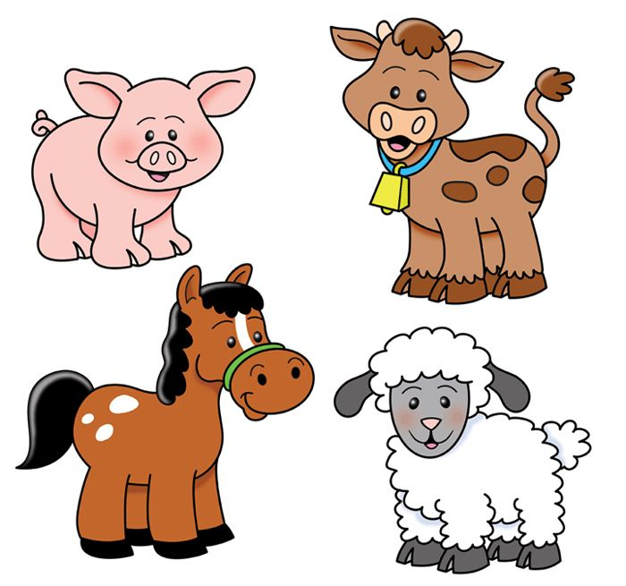

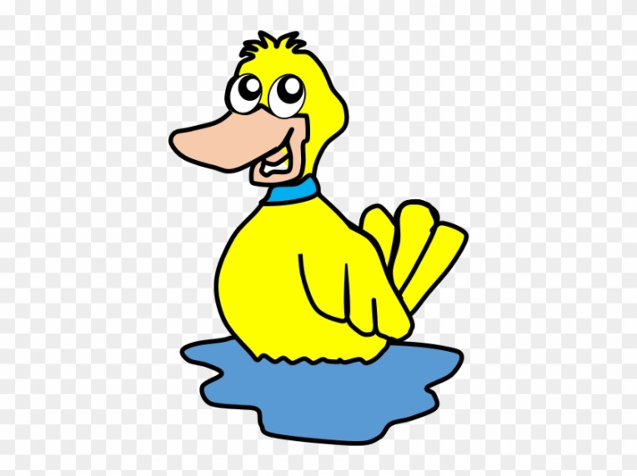

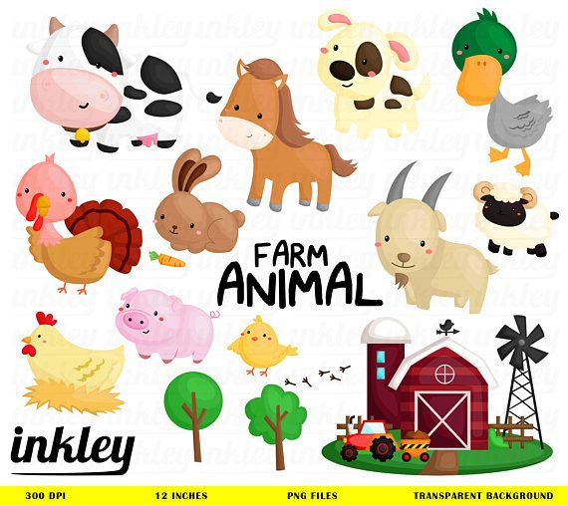

Let’s listen !!!
https://safeYouTube.net/w/BvDhb Old MacDonald
https://safeYouTube.net/w/GyDhb Five little ducks

Homework!!!!
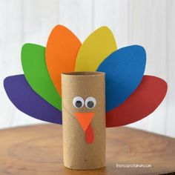
1 ) Make a turkey!!!

2) Make a finger duck-puppet
https://global.cbeebies.com/activities/sarah-and-duck-duck-finger-puppet

3) Colour!!!
