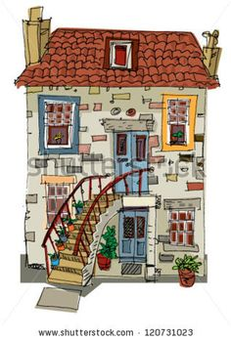
House

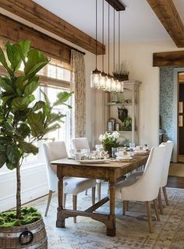
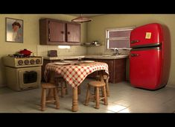
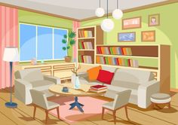
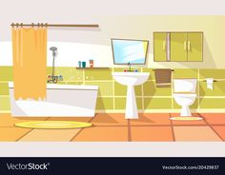
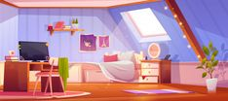

bathroom
bedroom

living room kitchen

dining room

B b

B
_____________________________________________________________
b
______________________________________________________________

bedroom

_________________________________________________________________________

bathroom

H h

H
____________________________________________________________

h
______________________________________________________________

house
__________________________________________________

Now let’s learn some more words!!!
Follow the link: https://video.link/w/3aO0b
Welcome to my house!!! https://video.link/w/kcO0b

Can you remember them??? Let’s play a game
Follow the link https://www.thinglink.com/scene/1385925817464258563
And now it’s your turn!!! https://learnenglishkids.britishcouncil.org/word-games/rooms

More games to play : https://www.learningchocolate.com/content/rooms-house-1

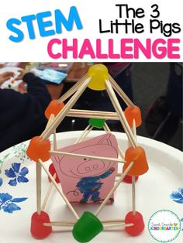
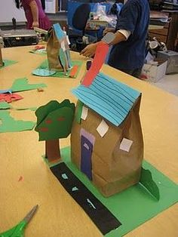
Make your own house:

What is your favourite room in the house? Why? Draw it and show it to me !!
(Ποιο είναι το αγαπημένο σας δωμάτιο στο σπίτι; Γιατί; Ζωγραφίστε το και δείξτε το)

