**Asking for and Giving Directions*: FINDING YOUR WAY IN LONDON***

**I- DRIVING IN LONDON**

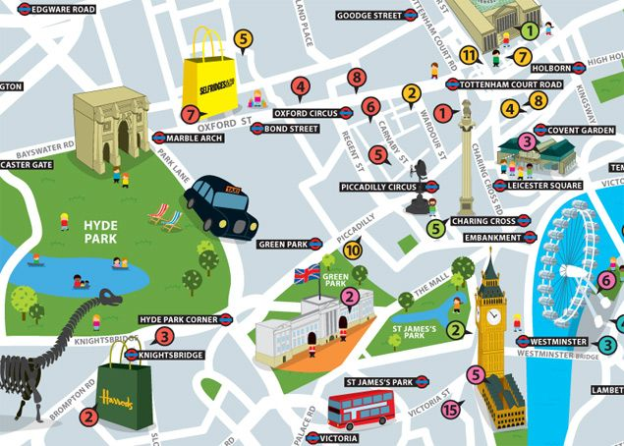

* **Read the directions and guess the place.**

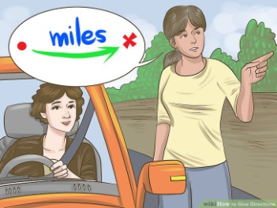**1-** **It's well signposted** as it's one of the most visited attractions of London. **It's situated** **on the South bank** **of** the River Thames. It's **very close to** Westminster Bridge and **not too far away from** the Palace of Westminster. It used to be the world's tallest Ferris Wheel in 2000. It's ______________________.

**2- It's located on** Brampton road in the neighbourhood of Knightsbridge. It's only **a five-minute drive from** the Natural History Museum and **it's less than two miles* away from** Hyde Park. It's the largest department store of London. It's _______________________. * 1 mile ≈ 1.6 km

**3-** You cannot **make a u-turn** on this attraction as it's strictly forbidden. You have to **cross** it if **you are heading South or Northbound.** It's **next to** Westminster Underground Station. It's ______________________.

**4-** It's **a road junction** of London's West End. It is often busy as drivers have to face traffic jams/ tailbacks because it is **the principal artery of the city.** There are many shops and theatres **around** the Shaftesbury Memorial Fountain and the Statue of Anteros. **On the corner of** Shaftesbury Avenue and Glasshouse Street**,** there is a huge advertising display. It's the largest in Europe. It's ____________________________.

**II- WALKING IN LONDON**

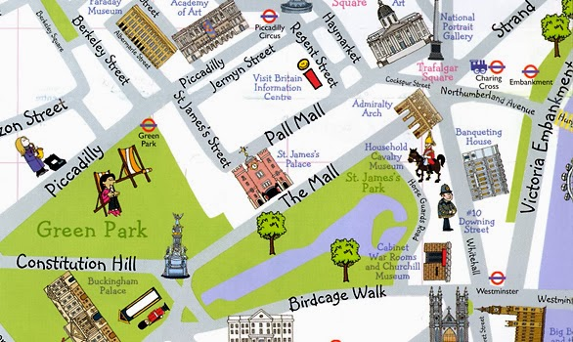

* **Read the dialogue and draw the direction on the map.**

***Tourist:*** Pardon me sir, how do I get to St James's Palace?

***Londoner*:** Let me think...what's the best way? Ok... First, cross Westminster Bridge. Go straight ahead, walk past Westminster Tube Station. Then, continue on Birdcage Walk for a few minutes, when you see the Cabinet War Rooms and Churchill Museum on your right, turn on Horse Guarded Road. It's a narrow road that runs alongside St James's Park. Pass by the Household Cavalry Museum which is on your right. At the next crossing, turn left on the Mall, keep walking for about five minutes, St James's Palace is on your right. It's opposite the park.

***Tourist:*** Thank you so much for your help! Have a good day, sir!

***Londoner:*** My pleasure! Good bye!

* **2-. Guess where the tourist is and where he is heading to. You have just got off the tube station.**

***Tourist:*** Excuse me, sir! Could you help me, please? How do I get to __________ _______?

***Londoner***: Good morning! That's quite easy. Walk straight ahead on the Mall, go through Admiralty Arch, pass St James's Park. Then, you will see the Victoria Memorial at the end of the Mall. It's behind the roundabout and it's near Green Park.

***Tourist***: Thanks.

***Londoner:*** You're welcome! See you!

**Starting point: ________________________ Destination: ________________________**

* **3- Complete the dialogue. You are at the Information Centre and you would like to see Big Ben.**

***Tourist:*** Good ________, madam! I'm really lost. What is the best way to ___ ____ Big Ben?

***The TIC employee:*** Big Ben, well... it's a bit far away from here. You can go there on foot but if I were you I would take the tube.

***Tourist:*** No, it's the rush hour! I don't want to be crammed in the tube. Plus, I don't mind walking.

***The TIC employee:*** All right then! In that case, take a ______when you leave the Tourist Office. As you reach Pall Mall, _______ left and then, turn ______ on Cockspur Street. You will see in the far distance Nelson's Column and the National Portrait Gallery on ______ _____. At the crossroads, take Whitehall Street and carry straight _____. Walk _______ Banqueting House and 10 Downing Street. Cross Westminster Road to head to Big Ben. The Palace of Westminster is ________ Westminster Abbey and ________ the River Thames.

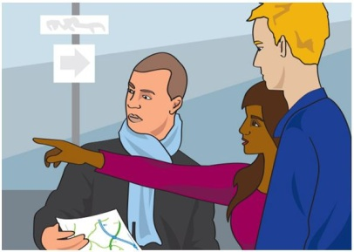***Tourist:*** Can you say that again?!... Actually, I've changed my mind. ______ you tell me the ________ to the closest tube station?

***The TIC employee:*** Sure! when you exit the TIC, turn ____ on Regent Street. Go _____ on for about 2 or 3 minutes _____ to Piccadilly Circus. The underground station is ______the corner.

***Tourist:*** Thanks!Bye!

***The TIC employee:*** Any time! Enjoy your stay in London!

**III- WRITING DIRECTIONS...**



**1-How do I get from the Albert Memorial to Madame Tussaud's?**

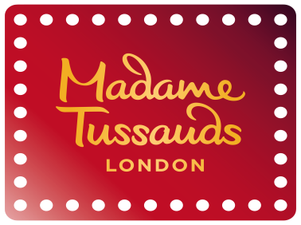__________________________________________________________________________________________________________________________________________________________________________________________________________________________________________________________________________________________________________________________________________________________________________________________________________________________________________________________________

**2- How do I get from Cleopatra's Needle to Battersea Park?**

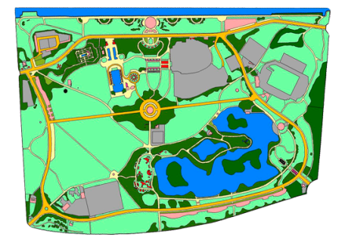__________________________________________________________________________________________________________________________________________________________________________________________________________________________________________________________________________________________________________________________________________________________________________________________________________________________________________________________________

**3-How do I get from the Tower of London to the Imperial War Museum?**

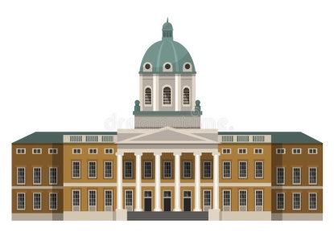__________________________________________________________________________________________________________________________________________________________________________________________________________________________________________________________________________________________________________________________________________________________________________________________________________________________________________________________________

**4-How do I get from Marble Arch to Tate Gallery?**

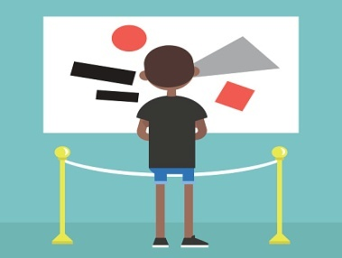__________________________________________________________________________________________________________________________________________________________________________________________________________________________________________________________________________________________________________________________________________________________________________________________________________________________________________________________________

**IV- ASKING FOR AND GIVING DIRECTIONS**

* **Use the same map and work in pairs. One pupil asks for a direction and the other one gives it. When you are done, switch roles. In the boxes below, you will find a few expressions to create your dialogue.**



* **Greetings**

Good morning! Good afternoon! Good evening! Hello!

Thanks! Thank you! Thank you so much for your time! Thanks for your help!

You're welcome! My pleasure! Don't mention it! It was no trouble! No problem!

Good bye! Have a nice day! See you!

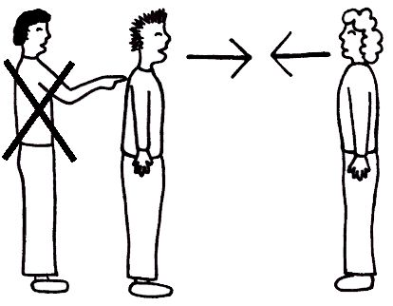

* **Interrupting**

Excuse me! / Sorry to bother you but I'm lost/ Pardon me, could you help me, please?

* **Asking for directions**

I would like to go to... *+ attraction/shop.* Can you tell me that way to get there?

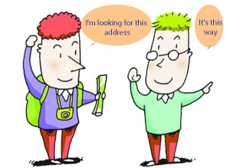I want to visit... *+ attraction/shop.* What is the best way to get there?

How do I get to ... *+ attraction/ shop?*

Where can I find...?

Where is..., please?

* **Giving directions**

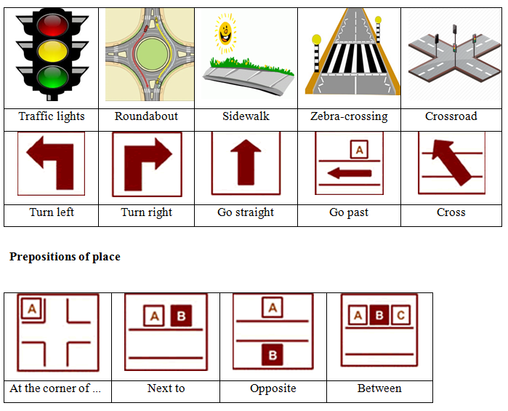

KEY

**Tourist:** Good **morning/afternoon/evening**, madam! I'm really lost. What is the best way to **get to** Big Ben?

**The TIC employee:** Big Ben, well... it's a bit far away from here. You can go there on foot, but if I were you, I would take the tube.

**Tourist:** No, it's the rush hour! I don't want to be crammed in the tube. Plus, I don't mind walking.

**The TIC employee:** All right then! In that case, take a **right** **turn** when you leave the Tourist Office. As you reach Pall Mall, **turn** left and then turn **right** on Cockspur Street. You will see in the far distance Nelson's Column and the National Portrait Gallery on **your left**. At the crossroads, take Whitehall Street and carry straight **on/ahead**. Walk **past** Banqueting House and 10 Downing Street. Cross Westminster Road to head to Big Ben. The Palace of Westminster is **next to** Westminster Abbey and **by** the River Thames.

**Tourist:** Can you say that again?!... Actually, I've changed my mind. **Could** you tell me the **way** to the closest tube station?

**The TIC employee:** Sure! When you exit the TIC, turn **left** on Regent Street. Go **straight** on for about 2 or 3 minutes **until** you reach Piccadilly Circus. The underground station is **around** the corner.

**Tourist:** Thanks! Bye!

**The TIC employee:** Any time! Enjoy your stay in London!

