**UNIT 4 / LESSON 1 Workbook (Key – Λύσεις στο Βιβλίο Εργασιών σελ. 45-46)**

**Activity 1 KEY: Match the animals with the phrases.**

**The mole is eating.**

**The weasel is running. [Example]**

**The mole is drinking.**

**The ant is saving food.**

**The cricket is putting on his jacket.**

**Activity 2 KEY: What are they doing? True or false?**

**1. Captain Cook is sailing. T [Example]**

**2. One Eye is playing. F**

**3. Kelly is opening the box. T**

**4. Kelly is sleeping. F**

**5. Smarty is reading the map. T**

**6. Cole, the mole, is eating. F**

**Activity 3 SCRIPTS: Listen and circle the correct picture.**

**1. [Example] Bread, salami and cheese. (b)**

**2. My tummy is empty.**

**3. This wall is tall.**

**4. This hole is small.**

**5. The cellar is full.**

**1. b [Example]**

**2. b**

**3. a**

**4. b**

**5. b**

**Activity 4 SCRIPTS: Listen and number.**

**1. [Example] Easel the weasel is running. (A)**

**2. Come on Easel join me, please!**

**3. This wall is very tall.**

**4. Cole my friend what are you eating?**

**5. There is bread and ham and cheese.**

**1. A [Example]**

**2. E**

**3. B**

**4. D**

**5. C**

**Activity 5 KEY: Look at the pictures and write.**

**1. bread**

**2. cheese**

**3. salami**

**4. ham**

**5. yoghurt**

**6. pears**

**LESSON 2 (p.47-48)**

**Activity 1 KEY: Match the pictures with the phrases.**

**1. In my cellar someone’s lunching. [Example]**

**2. Easel, the weasel, is licking his lips.**

**3. He is munching, he is crunching.**

**4. Hush, little weasel! Someone is coming.**

**5. Easel is having all the goodies.**

**Activity 2 KEY: Do the crossword.**

**1. sweets**

**2. bacon**

**3. cookies**

**4. chocolate**

**5. lollipops [Example]**

**6. eggs**

**7. chips**

**Activity 3 KEY: Circle the words and write**

**potato [Example], yoghurt, pears, cherries,**

**salami, bread, cheese, ham.**

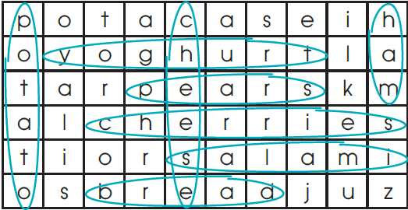

**Activity 4 KEY: Match the pictures with the phrases.**

**1. Run through the hole.**

**2. Save for a rainy day!**

**3. Join me! [Example]**

**4. Nice to meet you!**

**5. Welcome to my house!**

**Activity 5 KEY: Colour the words to find the phrase.**

**The phrase is: time for lunch**

**LESSON 3 (p.49-50)**

**Activity 1 KEY: Match the pictures with the phrases.**

**1. Eat your vegetables and fruit.**

**2. Vegetables and fruit? Yuk!**

**3. Please don’t pout! [Example]**

**4. Look! I’m so fat!**

**5. I’m thin again! I’m out of here!**

**Activity 2 KEY: Look and circle the correct word.**

**1. A tall wall.**

**2. A happy mole.**

**3. A small hole.**

**4. A cold day.**

**5. A thin weasel.**

**6. An empty cellar.**

**Activity 3 KEY: Listen, draw and colour.**

**In my basket, I’ve got green lettuce, yellow**

**cheese, brown nuts, blue berries, red apples and**

**pink lollipops. They’re so yummy! (mole)**

**Activity 4 KEY: Do the crossword.**

**1. pears**

**2. sweets**

**3. bacon**

**4. cherries**

**5. bread**

**6. honey**

**7. chips**

**8. cheese**

**9. ham**

**10. yoghurt [Example]**

**Activity 5 KEY: Do you remember?**

**Monday , Tuesday tasty cherries.**

**Wednesday , Thursday , plums and berries.**

**Friday , and Saturday nuts and honey.**

**Sunday lettuce is so yummy.**

**Eating right can make you happy!**