1. a bowl
2. a jar
3. a can
1. a jug
2. a jar
3. a bottle
1. a bucket
2. a box
3. a bag

1. a bottle
2. a box
3. a can
1. a bunch
2. a branch
3. a piece

1. a packet
2.a bar
3. a box

1. a tin
2. a can
3. a plate
1. a cone
2. a box
3. a carton

1. a slice
2. a piece
3. a packet
1. a bucket
2. a box
3. a barrel

1. a part
2. a piece
3. a slice
1. a bottle
2. a jug
3. a can

1. a box
2. a head
3. a loaf
1. a can
2. a pan
3. a tin

1. a packet
2. a carton
3. a bottle
1. a packet
2. a carton
3. a pan
1. a pot
2. a bag
3. a box

1. a plate
2. a pan
3. a bowl
a cup
2. a mug
3. a glass

1. a cup
2. a mug
3. a glass

1. a jar
2. a mug
3. a jug

1. a roll
2. a packet
3. a box
1. a mug
2. a cup
3. a glass

1. a bowl
2. a packet
3. a basket
Containers:
multiple choice

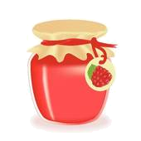
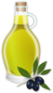
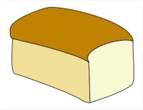
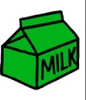
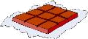
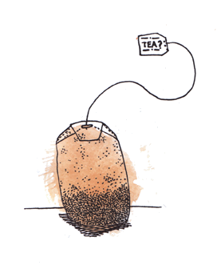
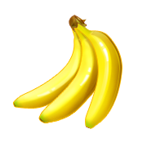
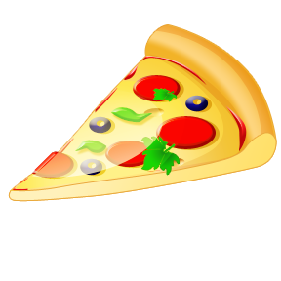
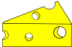
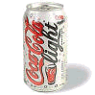
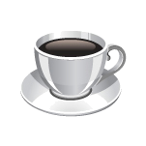
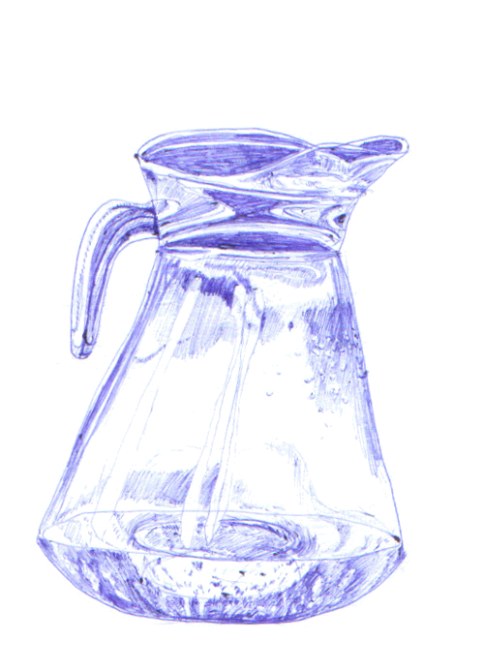
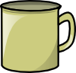
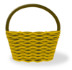
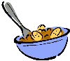
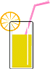
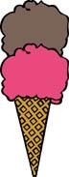
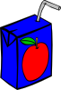
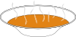
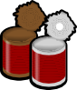
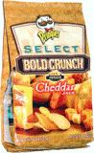
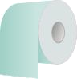
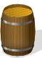
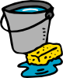

Key:
1. a bowl
2. a jar
3. a can
1. a jug
2. a jar
3. a bottle
1. a bucket
2. a box
3. a bag

1. a bottle
2. a box
3. a can
1. a bunch
2. a branch
3. a piece

1. a packet
2. a bar
3. a box

1. a tin
2. a can
3. a plate
1. a cone
2. a box
3. a carton

1. a slice
2. a piece
3. a packet
1. a bucket
2. a box
3. a barrel

1. a part
2. a piece
3. a slice
1. a bottle
2. a jug
3. a can

1. a box
2. a head
3. a loaf
1. a can
2. a pan
3. a tin

1. a packet
2. a carton
3. a bottle
1. a packet
2. a carton
3. a pan
1. a pot
2. a bag
3. a box

1. a plate
2. a pan
3. a bowl
a cup
2. a mug
3. a glass

1. a cup
2. a mug
3. a glass

1. a jar
2. a mug
3. a jug

1. a roll
2. a packet
3. a box
1. a mug
2. a cup
3. a glass

1. a bowl
2. a packet
3. a basket

