COUNTRY:
Capital:
Borders:
Terrain:

Famous people:

Other (wildlife, traditions etc):
COUNTRY:
Capital:
Borders:
Terrain:

Famous people:

Other (wildlife, traditions etc):
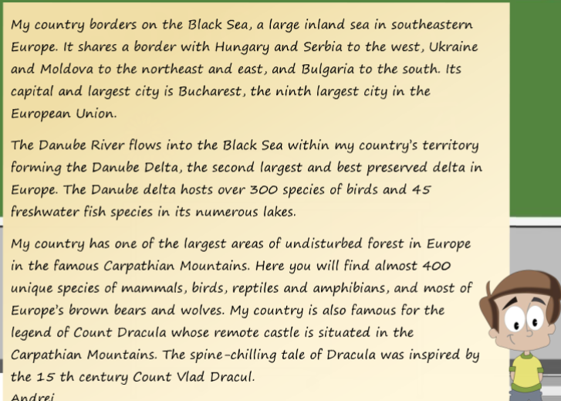
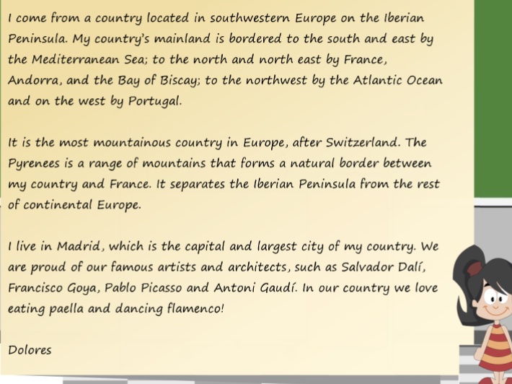
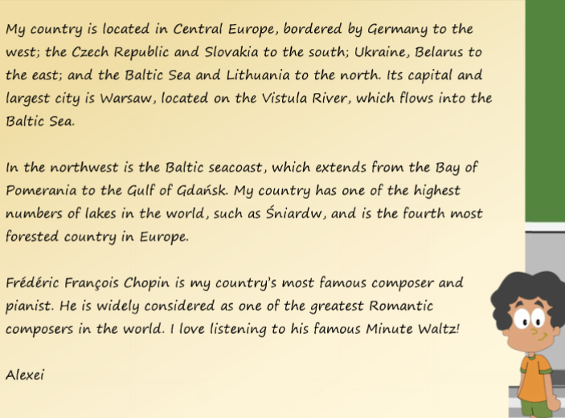
COUNTRY:
Capital:
Borders:
Terrain:

Famous people:

Other (wildlife, traditions etc):

