**Many people like baseball in the USA. There are 9 players in a baseball team. They play baseball with a long bat and a small, hard ball. The players wear baseball caps or helmets, gloves, shirts, pants and shoes.**

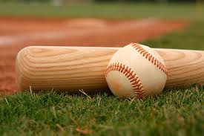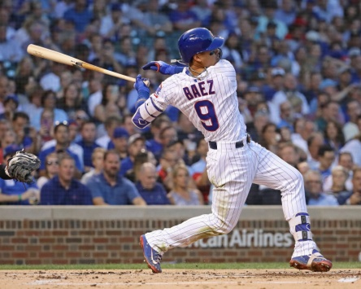

**Many people like rugby in Great Britain. There are 13 or 15 players in a team. They play rugby with a large oval-shaped ball. The players wear rugby shirts, shorts and rugby shoes.**

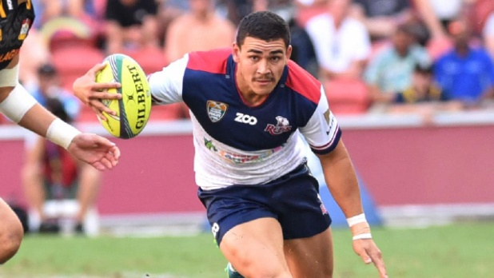

**Many people like cricket in Britain. They go to a cricket match between April and September. There are eleven players in a cricket team. They play cricket with a cricket bat and a leather ball. The players wear cricket caps, protective gear, white shirts and long trousers.**

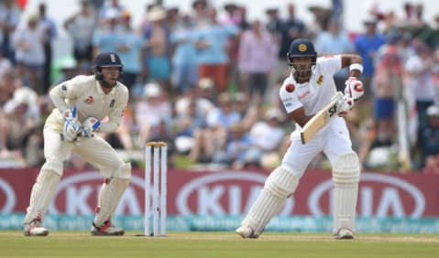 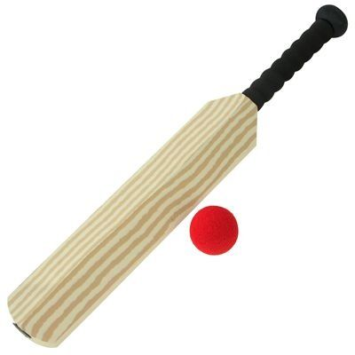

**Many people like field hockey in Britain. There are eleven players in a hockey team. They play hockey with a small white ball and a wooden hockey stick. The players wear shorts, a T-shirt and shoes.**

 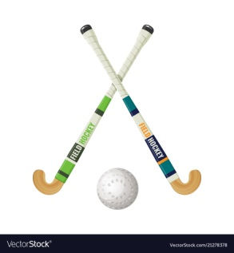

**Many people like taekwondo in Korea.. Taekwondo means “the art of hands and feet” in Korean. The players wear a white uniform and a belt and they blow each other’s head or body with their foot or fist.**

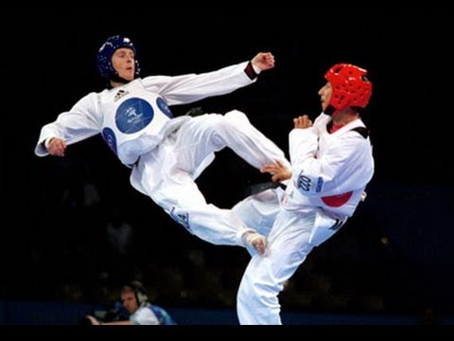

**What sports are popular in your country?**

**Name 3 team games. Where are they played? What equipment do you need?**

**Many people like __________ in Greece.____________________________________________________________________________________________________________________________________________________________________________________________________________________________________________________________________________________**