Adverbs of frequency
Επιρρήματα συχνότητας

Activity A: Grammar (S.B. p. 32, Activity F)
They answer the question: How often?
Απαντούν στην ερώτηση: Πόσο συχνά;
- How often do you play tennis? I sometimes play tennis.
- How often do you go to the park? I usually go there.
Τα κυριότερα επιρρήματα συχνότητας είναι:
never | ποτέ | always | πάντα
rarely | Πολύ σπάνια | usually | συνήθως
seldom | σπάνια
occasionally | Πότε-πότε, περιστασιακά | generally | γενικά
sometimes | μερικές φορές | often | συχνά

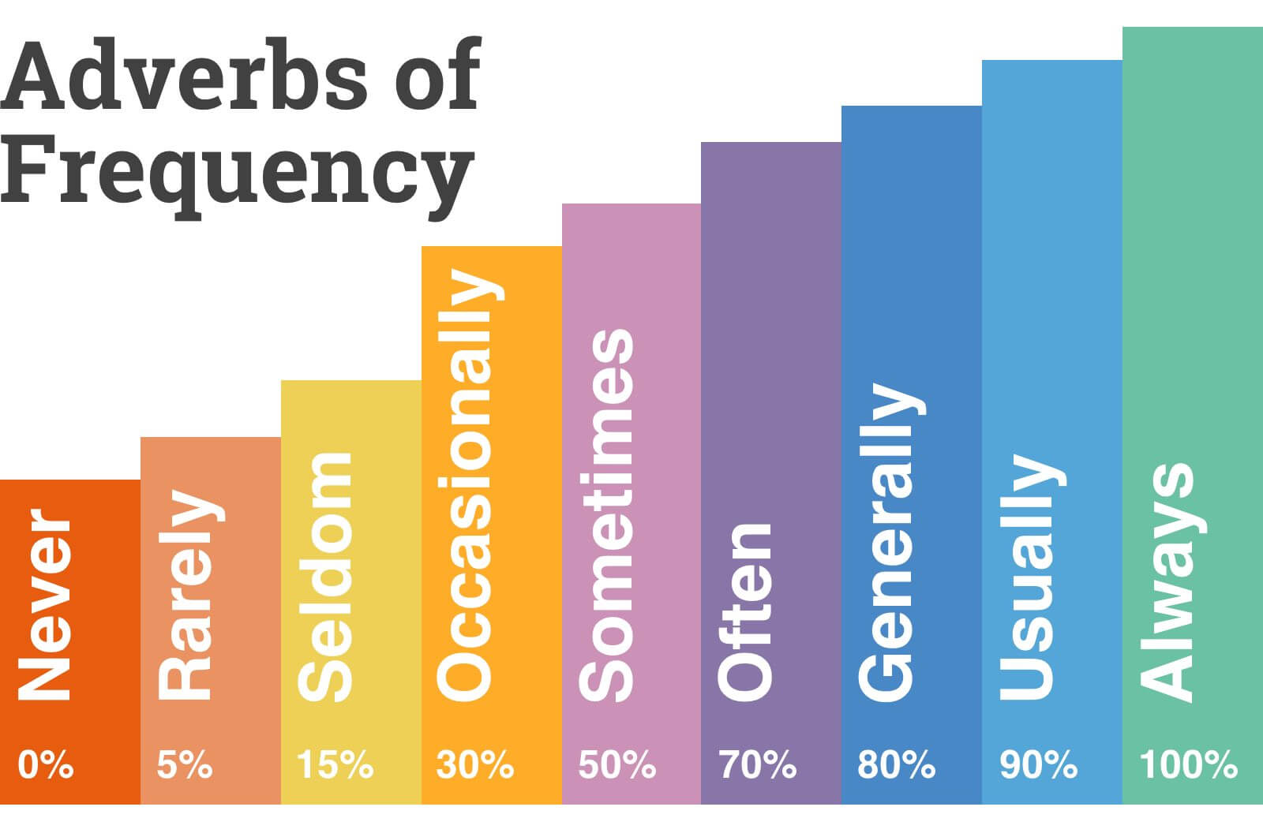

They go before the main verb.
- Πριν το κύριο ρήμα
He never eats any sweets.
But after auxiliary and modal verbs (to be, have, do, can, could, may, might, must, will, would, should…)!
- Αλλά μετά τα βοηθητικά όπως το ρήμα to be !
She is often late for school.
He doesn’t always wake up late.
Activity B: Grammar
Please write the sentences again in your grammar notebook putting the adverbs in the correct place.
He eats fish. (sometimes)

Harry can do magic tricks. (rarely)
_________________________________________________________
They travel to an island in the summer. (usually)
__________________________________________________________
Mary and Jane are bored. (often)

The children decorate a Christmas tree at school. (always)
___________________________________________________________
Activity C: Bonus games!
activity Game 1, Game 2

Activity D: Writing
Please answer the questions using full answers. Write them in your writing notebooks and we will discuss them on our online lesson next time.
How often do you brush your teeth?
___________________________________________________________
How often do children from your class play games during the break?

How often do you go on holidays at Christmas?
___________________________________________________________
How often does your English teacher give you homework?
___________________________________________________________

See you soon!


