Unit 6.3: Self-assessment test

Activity A: Grammar Activity
Please, go to S.B. p. 84C Comparative or Superlative of adjectives.

Activity B: Revision of grammar
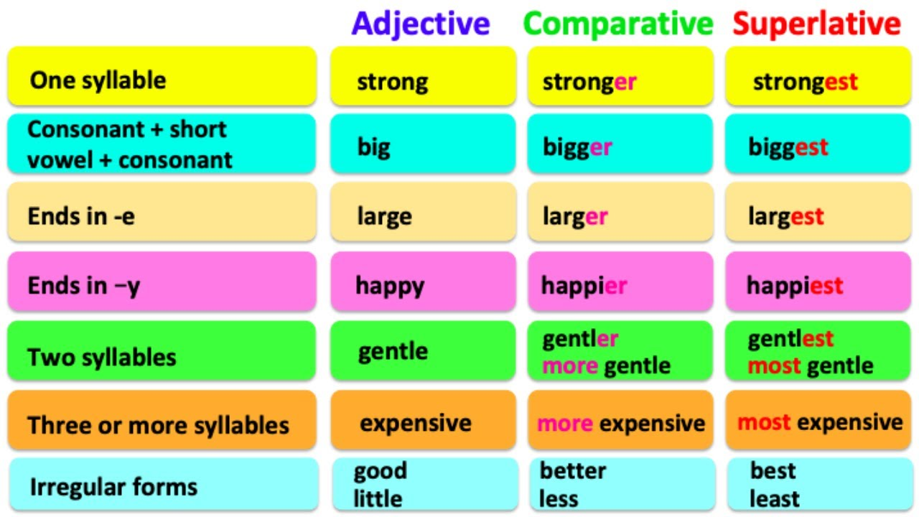
Ψηφιακός πόρος: LearnEasyEnglish

Activity C: Speaking (p.81)
Activity D: Extra material
First, we can try to do the listening. The adjectives are in red in the subtitles!
Gap-fill writing
Multiple choice
Activity E: Bonus material

Game 1 word game
Game 2 sentence game

Ψηφιακός πόροι: https://learnenglishteens.britishcouncil.org
https://learnenglishkids.britishcouncil.org

See you soon!



ANSWERS p. 84C
- prettier
- the fastest
- healthier/more healthy
- better
- more
- the heaviest
- bigger
- more comfortable
- the most untidy
- worse
- the longest
- more difficult more interesting
- the coldest

