UNIT 4.2 & 4.3: Feelings & a Christmas song!

ACTIVITY A: Verbs of senses (Ρήματα αισθήσεων) and feelings
Please, go to S.B. p.55. You can write the new words in your Vocabulary notebook.
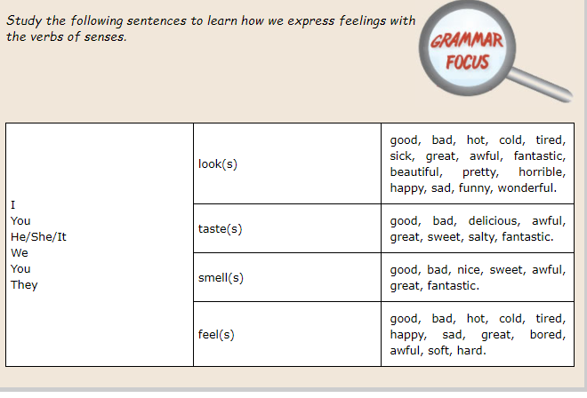
VOCABULARY
horrible | ≠great, απαίσιος  τρομακτικός
awful | ≠wonderful απαίσιος
wonderful | θαυμάσιος
sick | άρρωστος
delicious | very tasty,  πολύ νόστιμο
salty | full of salt, αλμυρό
bitter | ≠sweet ,πικρός
sour | ξινό
soft | απαλός
tired | κουρασμένος
taste | 1.έχω τη γεύση 2.δοκιμάζω φαγητό

Grammar rule (S. B. p.155): Verbs of senses: look, smell, taste, sound, feel
- They are stative verbs (no continuous tense). Το look με την έννοια του φαίνομαι, όχι κοιτάω.
e.g. That Christmas tree looks great!
BUT: He is looking at the tree.
- They are followed by adjectives, not adverbs!
Ακολουθούνται από επίθετα, όχι επιρρήματα.
e.g. It sounds good. (Ακούγεται καλό.)

If you want you can try this : A crossword

ACTIVITY B: Christmas song and games
Let’s sing a song! The book’s version, first! S.B. p.58

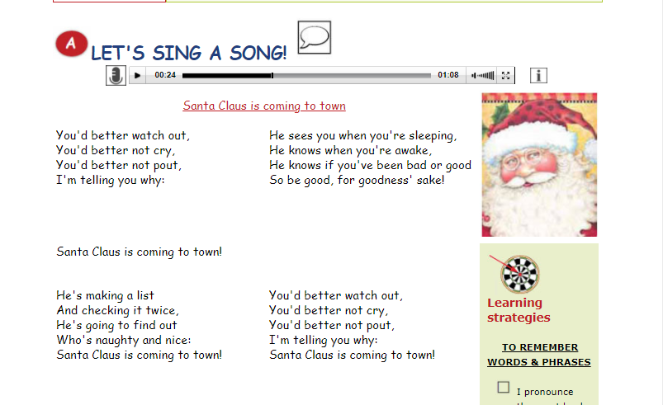
Santa Claus is coming to town
Christmas matching game and song


Thank you! See you soon!

