Happy Easter to all of you!

Activity A: Easter wishes padlet
Optional –if you want! Προαιρετικό!

Activity Β: answers for Activity Book
Kahoot game
If you want you can play the kahoot about famous people of the past, again!
A.B. p. 44 Act. C & D
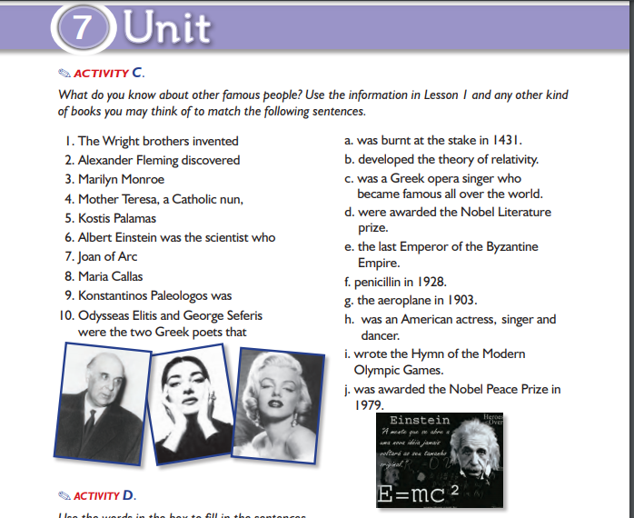

- g 2. f 3. h 4. j 5.i
6. b 7. a 8. c 9.e 10. d

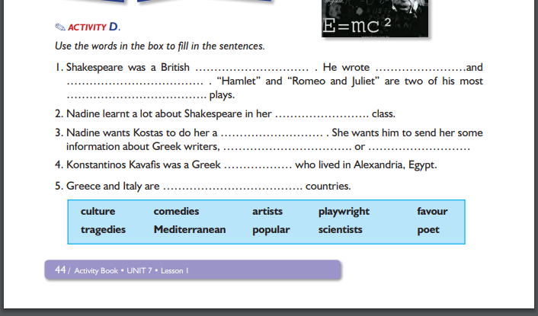

Do a favour= κάνω χάρη
Culture= πολιτισμός, κουλτούρα

- playwright tragedies
comedies popular
- culture
- favour artists scientists
- poet
- Mediterranean

Activity C: Homework
Revision (after Easter)
S.B. p. 162 be- leave
To learn and have fun, try playing the game I created for you!
Simple Past Quizlet game!

Προφορά κατάληξης -ed

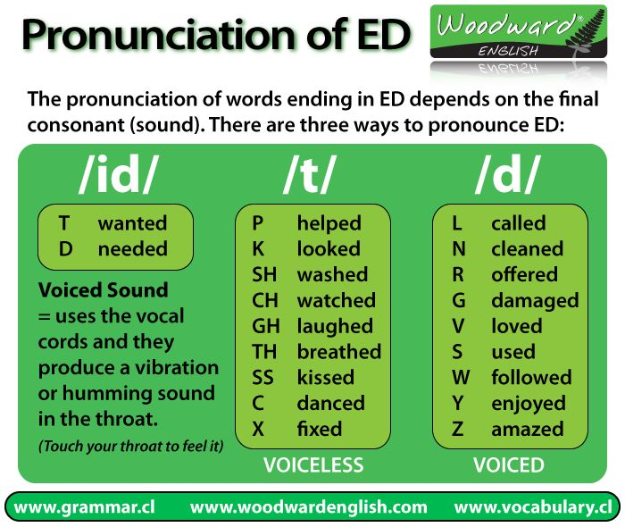

Activity D: Art time!

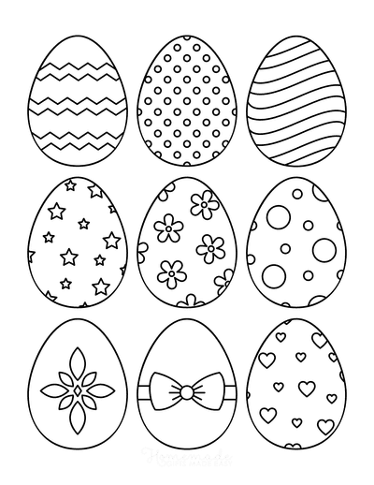

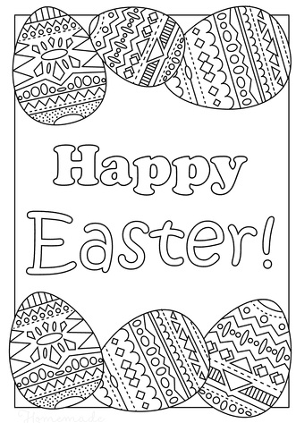

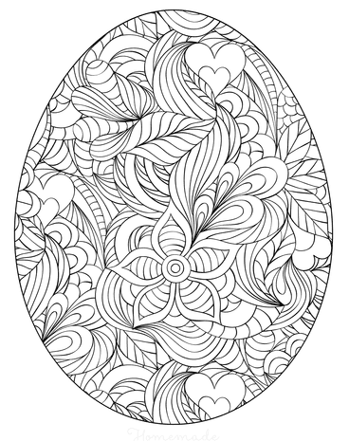
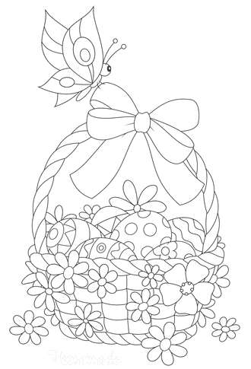

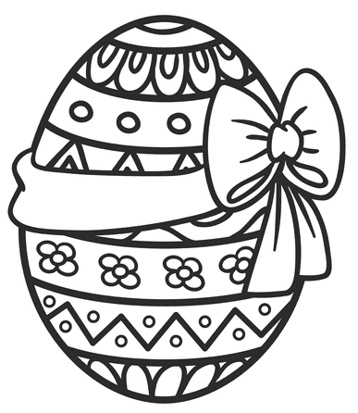

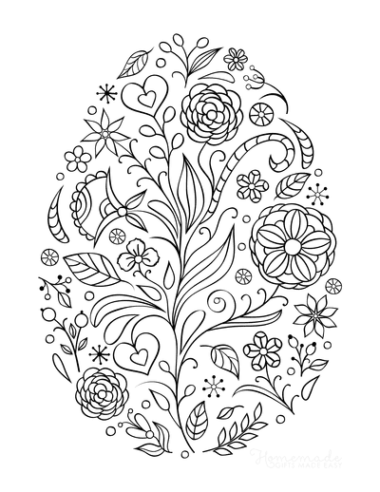

Happy Easter!

