7.1: Going back in time!

Activity A: Irregular Verbs W.B. p. 42
Please, check again the Irregular Verbs table S.B. p. 162
PRESENT SIMPLE | PAST SIMPLE
start | started
am, are, is | Was, were
go | went
cry | cried
study | studied
stop | stopped
enjoy | enjoyed
have | had
give | gave
die | died
live | lived
love | loved
paint | painted
discover | discovered
write | wrote
meet | met
hate | hated
kill | killed
become | became
know | knew

Activity B: Part B- W.B. p. 42 Homework!
Use the above verbs to fill in the sentences.
- Who discovered Australia? Captain Cook.
- Marie Curie was Polish. She was born in 1867.

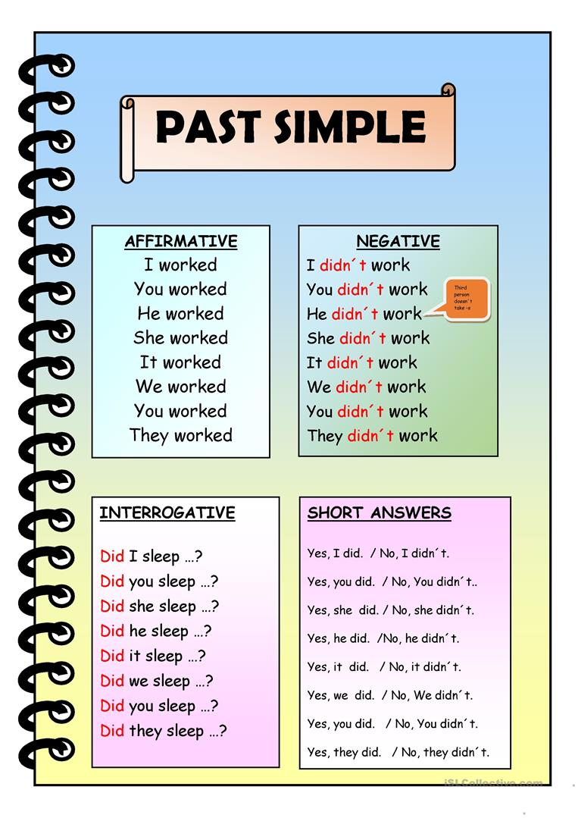
Source: https://en.islcollective.com/
See you soon! Bye!

