Let’s celebrate Christmas together!

ACTIVITY A: Cloze Test
Photodentro gap filling
Let’s have a closer look at this activity together!
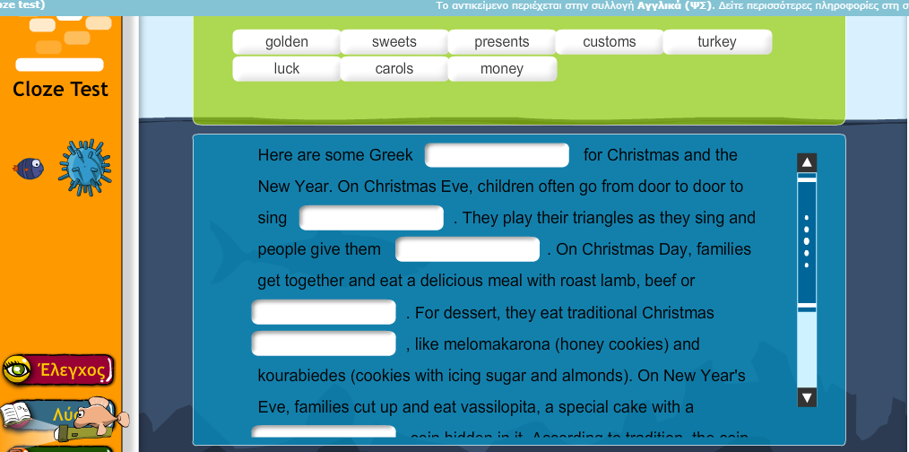

ACTIVITY B: Let’s sing together!
Jingle Bells Rock

Lyrics
Song by Bobby Helms
Jingle bell, jingle bell, jingle bell rock
Jingle bells swing and jingle bells ring
Snowin' and blowin' up bushels of fun
Now the jingle hop has begun
Jingle bell, jingle bell, jingle bell rock
Jingle bells chime in jingle bell time
Dancin' and prancin' in Jingle Bell Square
In the frosty air
What a bright time, it's the right time
To rock the night away
Jingle bell time is a swell time
To go glidin' in a one-horse sleigh
Giddy-up jingle horse, pick up your feet
Jingle around the clock
Mix and a-mingle in the jinglin' feet
That's the jingle bell rock
Jingle bell, jingle bell, jingle bell rock
Jingle bells chime in jingle bell time
Dancin' and prancin' in Jingle Bell Square
In the frosty air

Last Christmas
Song by Wham!
Last Christmas I gave you my heart
But the very next day you gave it away
This year, to save me from tears
I'll give it to someone special
Last Christmas I gave you my heart
But the very next day you gave it away (you gave it away)
This year, to save me from tears
I'll give it to someone special (special)
Once bitten and twice shy
I keep my distance, but you still catch my eye
Tell me baby, do you recognize me?
Well, it's been a year, it doesn't surprise me
"Merry Christmas" I wrapped it up and sent it
With a note saying "I love you", I meant it
Now I know what a fool I've been
But if you kissed me now, I know you'd fool me again
Last Christmas I gave you my heart
But the very next day you gave it away (you gave it away)
This year, to save me from tears

ACTIVITY C: Vocabulary games
Time for some fun. Are there any other words you would like to add?
Christmas quizlet games

ACTIVITY D: Fill in the gaps!
Please go to your S.B. p.59, Activity B. Complete Kostas’ letter with the verbs in brackets (parentheses) in Simple Present or Present Continuous.
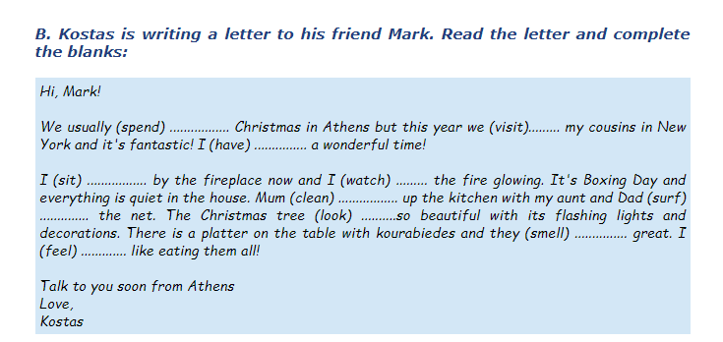

Examples
- spend 2. are visiting 3. am having

ACTIVITY E: Art time!

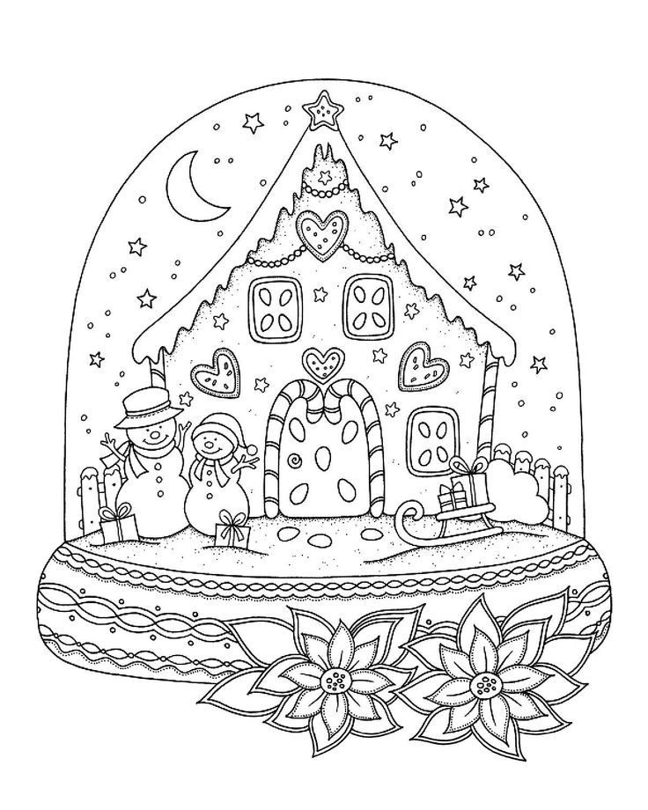



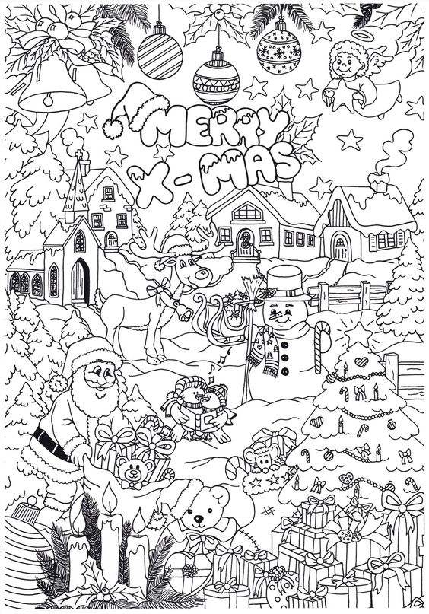

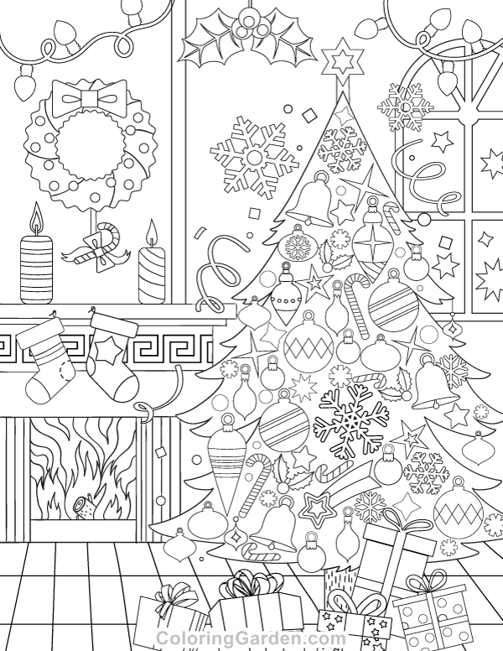

Πόροι εικόνων: coloringGarden.com, gr.pinterest.com

Thank you! See you soon!

