School rooms and subjects!
Revision Unit 2
Τμήμα Ε1΄

Activity A: Let’s start our revision (επανάληψη) with remembering the school rooms. If you want, you can look in your Student’s book p. 27 (D1).

VOCABULARY –School Rooms
Classroom
Computer lab
Chemistry/Science lab
Gym
Library
Toilets
School canteen
Assembly Hall (αίθουσα συγκεντρώσεων)
Corridor (διάδρομος)
Headteacher’s office
Teachers’ office
Dining room
School yard/playground

Activity B: Please go to this link and play the game by answering the questions!

Activity C
VOCABULARY –School Subjects
Please write in the chat or in your notebooks, as many school subjects as you can remember! You have 3 minutes!

Let’s now write them together!
Language
History
Maths
Science (Chemistry, Physics and Biology)
Geography
Foreign Languages (English, French, German)
P.E. (Physical Education)
R.E. (Religious Education)
Art
Music
I.T. (Information Technology)
Drama
Skills lab (εργαστήριο δεξιοτήτων)

Activity D: Let’s play a game to remember school subjects! Please go to this link and play the game!

Activity E: Homework!
Please, go to S.B. p. 30 read and try to complete the dialogue by listening here (Ctrl and click) if you can. Listen as many times as you want and we will talk about the answers in our next lesson. Click next to the microphone.

Ακούστε και συμπληρώστε τον διάλογο στο μάθημα στη σελίδα 30, για την επόμενη φορά, αν μπορείτε. Ακούστε όσες φορές θέλετε και θα πούμε τις απαντήσεις στο επόμενο μάθημα. Πατήστε δίπλα στο μικρόφωνο.
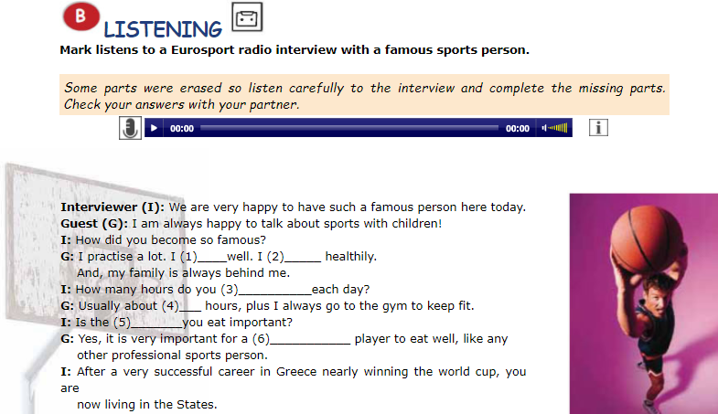

See you soon!


