Unit 4.1
Getting ready for Christmas!

Activity A
Please, go to S.B. p. 50 Act. A
New words:
glue
scissors
card
string
- card 2. string 3. glue 4. scissors

Activity B
Now let’s do Act. B listening
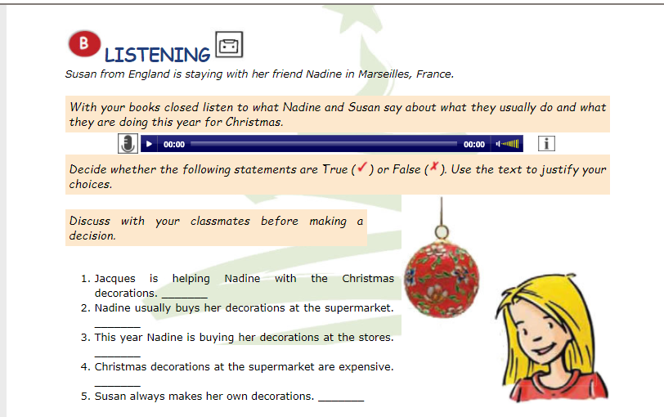

Activity C

Christmas
Fill in the gaps with Christmas words!

Activity D

Christmas multiple choice

Activity E
Find the words! Horizontally, vertically, upside down and diagonally!

Activity F
Art time!
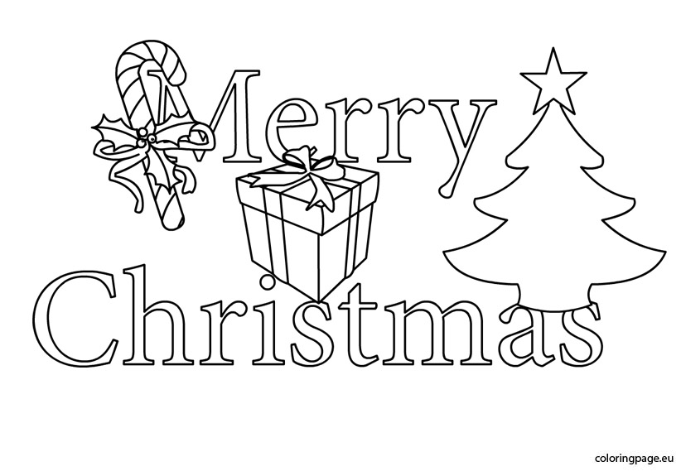

Thank you! See you soon!

