Unit 7.1: El Greco (Simple Past)

Activity A: Reading and Vocabulary (S.B. p. 88)

Republic of … | Δημοκρατία της…
Byzantine | Βυζαντινός-ή-ό
move | μετακινούμαι, μετακομίζω
individual | ατομικός-ή-ό
style | στυλ, τεχνοτροπία
religion →religious | θρησκεία →θρησκευτικός-ή-ό
element | στοιχείο
(v, n) influence | επηρεάζω, επιρροή
autobiography | αυτοβιογραφία

Activity B: Reading and Grammar (S.B. p. 88)

SIMPLE PRESENT | SIMPLE PAST  (regular & irregular)
is | was
study | studied
move | moved
continue | continued
go | went
live | lived
work | worked
die | died
have | had
influence | influenced
call | called

Activity C: Reading & Listening
El Greco photodentro reading activity
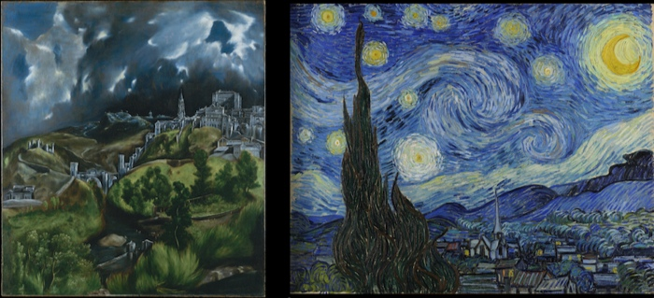
Left: El Greco, View of Toledo; right: Van Gogh, Starry Night, 1889
digital resource: khan academy
Activity D: Knowledge Quiz
First, have a look at S.B. p. 89. Do you know any of these people? Share your thoughts in class. Then try the following game, alone or in class.
Mystery game quiz- famous Greek people

See you soon! Thank you!

