Unit 4.1
Getting ready for Christmas!

Activity A: Listening
Please go to S.B. p. 54 and let’s listen together!
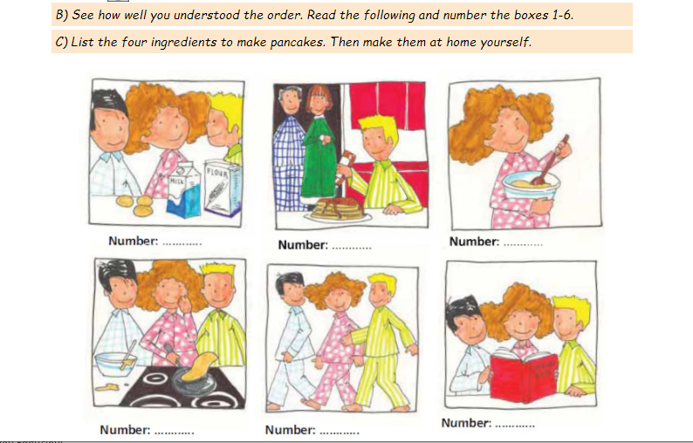

___3_ ___6___ ___4__
__ 5_ ___1___ ___2__
Activity B: Let’s play photodentro games!

Hidden words
hangman

Activity C: Let’s draw a Christmas picture!

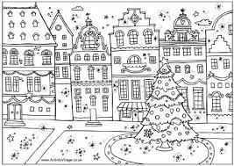

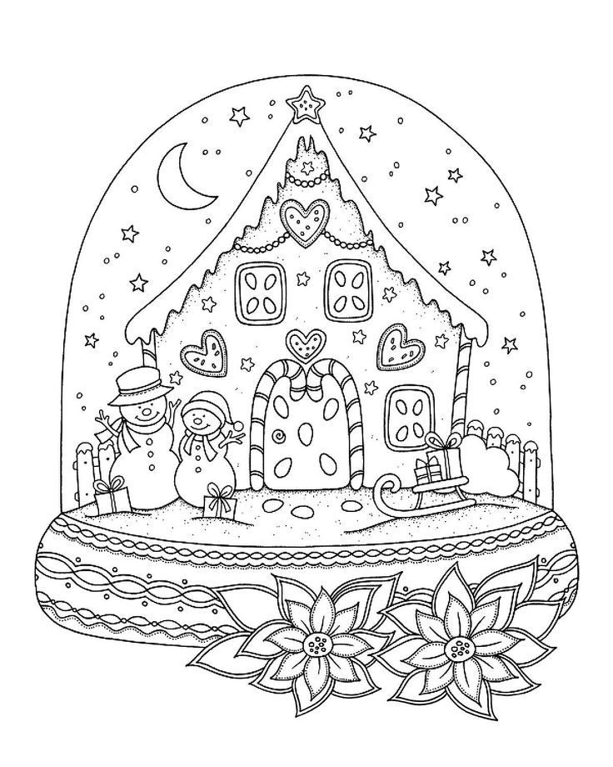



Thank you! See you soon!

