This is my day!

Activity A: Daily routines
VOCABULARY
Please, write the new words in your Vocabulary notebook.
Γράψτε τις νέες λέξεις στο τετράδιο του Λεξιλογίου.
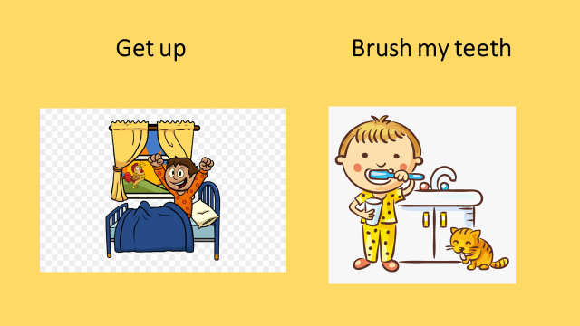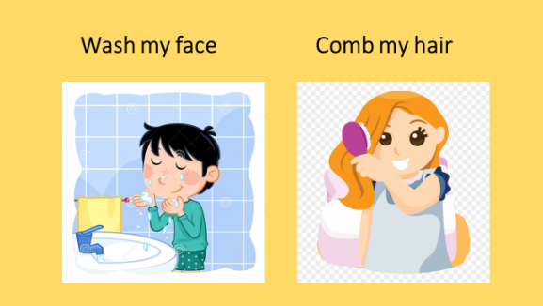
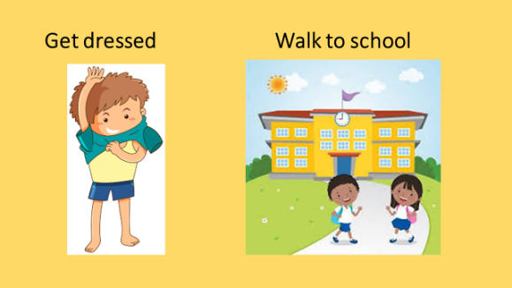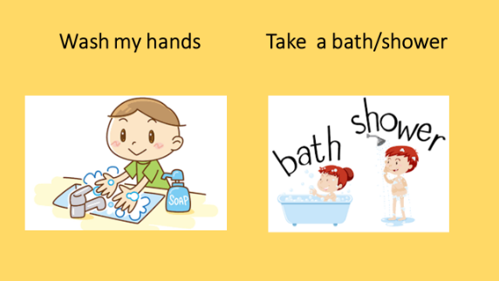
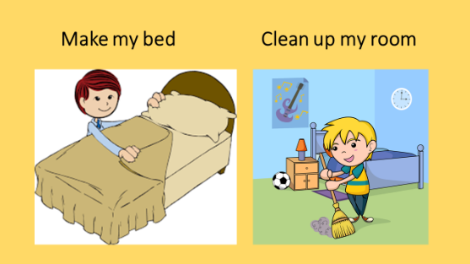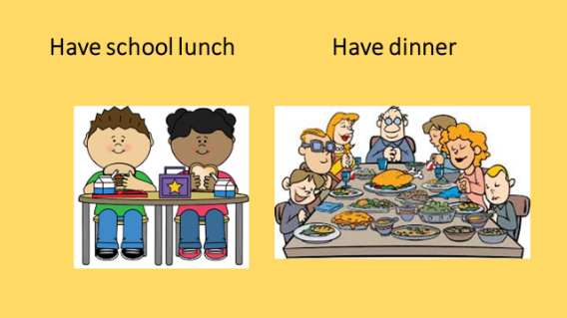
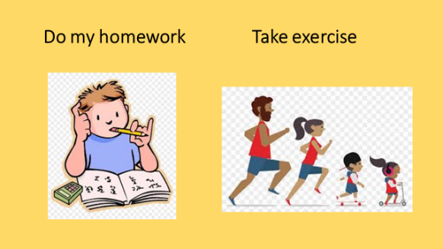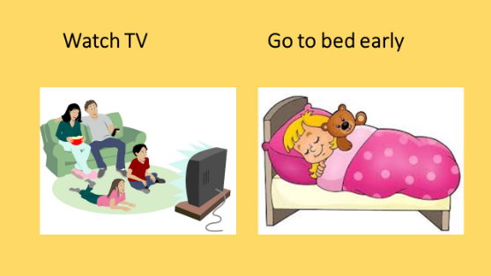
Θυμίζω→ Early=νωρίς late= αργά
Lunch=Μεσημεριανό dinner= βραδινό φαγητό

Activity B: Let’s play a game!
1. Please, match the words. Go to:
http://photodentro.edu.gr/v/item/ds/8521/6144

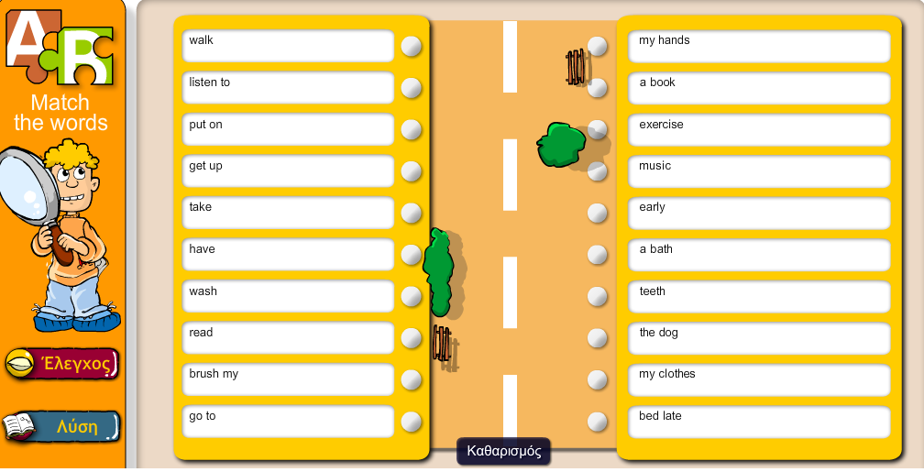

Write the correct pairs/phrases in your Exercise or Vocabulary notebook! You will read them to me next time. Γράψτε τις φράσεις που σχηματίζονται στο τετράδιο των Ασκήσεων ή το Λεξιλόγιο και θα μου τις διαβάσετε την άλλη φορά.

Activity C: Tell us about your day!

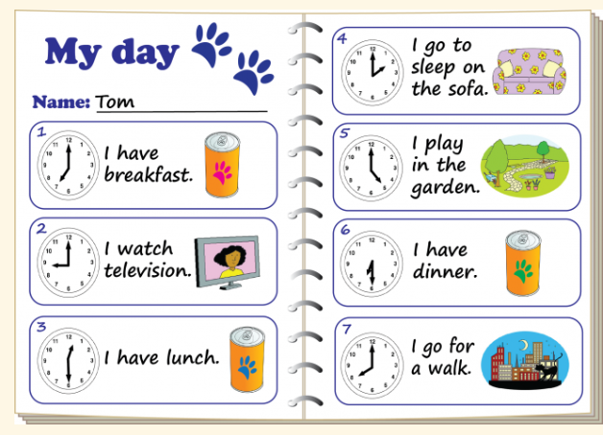
Here is what Tom writes about his day! Can you write 6-7 sentences about your day? Go to εργασία, υποβολή ή μήνυμα!
Please write also the time. Think about what you do
- in the morning,
- in the afternoon
- in the evening,
e.g. In the morning I get up at seven o’clock.

Image: https://wikiclipart.com/thank-you-clipart_1348/

S.B. p. 59
ANSWERS: 1. g 2. e 3. h 4. i 5. a 6. b 7. d 8. c 9. f

