Olympic Games started in Greece, in ancient Olympia in 776 B.C. They were held every 4 years and athletes from all Greek cities came. Wars stopped during the Games.
The ancient stadium could host 20.000 spectators, all men. The Games were dedicated to Zeus, but there were also the Heraia Games for women in honour of the goddess Hera.

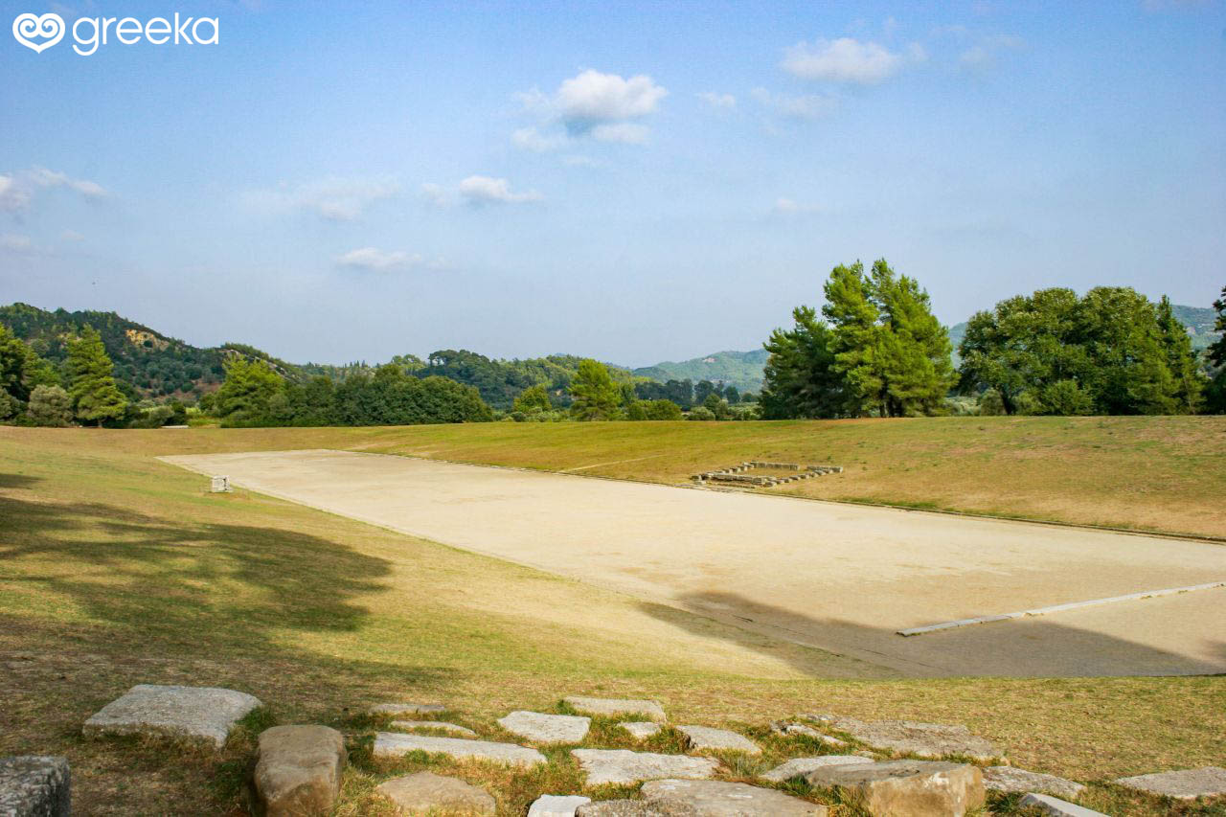

The Games stopped in 393 A.D. under the emperor Theodosius.
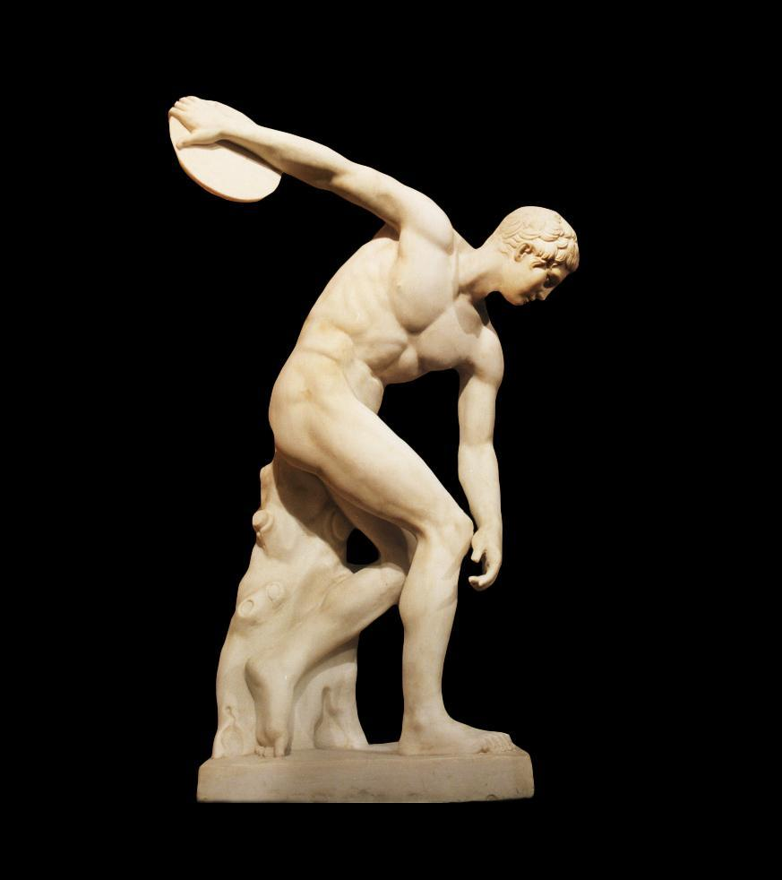
Discobolus is a statue showing an Olympic athlete, throwing the disc.
Originally Myron made the statue, but many artists copied it during Roman times.
Modern Olympics started again in 1896 in Athens.
This year, 2024, the Summer Olympic Games will be held in Paris from 26 July to 11 August.
Summer and Winter Olympic Games have their mascots. Here are some of them.
Statue of Zeus in Olympia
Olympic Medals
Athens 2004 Spyridon Louis 1896

